

Year 6 – Summer 2:
Key Theme

Evolution and Inheritance inc. the Evolution of Chesterfield
Key Vocabulary
evolution | the process by which different kinds of living organisms are believed to have developed from earlier forms during the history of the Earth
environment | the surroundings or conditions in which a person, animal, or plant lives
inherit | derive (a quality, characteristic, or predisposition) genetically from one's parents or ancestors
adaptation | the process of change by which an organism or species becomes better suited to its environment
fossil | the remains or impression of a prehistoric plant or animal embedded in rock and preserved in petrified form
organism | an individual animal, plant, or single-celled life form
naturalist | an expert in or student of natural history and nature
geology | the science which deals with the physical structure and substance of the Earth, its history, and the processes which act on it
geologist | an expert in or student of geology
palaeontology | the branch of science concerned with fossil animals and plants
palaeontologist | an expert in or student of palaeontology

Significant Scientists
Charles Darwin  Charles Robert Darwin (12 February 1809 – 19 April 1882) was an English born evolutionary biologist, naturalist and geologist who was best known for his contributions to the science of evolution. He first formulated his theory in his book "On the Origin of Species" in 1859 | 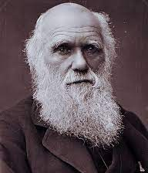
Mary Anning  Mary Anning (21 May 1799 – 9 March 1847) was an English fossil collector, dealer, and palaeontologist who became known around the world for important finds she made in Jurassic marine fossil beds in the cliffs along the English Channel at Lyme Regis, Dorset. | 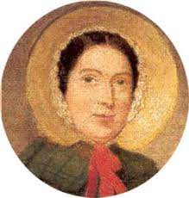

Core Value Focus
Curiosity, critical thinking, resilience, compassion.

Core Text
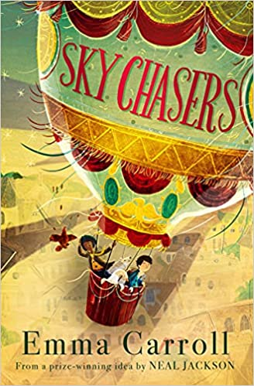

Sticky Knowledge & Skills
What was Darwin’s theory of evolution?
The theory of evolution by natural selection is the process by which organisms change over time because of changes in inheritable physical or behavioural traits.
Inheritance refers to the characteristic traits that are genetically passed to offspring from their parents e.g. hair colour, eye colour, height etc. Darwin refers to this as natural selection when the strongest traits survive over generations.
How are fossils formed and what do they tell us about animals and plants that used to inhabit the Earth?
Fossils are the impressions of the remains of prehistoric animals or plants embedded in rock and preserved in petrified form.
Animals change over time and adapt to the surroundings in which they live. Darwin observed that there were many
forms of finches that had different beak sizes and shapes. Once he considered the food sources of each finch, he noted the reason for these adaptations

The Great Plague
1665-1666 – the worst outbreak
Eyam – Derbyshire - The village that stopped the Plague.
Key people – Reverend Mompesson

Links to past and future learning
Which things are living and which are not.
Identifying animals and plants using classification keys
Animals that are carnivores, herbivores and omnivores.
Animals have offspring that grow into adults.
The basic needs of animals for survival
Some animals have skeletons for support, protection and movement.
Fo food chains, food webs and the role of predators and prey.

Key Texts

History |  | Science
When was the Great Plague?  How does the plague spread?  How did the plague spread throughout England?  Tell the story of how the Plague reached Eyam.  What did the people of Eyam do to stop the Plague from spreading?  How did people think you could prevent being infected by the plague?  How many people died in Eyam of plague.  Can you name the Reverends in the village?  Can you name any other families who died from the Plague? | 1665-1666  From a bite from an infected flea.  Trade moving around the villages.  Richer people moving from the Plague infected towns and cities to the smaller, rural villages.  A package of cloth sent to a tailor in Eyam - Alexander Hadfield from London. George Vickers opened the cloth and found it infested with rats and fleas.  They set up a cordon around the village disallowing any Eyam resident from leaving the village.  They held bunches of herbs to their noses.  Children were encouraged to smoke as it was thought heat and smoke would prevent it.  260 villages – 76 families in total. Some were wiped out completely.  Thomas Stanley  William Mompesson  George Darby  Mary and Abel Rowland  John Torre | 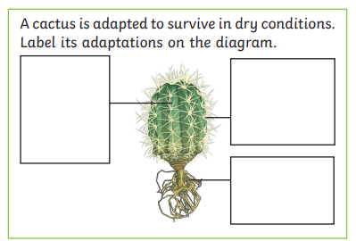  Why are fossils important to the theory of evolution?  Underline the words that are spelt incorrectly, then rewrite the sentence correctly.  Aminals and palnts have special features that make them better adpated to their enviroment so they are more likely to survive. | 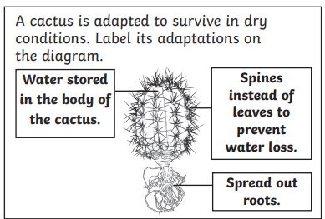  Fossils provide us with evidence of organisms that lived on Earth millions of years ago. They help to support Darwin’s theory of evolution. Fossils show us how organisms have changed over a long period of time.  Animals and plants have special features that make them better adapted to their environment so they are more likely to survive.
Geography
Where is Eyam?  How many people lived in Eyam at the time of the the Plague.  How many people live there now? | It is a village in Derbyshire, near Sheffield in England.  Approximately 800 people.  611 at the last census 2021

