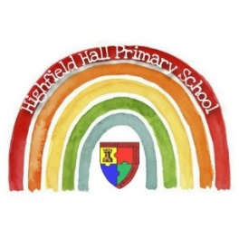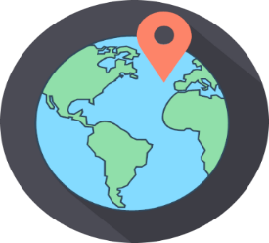 Year 3 – Autumn 1: Where does our food come from?

|  |
| --- |
| **Key Theme** |
|  |

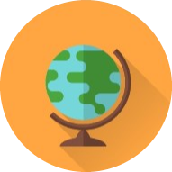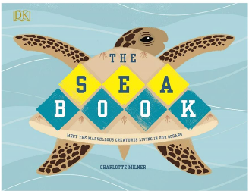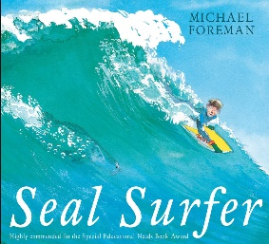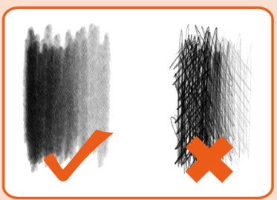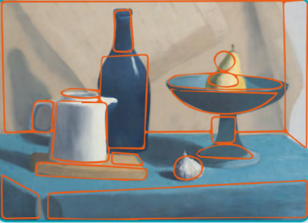

|  |
| --- |
| **Links to past and future learning** |
| In Year 2 we studied how to keep ourselves clean and healthy and the basic needs of survival for animals and humans.  In Year 4 we will learn how humans and animals digest food.  In Year 1 we studied the 4 countries of the UK and their capitals.  In Year 2 we investigated aspects of human and physical geography in relation to Chesterfield.  In Year 4 we will use our knowledge of the world to investigate climate zones, biomes and vegetation belts. |

|  |  |
| --- | --- |
| **Key Vocabulary** | |
| Physical feature | A physical feature is something that is on of the Earth’s natural features, for example a mountain or rivers. |
| Human feature | Something that would not have existed without humans, such as buildings. |
| Biome | Biomes are areas of the planet with similar climates, landscapes, animals and plants. |
| Types of biome | Savannah, desert, temperate deciduous forest, tropical rainforest, boreal rainforest, tundra |
| Food miles | The distance food has travelled to reach you. |
| Import | An item brought in from another country. |
| Consume | To buy, use or eat |
| Cooperative | A group of people working together who share ideas and income |
| Sustainability | A way of doing something that does not h arm the environment |
| Source | The place where something originally comes from |

|  |
| --- |
| **Key Texts** |
|  |

art

|  |
| --- |
| **Sticky Knowledge & Skills** |
| * I know the advantages of buying food locally. * I know the disadvantages of buying food locally. * I know the advantages of importing food. * I know the disadvantages of importing food. * I can name the different biomes and some of their unique features. * I can talk about sustainability. * I can talk about food miles. * I can name the different food groups. * I know what a nutritional diet should include. * I can name some bones in the human body. * I know the difference between an endo skeleton and an exoskeleton. * I can identify shapes within an object to help me draw more accurately * I know how to use my pencil to shade, creating light and dark tones. |

|  |
| --- |
| **Core Value Focus** |
| Curiosity, critical thinking, resilience, creativity |

|  |  |  |  |  |  |
| --- | --- | --- | --- | --- | --- |
| Geography | | Science | | RE- What is it like for someone to follow God? | |
| What are food miles?  What does import mean?  What does trade mean?  Can you tell me what responsible trade is?  Can you explain what sustainability means?  What is seasonal food?  Name an advantage of buying food locally.  Name a disadvantage of buying food locally.  Name an advantage of importing food.  Name a disadvantage of importing food? | The distance food has travelled to reach you.  An item brought in from another country.  The buying or selling of goods and services.  Workers have a voice, they can get the best deal for their product and work in a safe place.  It’s a way of doing something that doesn’t harm the environment.  Food which is best eaten in a particular season.  -Reduces food miles.  -Provides people with fresh seasonal food.  -Creates jobs in the local community.  -May mean greenhouse gases are used to grow food out of season.  -May be more expensive  -Helps to support communities in developing countries.  -Provides people with a wider variety of food.  -May encourage deforestation to produce more food.  -Increases food miles | Name the different food groups.  Give an example for each of the food groups.  Can you name any bones in the human skeleton?  What type of skeleton does a human have?  What is the difference between an endoskeleton and an exoskeleton?  What is the scientific name for a backbone?  What is the difference between a voluntary muscle and an involuntary muscle? | Carbohydrates, protein, oils and spreads, dairy, fruit and vegetables,  **Carbs** –Cereals, bread, rice and pasta.  **Proteins** - Fish, meat, eggs and dairy products **Fats -** Butter, oils and nuts **Fruit and veg** – apples. Broccoli etc **Dairy –** yoghurt, cheese  skull / clavicle / scapula / humerus / pelvis / radius / femur / fibula / tibia / ulna / vertebral column / ribcage  Endoskeleton  An endoskeleton is on the inside and an exoskeleton is on the outside of the body  The vertebral column or the spine.  A person chooses to move a voluntary muscle. Involuntary muscles move without you thinking about them – the heart and the intestines | What is a Prophet?  Can you name any Prophets from the Old Testament?  What is the Old Testament?  What do Christians believe?  Can you tell me about Noah? | Prophets are messengers sent from God.  Abram: the Prophet who made a covenant with God who is later called Abraham.  Noah: the prophet who was told to build an Ark by God and who made a covenant with God.  It is the first 39 books of the Bible which tell about Creation and God’s covenant with his people.  They believe Jesus is the Son of God who came to save them.  Noah was told by God to build an Ark as the people did not listen to God.  When the flood arrived Noah took his family and the animals into the Ark.  At the end of the flood God placed a rainbow in the sky and made a covenant with Noah that he wouldn’t send another flood or destroy the earth again. |