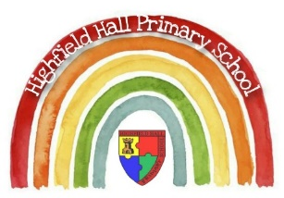
Key Theme

Year 4 – Spring 1 2023 – Volcanoes & Earthquakes
Links to past and future learning

Key Texts
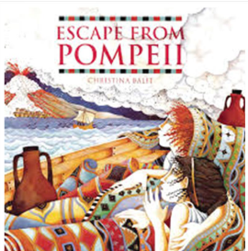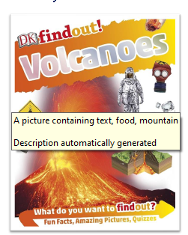

Sticky Knowledge & Skills
- Mount Vesuvius erupted in AD79.
- Pompeii was buried underneath a blanket of ash, pumice-stone and lava and was not re-discovered again until 1748.
- Approximately 2000 people in Pompeii lost their lives following the eruption.
- There are around 1,500 active volcanoes around the world.
- Tectonic plates move towards each other, away from each other and when this happens, it can cause both volcanic eruptions and earthquakes.
- The Ring of Fire is a region which spans much of the Pacific Ocean where a great many volcanic eruptions and earthquakes happen every year.

Labelled diagram of a volcano
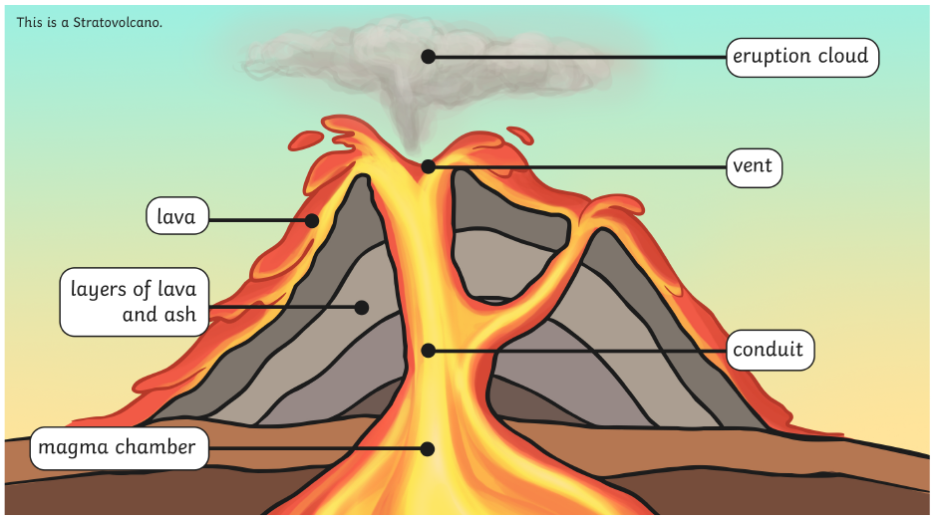

Key Vocabulary
active | An active volcano has erupted in the last 10,000 years.
dormant | A dormant volcano has not erupted in the last 10,000 years but could erupt in the future.
extinct | An extinct volcano will not erupt ever again.
volcanic eruption | A volcanic eruption is when lava and gas are released from a volcano.
core | The Earth’s core is the central layer which is made of iron and nickel.
mantle | The Earth’s mantle is the middle layer which is moving hot rock.
crust | The Earth’s crust is a thin outer layer of hard rock.
Ring of Fire | The Ring of Fire is a region in the Pacific Ocean which experiences lots of volcanic eruptions and earthquakes.
Mount Vesuvius | Mount Vesuvius is an active volcano situated in the Bay of Naples in Italy.
Richter scale | The Richter scale measures how powerful an earthquake is.
magnitude | How word used to describe how strong an earthquake is.
tremor | A small earthquake in which the Earth shakes slightly.

Core Value Focus
Compassion
Emotional health
Respect

Geography |  | Science – States of matter |  | RE – Why are festivals important to religious communities?
What are the three main layers of the Earth?  What are the three volcano states?  What is a volcanic eruption?  What is the difference between lava and magma?  Where is Mount Vesuvius located?  What does the Richter scale measure?  Describe the movement of tectonic plates… | The core, mantle and crust.  Active, dormant or extinct.  When lava and gas are released from a volcano with force.  Lava is flowing molten rock above ground and magma is the same but underground.  The Bay of Naples in Italy.  The strength of an earthquake on a scale of 1-9.  They can move towards each other, away from each or past each other. | What are the three states of matter?  At what temperature does water start to freeze and become ice?  Are all melting points the same?  What is evaporation?  Why is water special?  Describe the particles of a gas. | Solid, liquid and gas.  0 degrees Celsius.  No – it depends on the material you are trying to melt. Not all of them have the same properties.  This is a process which takes place when a liquid warms up and turns into a gas.  Because it can exist in all three states of matter.  They are spread out and move around quickly and freely. | What is holy week?  Name a Christian celebration that happens during holy week.  Number these pictures from The Easter Story in order.  What happened when Mary went to Jesus's tomb?  Draw a Christian symbol of Easter.  Why is your symbol you drew important to Christians?  What other festivals are celebrated in other religions communities in Britain? | It is the week leading up to Jesus’s death.  Palm Sunday, Maundy Thursday, Good Friday, Easter Sunday.  See sheet attached.  She saw that the stone had been removed and Jesus’s body was not there.  Cross, palm branches, Easter egg, hot cross buns, chicks  - Cross - represents Jesus’s crucifixion  - Palm branches - represents when Jesus was welcomed into Jerusalem  - Easter egg - represents Jesus’s empty tomb  - Hot cross buns - represents Jesus’s crucifixion  - Chicks - represents new life  Diwali, Ramadan, Eid

