Highfield Hall Primary and Nursery School Handwriting Policy

Rationale
At Highfield Hall Primary and Nursery School, we believe that fluent, legible handwriting is an essential life skill which supports successful written communication across the curriculum. We follow the PenPals for Handwriting programme to ensure a consistent, progressive approach to teaching handwriting from Reception to Year 6. This approach enables children to develop accurate letter formation, efficient joins, increased writing fluency and pride in presentation.
Research demonstrates that fluent handwriting reduces cognitive load, allowing children to focus more effectively on composition, vocabulary and spelling. Consistent teaching and high expectations are therefore essential in helping pupils become confident and successful writers.
The teaching of handwriting forms part of our wider writing curriculum and aligns with the expectations outlined in our existing writing policy, which states that letter formation and handwriting are taught and modelled using PenPals throughout EYFS, KS1 and KS2.

Expectations for Handwriting Teaching

Frequency
- Handwriting should be taught explicitly through discrete lessons. In Y1-Y6, this will be taught daily.
- Children must be able to clearly see the teacher modelling handwriting. Use of Handwriting Repeater will aid teachers in circulating and supporting, whilst still ensuring accurate modelling is continuing.
All classes from Reception to Year 6 should receive regular handwriting instruction using PenPals. Reception children will be exposed to additional resources, including the Monster Phonics letter mnemonics, during daily phonics sessions. Explicit handwriting teaching uses a shared movement vocabulary and follows the PenPals letter families to provide a clear and consistent approach to letter formation.
Handwriting expectations should be reinforced across all curriculum areas.

Handwriting Lines
In line with National Handwriting Association (NHA) guidance:
- Standard writing lines should be used for all handwriting lessons and handwriting practice.
- The only alternative format permitted is the NHA half-line format where appropriate for individual pupils.
- Other handwriting line formats should not be used, including Bubble Writing.

Presentation
To ensure consistency throughout school:
- Pupils must form letters correctly and place them appropriately on the line.
- Work should be presented neatly and with pride.
- Staff should model high standards of handwriting at all times.

Teaching Progression

EYFS
In EYFS, we believe ‘Strong Bodies, Strong Hands, Strong Writers’. Children first develop the physical foundations for handwriting through rich gross and fine motor experiences before moving into explicit handwriting teaching in Reception.

Children will:
- Develop gross and fine motor control through mark-making and physical activities.
- Learn correct pencil grip, posture and paper positioning.
- Learn correct letter formation through PenPals and pre-writing activities.
- Be taught to form lower-case and capital letters correctly, in letter families, and begin applying this in writing.
- Begin to write simple words and sentences with correctly formed letters.

Year 1
Children will:
- Secure correct letter formation.
- Develop consistency in letter size and orientation.
- Learn letter families and movement patterns.
- Write letters sitting correctly on the line.

Joins
- No formal joins taught.
- Focus remains on accurate formation and orientation.

Year 2
Children will:
- Consolidate correct formation of all letters.
- Develop consistency in size and spacing.
- Begin to understand how letters are prepared for joining.

Joins
- Introduction to the concept of joining.
- Teach simple diagonal joins from letters with exit strokes.
- Teach some of the horizontal joins needed to join letters.
- Learn that there are some letters that are best left unjoined when they are adjacent to one another.
- Focus on accuracy before speed.

Year 3
Children will:
- Secure basic joins.
- Increase fluency and consistency.

Joins taught
Children will be taught:
- Diagonal joins to letters without ascenders.
- Diagonal joins to letters with ascenders.
- Horizontal joins to letters without ascenders.
- Horizontal joins to letters with ascenders.
Children should begin to join most handwriting independently by the end of Year 3.

Year 4
Children will:
- Consolidate all joins.
- Improve writing fluency.
- Develop consistency of slant, size and spacing.

Joins taught
- Revision of all PenPals joins.
- Focus on maintaining joins within longer pieces of writing.
- Development of speed without loss of legibility.

Year 5
Children will:
- Apply joined handwriting consistently across the curriculum.
- Develop a personal, efficient handwriting style while maintaining legibility.

Joins taught
- Secure application of all joins.
- Greater focus on fluency and stamina in extended writing.

Year 6
Children will:
- Demonstrate a fluent, legible and efficient joined handwriting style.
- Write automatically and comfortably across a range of subjects.

Joins taught
- Refinement and mastery of all joins.
- Application of handwriting skills in all written outcomes.

School Agreed Variations
Whilst PenPals provides the core teaching sequence, the following variations are permitted once children have securely mastered the standard joins:

Break Letters
The following letters are considered break letters:
g, j, f and y
- These letters may be joined where this is carried out carefully, accurately and consistently.
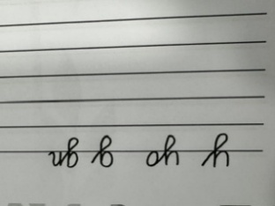
The returning descender should cross the line where it meets the descending line. ie
- Children must not be encouraged to force joins that reduce legibility.
- Staff must closely monitor pupils to ensure joins remain correct and efficient.

Additional Permitted Joins
Children may also join from:
- b
- p
- s
where this is:
- formed correctly,
- fluent,
- legible,
- and consistently accurate.
These joins should only be encouraged once pupils are secure in the standard PenPals joins.
Staff must monitor these adaptations closely and intervene where inaccuracies develop.

Inclusion
Children experiencing difficulties with handwriting may require:
- Additional practice.
- Fine motor interventions.
- Alternative pencil grips.
- Occupational Therapy recommendations.
- Targeted adult support.
The expectation remains that all pupils will make progress from their individual starting points.

Monitoring and Quality Assurance
SLT will monitor handwriting through:
- Book looks.
- Learning walks.
- Pupil discussions.
- Moderation activities.
Particular focus will be placed on:
- Consistency of teaching.
- Use of agreed handwriting lines.
- Correct implementation of PenPals progression.
- High standards of presentation.
- Appropriate use of permitted break-letter joins and joins from b, p and s.
Teachers are responsible for ensuring handwriting expectations are applied consistently across all curriculum subjects.

Non-Negotiables
- Handwriting is taught using the PenPals progression.
- Handwriting lessons use standard handwriting lines.
- The only alternative format permitted is the National Handwriting Association half-line format.
- Bubble Writing is not permitted.
- Children are expected to apply handwriting expectations across the curriculum.
- Additional joins from break letters, b, p and s may only be used when they are formed carefully, accurately and legibly.
- Staff must actively monitor the accuracy of all non-standard joins.
- Presentation standards are consistently upheld in every subject.

Appendix 1 – EYFS Handwriting on a Page document
Appendix 2 – Whole-school Handwriting on a Page document

Appendix 1
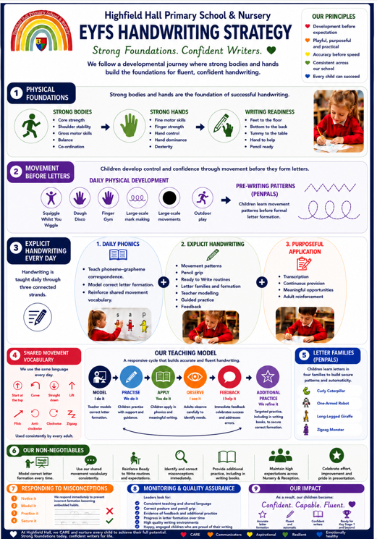

Apendix 2