Year 4 – Spring 2 2023: The Romans (short unit).
Key Vocabulary
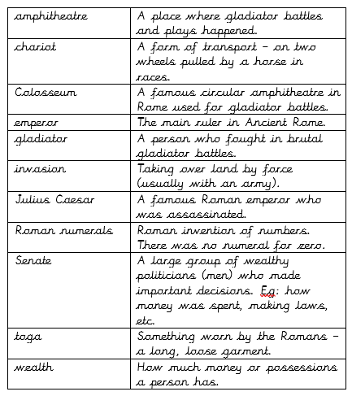
Key Theme

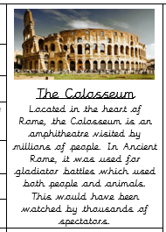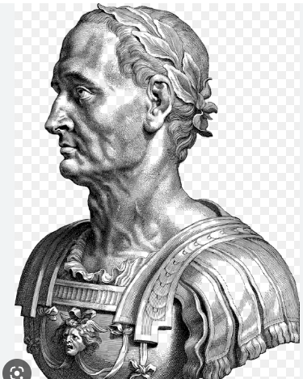
Key Texts

Links to past and future learning
You learned about some aspects of the Romans in year 3.

You will learn about the people who followed on from the Romans: the Anglo Saxons & Vikings (year 5).

Core Value Focus
Resilience
Curiosity

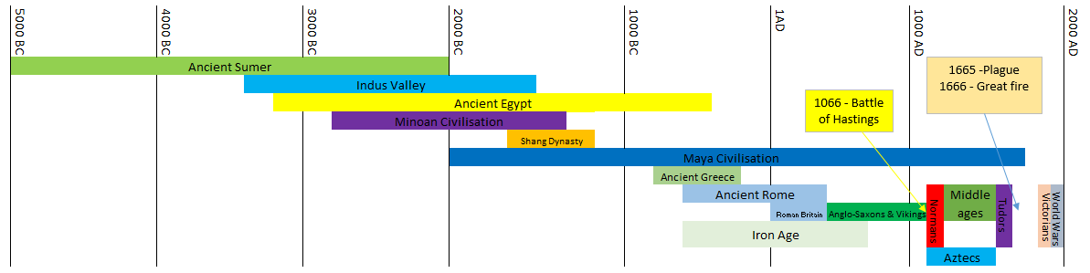

Sticky Knowledge & Skills
- The Romans came to Britain around 2000 years ago.
- They invented many things which we still use today such as calendars, roads and baths.
- Julius Caesar tried to invade Britain in 55BC and then again in 54BC.
- Almost 100 years later in 43AD, Emperor Claudius organized a final attack on Britain and was successful in defeating the Celtic tribes.
- The Romans remained in Britain for 400 years.

History (Romans) |  | Science (Human nutrition) |  | RE???
How long ago did the Romans come to Britain?  Give an example of something the Romans invented which we still use today?  How long did the Romans remain in Britain?  Name a famous Roman emperor that we have learned about…  What did a gladiator do?  Describe the Colosseum…  Which number is missing in Roman numerals? | Around 2000 years ago.  ANY OF THE FOLLOWING:  Calendars, roads, baths, Roman numerals on clocks.  Around 400 years.  Julius Caesar or Emperor Claudius.  They fought battles with people/animals in an amphitheatre.  A famous Roman amphitheatre which still stands (in part) today.  There is no number for zero. | Name at least TWO types of human teeth…  What is tooth decay and how do we stop it?  Describe what the oesophagus in the human body is for…  What are faeces and where do they come from?  Name some things which are bad for our teeth… | ANY TWO OF THE FOLLOWING:  Incisors, canines, pre-molars or molars.  Tooth decay is a build of plaque on teeth which over time, damages them. Good dental hygiene is needed to prevent this happening.  This is a tube in your throat which helps carry food down towards the stomach.  Faeces is a scientific word for ‘poo’ and it leaves the body through the anus.  Fizzy or sugary drinks, not brushing them with toothpaste regularly.

