Extra curricular SEND activities
4.85% of the school have a diagnosis of ASD. This comes under the broad area of need of Communication and Interaction.
These children make up 20% of the SEN register

https://www.highfieldhall.derbyshire.sch.uk/web/send_information/663287
Working with parents
At HHPS, we recognise that working with parents is key to ensuring the success of children with SEND in school.
We do this through
- termly One Page Profile meetings where parent voice is listened to and recorded and successes, concerns and targets are shared
- termly workshops for parents with autistic children
- updating the website with advice, and signposting to local and national support; this includes the SENCO’s school email address for contact

Key data:
SEN support | HH | 16.5% (63 chn) | National | 14.1%
EHCP | HH | 2.9% (11 chn) | National | 3.0%

Children on the SEN register per year group
Year group | N | YR | Y1 | Y2 | Y3 | Y4 | Y5 | Y6
Number of children | 1 | 12 | 9 | 12 | 6 | 16 | 8 | 9
% of year group | 4% | 25% | 18% | 21% | 12% | 33% | 17% | 16%

Area of need | % of children on SEN register
Communication and Interaction | 41%
Social, Emotional and Mental Health | 41%
Cognition and Learning | 14%
Sensory and Physical | 3%

We currently have 8.4% of children in receipt of Inclusion Panel Funding/Key stage GRIP funding.
There are currently 1.9% of children going through an EHCNA/have applied for an EHCNA

https://www.highfieldhall.derbyshire.sch.uk/web/send_information/663287

Our SENCO
Anna Higham  is the whole school SENCO | 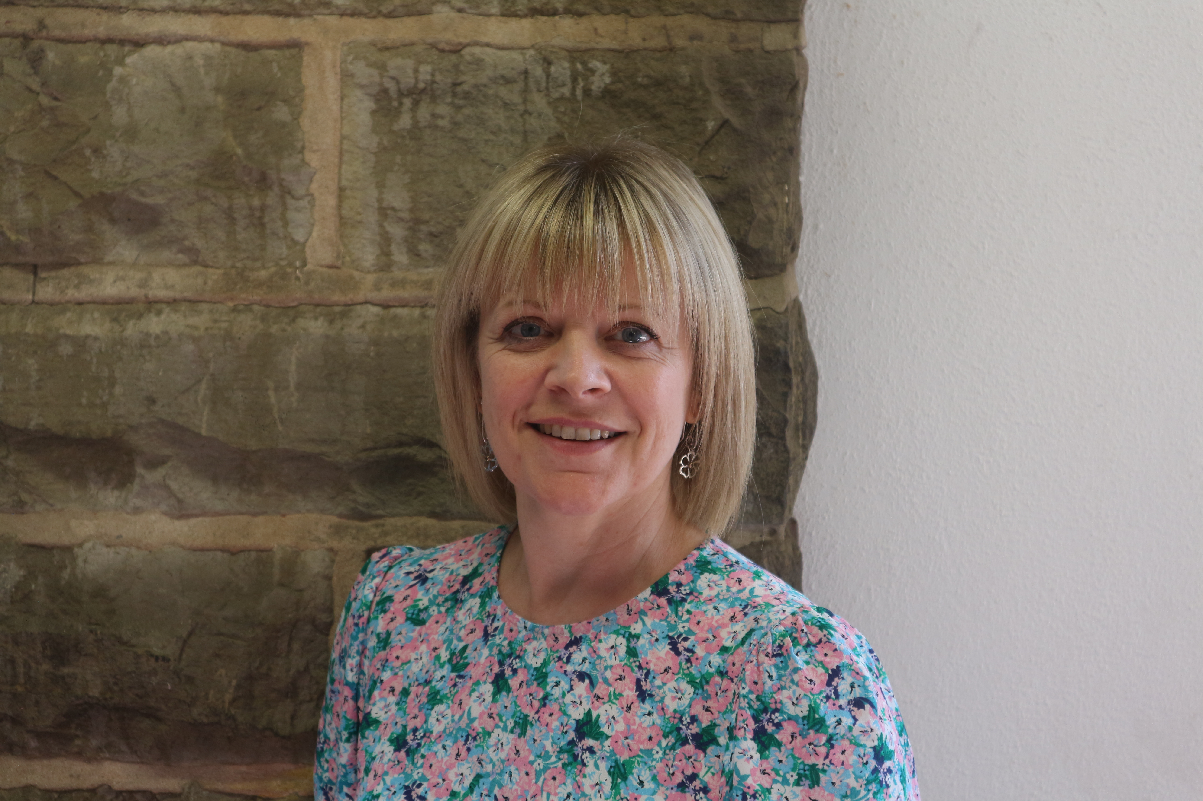
Sally works closely with outside agencies, including
Autism Outreach
Behaviour Support
Educational Psychologist
SSSEN teachers
School nurse service
Local SEND team
Speech and language services
Physiotherapy and occupational therapy services
Vision impairment service
Teacher for the deaf

Key Policies
SEN policy
SEN information report
Behaviour policy
At HHPS we know that every teacher is a teacher of SEND.
- Teachers know that they are “responsible and accountable for the progress and development of the pupils in their class, including where pupils access support from teaching assistants or specialist staff.” (SEND Code of Practice 2016, 6.36)
- We identify a child has having SEND when “their learning difficulty or disability calls for special educational provision, namely provision different from or additional to that normally available to pupils of the same age.” (SEND Code of Practice 2016, 6.15)

Initial concerns
- Share concerns with the SENCO using the HHPS initial concerns form
- Talk to parents
- Ensure QFT is in place, as per the whole school provision map
- SENCO will observe the child in class and write an observation report, offering advice
- Discussions around placing the child on the SEN register, and possible referrals to outside agencies
CPD
- The SENCO has delivered “ Making Sense of Autism” face to face training to the whole school (summer 2023)
- Further training “Good Autism Practice” is to be delivered face to face summer 2024
- Staff are signposted to appropriate training according to the needs of the pupils in their classes.
- Outside agencies offer support and advice around working with individual children, and signpost to further guidance and training

Ten pin bowling, Boccia, Panathalons, SEND cricket
Key School Governors
Our SEND governor is Stuart Yeowart. Stuart is also Chair of Governors.

