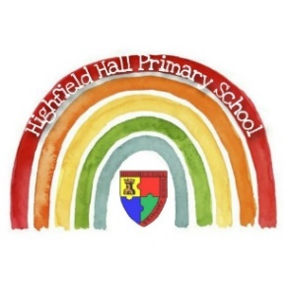Year2 – Autumn 2:

|  |
| --- |
| **Key Theme** |
|  |

The Owl Who Was Afraid of the Dark

|  |
| --- |
| **Sticky Knowledge & Skills** |
| * Important events happened in the past * The Gunpowder Plot happened in 1605 * We use evidence to find out what happened in the past * Use phrases and words like: ‘before’, ‘after’, ‘past’, ‘present’, ‘then’ and ‘now’; in historical learning * Sequence a set of events in chronological order and give reasons for their order |

|  |  |
| --- | --- |
| **Key Vocabulary** | |
| Barn owl | A type of owl, which is a bird of prey |
| Telescope | A tool to make distant objects, like stars and planets, appear nearer |
| Startled | Feeling or showing shock |
| Campfire | An open air fire used for cooking and heat |
| Supper | An evening meal (usually a small one) |
| Bleary | Feeling unfocussed due to sleep or tiredness |
| Enormous | Big, huge, massive, gigantic! |
| Necessary | Needing to be done |

|  |
| --- |
| **Core Value Focus** |
| Compassion, critical thinking, curiousity |

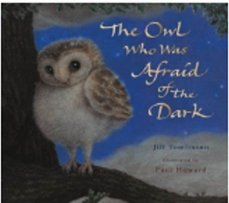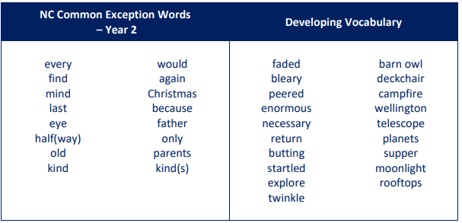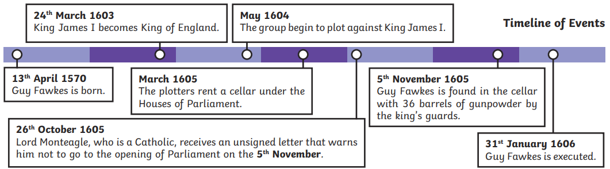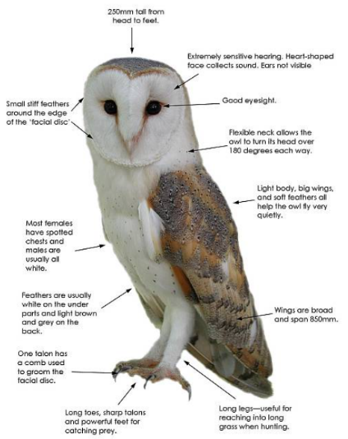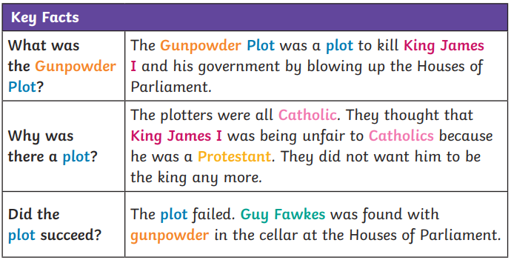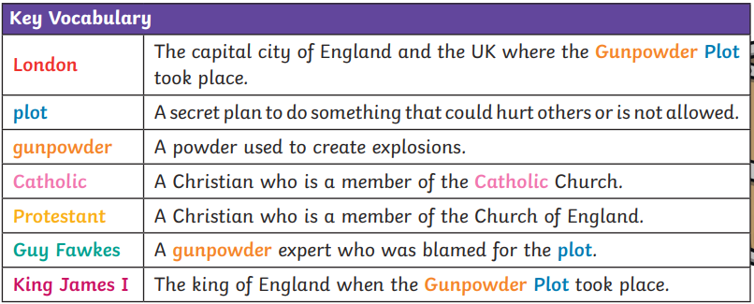

|  |
| --- |
| **Key Texts** |
|  |

Find out more about barn owls here!

Watch a video about the Gunpowder Plot here!

Events Beyond Living Memory: The Gunpowder Plot

|  |
| --- |
| **Links to past and future learning** |
| In Year 1 we learnt about chronology and that things change over time.  In Year 3 we will begin to study how modern Britain came to exist |

|  |  |  |  |  |  |
| --- | --- | --- | --- | --- | --- |
| History | | Science | | RE | |
| What year was the Gunpowder Plot?  Which city did the Gunpowder Plot take place?  Who do we remember in the Gunpowder Plot?  Which building did the plotter want to blow up?    Why did the Gunpowder Plot happen?  Did it succeed? | 1605  London  Guy Fawkes  The Houses of Parliament.  The Protestant King was being unfair to Catholics. They did not want him to be King anymore.  No | What are 3 natural materials?  What are man-made materials?  What does “recyclable” mean?  What are 3 recyclable materials?  Why is it important to reuse and recycle materials? | Rock, wood, clay, wool. Straw, stone  Plastic, glass, metal, brick, paper, cardboard  Can be used again  Various answers  To save energy, reduce pollution, stop landfill | Which religion celebrates Passover?  What does Passover celebrate?  Which religion celebrates Eid?  What do Muslims do during Ramadan?  What are 3 key events in the Christmas story | Judaism  Moses leading the Jewish people to freedom from slavery.  Islam, Muslim  Fasting from sunrise to sunset, pray more, donate  money to charity, do good deeds.  Jesus’ birth, angel Gabriel, kings, shepherds, taxes, |