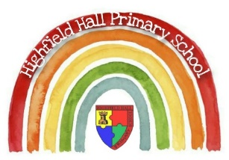
Year 1 – Spring 1: The Lion Inside
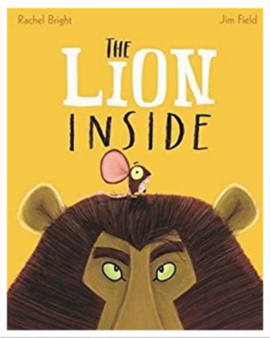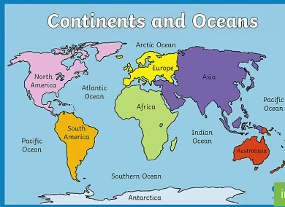
Science Sticky Knowledge/key questions
We can look at the everyday objects and identify the properties of the materials they are made out of.
How do you know what material an object is? Which is the hardest material? Which material would you use if you were building a window? What material is a table made from?

Geography Sticky Knowledge – animals
We have looked at the UK and that we live in the UK.
Can you point to Africa on the map of the world? Can you point to the UK on the map of the world? Can you name any other continents?

D&T Knowledge/ Key questions
We can think about how to make stronger, stiffer and more stable by using our knowledge of materials from science.

Why have you chosen this design? Is it in line with the design criteria?
Why have you selected these tools for that job? Which tool would you need for sticking? Which tool would you need for cutting?
Which materials would be better suited to make your mask? Why?

Key Texts
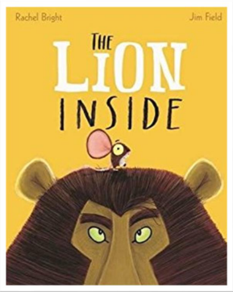

Core Value Focus
Creativity, critical thinking, curiosity, resilience, emotional heath.

Key Theme

Key Vocabulary
toothsome | Tasty or attractive.
slumber | To sleep lightly.
whimper | To make a series of low, small sounds showing fear, pain, or unhappiness.
foe | An enemy or opponent.
mane | Long hair on the neck of a horse, lion, or other mammal.
continent | Any of the world's main continuous expanses of land.
atlas | A book of maps or charts
week | A period of seven days beginning with Sunday and ending with Saturday.
plain | Not decorated or elaborate; simple or basic in character.

Links to past and future learning
In Reception we learnt about changes of state e.g. when ice melts and turns into puddles. This will be the first time we are looking at properties of materials in this way.

In reception have had a lot of practice at making structures through junk modeling. In year 1 we are now linking our skills of junk modeling with our science knowledge. We will also upskill our junk modeling by sticking to a design brief and thinking carefully about our tools.

Geography |  | Science |  | RE
What are the names of the 7 continents?  What is the name of the largest continent?  Which animal would you find in Africa?  What is the climate like nearer the equator? | Asia, Africa, North and South America, Antarctica, Europe, Australia  Asia, England, Europe  Polar Bear, Lion, Fox  Hot or cold? | Which of these is a property of a material?  What is a material?  Which material is a table made from?  Which property makes wood a good material for a table? | Soft paper wood  What something is made out of. Table. Jumper.  Fabric Wood Potato  Bendy Hard Stretchy | Muslims believe in one God. What God’s name?  Muslim’s follow the teaching of a Prophet. What is the name of the Prophet?  Why do Muslims try to follow Prophet Muhammed? | Allah  Muhammed  So they can behave like Muhammed e.g.  - Be kind  - Care for the earth  - Help treat people fairly

