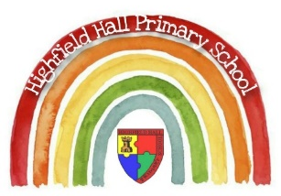
Key Theme

Year 5 – Summer 1 Caring for our world
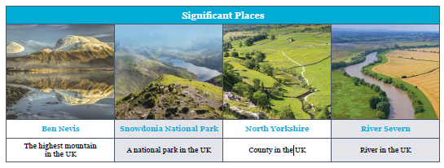
Key Texts
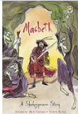

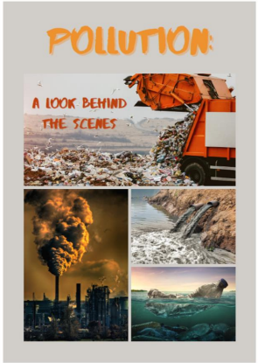

Links to past and future learning
In Y4 we learnt about the water cycle.
In Y6 we will learn about land use in other countries.
In Y6 we will learn about biomes and ecosystems around the world.

Sticky Knowledge & Skills
- To locate geographical features on a map.
- To identify and describe geographical features of the UK.
- To identify different types of human settlement.
- To understand the types of land use in different areas of the UK.
- To understand that land use varies between the four countries of the UK.
- To identify Derbyshire and the surrounding counties on a map.

Core Value Focus
Critical thinking, resilience, compassion.

Key Vocabulary – Land
Land Use | How humans use the land and natural resources.
Peak | The highest point of a mountain.
National Park | Land which is protected by laws which control how it can be used.
Coastline | Where the land meets the sea.
Settlement | A place where humans have chosen to live.
Rural | Areas with a small human population and few buildings.
Urban | Places with a large population of people and many buildings.
Hamlet | A settlement with a small group of houses and no other buildings
Village | A settlement with a small number of houses and other buildings.
Town | A settlement with lots of houses and other buildings.
City | The largest type of settlement with lots of houses, buildings and a cathedral.
Population | The number of people living in one place.
County | A part of the UK with its own council.

Geography |  | Art |  | Science |  | RE
What are areas of raised land known as?  Where is Snowdon located?  How many seas and oceans surround the UK?  Name the seas and oceans which surround the UK.  What is the smallest type of settlement called?  What attracts settlers to an area?  Name 3 of the counties which surround Derbyshire? | Hills or mountains.  Wales  4  North Sea, English Channel,  Atlantic Ocean, Irish Sea.  Hamlet  Water, food, shelter, resources.  Nottinghamshire, Yorkshire, Leicestershire, Cheshire, Staffordshire. | What artistic style was Barbara Hepworth famous for?  What materials did Barbara Hepworth use in her sculptures?  From where did Barbara Hepworth take her inspiration?  Where is the Barbara Hepworth sculpture in Chesterfield? | Abstract art.  Wood, metal and stone.  Nature and natural forms.  Near the Queen’s Park bridge. | Give an example of a solid, a liquid and a gas.  How do you convert a liquid into a gas?  How do you turn a liquid into a solid?  What does durable mean?  What does absorbent mean?  What is a variable in a science experiment?  Which common materials are magnetic?  What does irreversible mean? | Various answers.  By heating the liquid.  By cooling the liquid.  Hardwearing / lasts a long time.  A material which soaks up liquid.  The thing which changes in order to test the hypothesis.  Iron and steel  A process of change that cannot be undone.

