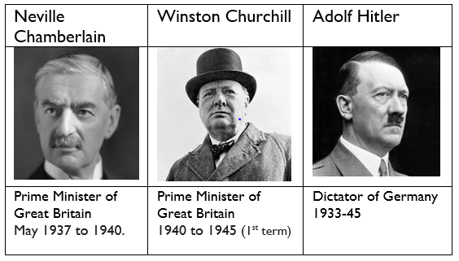
Year 6 –

Autumn 1: Is it ever right to fight?
Sticky Knowledge & Skills
1939 | - Hitler invades Poland  - Britain declares war on Germany
1940 | - Rationing begins  - Dunkirk evacuation  - Battle of Britain  - Blitz begins
1941 | - Blitz ends
1944 | - D-Day (6th June)
1945 | - Germany surrenders  - V.E. Day (8th May)  - V.J. Day (15th Aug)
1954 | - Rationing ends

Key Theme

Core Value Focus
Curiosity, critical thinking, resilience, compassion.

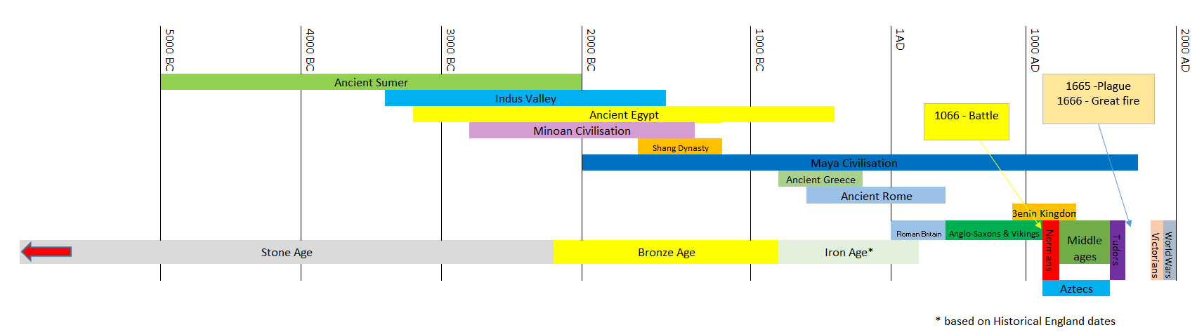
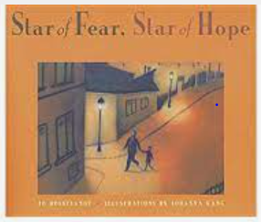
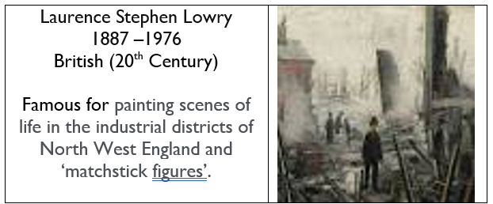
Links to past and future learning
Children will have studied periods of British and World History throughout Key Stage 2 up to 1066. In KS3 we will study the challenges for Britain, Europe and the wider world 1901 to the present day, including studying the Holocaust.

The Allies | The Axis
- France  - Great Britain  - United States  - Soviet Union  - China | - Germany  - Italy  - Japan

Key Text

Key Vocabulary
Blitz | the heavy bombing of British cities by German aircraft
Dictator | a person who rules with total power and often in a cruel manner
Evacuation | to evacuate someone means to send them to a place of safety
Invasion | to try and take over a place by force
Jew | a person who is of Jewish heritage or who has converted to the Jewish religion
Nazi | a member of the far-right political party in Germany
Prime Minister | the leader of the government
Rationing | The controlled distribution of scarce resources (mainly food & clothing)

History |  | Science |  | RE
What were the dates of World War II?  Match the individuals to their role?  Lilian Bader Spy and Resistance Agent for the British Government  Neville Chamberlain British Prime Minister (end of war)  Winston Churchill British Prime Minister (outbreak)  John ’Polly’ Flinders One of the first women in the British Armed Forces  Adolf Hitler German dictator- leader of Nazi Party  Noor Iniyat Khan Local Spitfire and Hurricane Pilot who participated in the Battle of Britain  Name the axis and allies  Name a law that was applied to the Jewish people in the build up/ beginning of the war and explain how this affected their rights? | 1939-1945  Lilian Bader - One of the first women in the British Armed Forces  Neville Chamberlain - British Prime Minister (outbreak)  Winston Churchill - British Prime Minister (end of war)  John ’Polly’ Flinders Local Spitfire and Hurricane Pilot who participated in the Battle of Britain  Adolf Hitler - German dictator- leader of Nazi Party  Noor Iniyat Khan - Spy and Resistance Agent for the British Government  Axis: Germany, Italy, Japan  Allies: Great Britain, United States, Soviet Union, China, France  - Cannot drive cars  - Cannot own pets  - Can be thrown out of home at any time  - Cannot attend university  - Cannot own a radio | Light:  Light travels in a ________________ line.  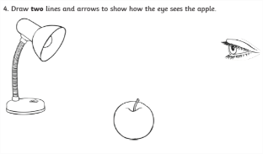  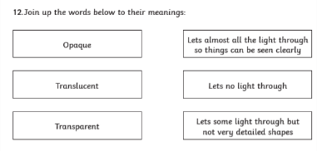  Describe what happens and what is created when an opaque object is put in front of a light source.  Describe how the size of the shadow changes as an opaque object is moved closer to the light source. | Straight  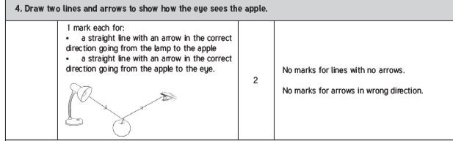  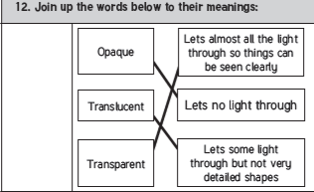  A shadow is formed/ created. The opaque object blocks the light from the source.  The closer the object is the larger/ bigger the shadow | Revision  Name the 5 pillars of Islam.  What does each pillar mean?  Why is the Qu’ran special to Muslims?  How might following the Qur’an what a person does in their life?  What the Mosque is used for? | Shahadah – Belief that Allah is the one god, and that Muhammad is his prophet  Salah – prayer 5 times a day  Zakat – Muslims must donate some of their money to charity  Sawm – Muslims must fast during the daylight hours throughout Ramadan  Hajj – Is a pilgrimage to Mecca that Muslims must take once in their lifetime  It is the word of Allah (God) delivered to Muhammad.  It guides the lives of Muslims-moral, social and spiritual values  Forbids:  Bad behaviour - consuming alcohol and drugs; selfish habits - adultery, gambling;  Jealousy, backbiting, arrogance and anger  Prayer, learning, meeting, supporting the community

