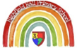  Knowledge Organiser  Nursery  Autumn 1 - 2022 |  | Our Key Text:  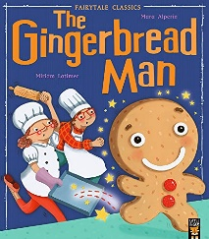
Key Nursery Rhymes: | Wind the bobbin up  Humpty Dumpty  Old McDonald had a farm | Cultural or religious festivals: | Halloween  Harvest Festival
Specific vocabulary: |  | Sticky knowledge & Skills
Tier 1 | Tier 2 | Our teachers are helping us to...  Hold a book and turn the pages.  Remember the names of a goat, a cow, a horse and know the names of their babies.  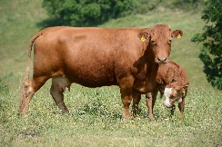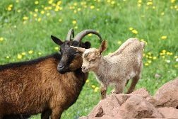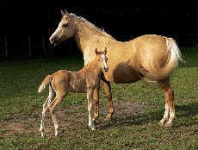  cow and calf goat and kid horse and foal
cow | piping hot
goat | haystack
fox | riverbank
quick | frolicked
oven | bakery
How you can help us at home:

Help us to hold a book and turn the pages.
Ask us what happened in the Gingerbread Man story.
Make a puppet and tell the story with us.
Talk about cows, horses and goats and help us to name their babies.
Look out for and name farm animals around you.
Have a go at baking with us.
Help us to use the toilet and wash our hands.

