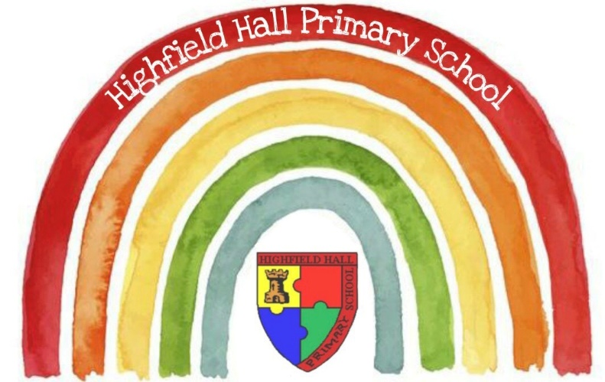
Early Years Foundation Stage Policy, Philosophy and Practice 2024-25

This document provides the Vision, Policy, Philosophy and Practice in the Early Years Foundation Stage (EYFS) at Highfield Hall Primary School. It outlines our intentions in the EYFS and how we implement this within our provision.
Vision: Happy, healthy, loved and successful children.

In our Early Years Foundation Stage at Highfield Hall Primary School, we aim to start the day of every child’s life with love, laughter and fun!
The relationships we foster with the children are led by professional knowledge, experience, love and integrity where we model high levels of spoken literacy, kindness, equality and respect for ALL.

Aims
This policy aims to ensure:
- That children access an enjoyable, rich, broad and balanced curriculum that gives them a wide range of knowledge and skills needed for good progress throughout school and life.
- That children demonstrate high levels of involvement by accessing high quality learning environments, which promote independence and perseverance.
- Excellent quality and consistency in teaching and learning so that every child makes good progress and no child is left behind.
- By fostering secure relationships and creating a close partnership working between practitioners and with parents and/or carers.
- Every child is included and supported through equality of opportunity and anti-discriminatory practice.
- That children develop their skills and knowledge through the EYFS curriculum as well as moral and spiritual development so that they can be successful in Key Stage One and go on to be active citizens of society as happy, curious, lifelong learners.

Legislation
Our policy is based on the requirements as set in the 2021 EYFS Statutory Framework.

Structure of the EYFS
At Highfield Hall Primary School, the EYFS has a Nursery offering part-time or 30 hours full-time places with a nursery teacher and teaching assistants. In Reception, the number on roll is 60 with a two form entry. Each Reception class has a class teacher and teaching assistant with a maximum of 30 children per class.

The Nursery at Highfield Hall takes children the term after they are 3 years old until they are ready to start school. All children are eligible to attend for 15 hours. These can be taken either-
The Nursery session times will be:
Morning: 8.40am-11.40am
Afternoon: 12.30pm-3.30pm
30 hours: 9.30am-3.30pm

15 hours over 2 and a half days:
Monday and Tuesday all day 9.30am-3.30pm / Wednesday morning: 8.40am-11.40am
Wednesday afternoon: 12.30-3.30pm / Thursday and Friday all day: 9.30am-3.30pm

There is an option of paying from 8.40am on the days which start at 9.30am, at a cost of £3 per day for the extra 50 minutes.

There will be no option to start at different times on different days; children will need to start at either 8.40am every day OR 9.30am every day. This is to ensure consistency, and to be able to plan for numbers and staffing.

4. Curriculum Intent, Implantation and Impact
4.1 2021 EYFS Curriculum
Within the 2021 EYFS statutory framework of the EYFS there are four guiding principles which shape our practice. These are:
- Every child is a unique child, who is constantly learning and can be resilient, capable, confident, and self-assured.
- Children learn to be strong and independent through positive relationships.
- Children learn and develop well in enabling environments with teaching and support from adults, who respond to their individual interests and needs and help them to build their learning over time. Children benefit from a strong partnership between practitioners and parents and/or carers.
- Children develop and learn at different rates.

The framework covers the education and care of all children in early years provision, including children with special educational needs and disabilities (SEND).

Our curriculum encompasses seven areas of learning and development. All areas of learning and development are important and interconnected. Three areas are particularly important for building a foundation for igniting children’s curiosity and enthusiasm for learning, forming relationships, and thriving.
These are called the prime areas:
• communication and language
• physical development
• personal, social, and emotional development.
Four areas help children to strengthen and apply the prime areas. These are called the specific areas:
• literacy
• mathematics
• understanding the world
• expressive arts and design .

Throughout their time in the EYFS our children partake in an ambitious curriculum which is designed in a sequential way to ensure progress towards the end of reception goals. These goals are defined as Early Learning Goals (ELGs). The descriptors for these can be found in the EYFS framework document. Our curriculum incorporates learning through play, learning by adults modelling, by observing each other and through guided learning and direct teaching. It is also important to highlight that our plans are flexible to allow us to respond quickly to children’s new interests and/or needs.

Weaving throughout the EYFS curriculum at Highfield Hall are three Characteristics of Effective Learning.
• playing and exploring - children investigate and experience things, and ‘have a go’
• active learning - children concentrate and keep on trying if they encounter difficulties, and enjoy achievements
• creating and thinking critically - children have and develop their own ideas, make links between ideas, and develop strategies for doing things.

These elements underpin how we reflect on each child’s development and adjust our practice accordingly. Supporting children in their individual learning behaviour and observing the context of children’s play is essential.

  - Our EYFS Curriculum Intent
At Highfield Hall, our EYFS curriculum incorporates everything we want the children to experience, learn and be able to do. It meets all the requirements of the educational programmes in the statutory framework for the Early Years Foundation Stage (EYFS) and has the flexibility to allow us to respond quickly to children’s new interests and/or needs. The intent for our children is for them to enter the next stage of their education ready to tackle new challenges with confidence and a positive mind set.

This is delivered through a holistic curriculum which maximises opportunities for meaningful cross-curricular links and learning experiences as well as promoting the unique child by offering extended periods of play and sustained thinking following children’s interests and ideas. We value imagination and creativity and seek to create a sense of enjoyment and fascination in learning through a vibrant continuous indoor and outdoor provision, alongside trips, visits and weekly forest school inspired sessions.

We engage our pupils in a stimulating environment led by the children, yet carefully organised and managed by adults. We provide an ambitious curriculum responsive to individual starting points and needs. Our children take the lead in their own learning, encouraging confidence to explore new ideas, think about problems, take risks, make links and seek challenge. They develop high levels of engagement, curiosity, collaboration and cooperation, respecting the opinions and values of themselves and others. They learn to manage their own personal hygiene, behaviour in the classroom and in social situations. We create a curriculum that includes meaningful and culturally diverse material that utilises and commemorates diversity.

  - Our EYFS Curriculum Implementation
    - Our pedagogy - How do we help children to learn in the EYFS at Highfield Hall Primary School?

- Children are powerful learners. Every child can make progress in their learning, with good teaching and the right help.
- Effective pedagogy is a mix of different approaches. Children learn through play, by adults modelling, by observing each other and through guided learning or direct teaching.
- Our Early Years practitioners carefully organise enabling environments for high-quality play. Sometimes, they make time and space available for children to invent their own play. Sometimes, they join in to sensitively support and extend children’s learning.
- Children in the Early Years also learn through group work, when practitioners guide their learning.
- Older children in Reception need more of this guided learning and this is reflected through our detailed medium and short term planning.
- A well-planned learning environment, indoors and outside, is an important aspect of our pedagogy. We refer to this as the ‘third teacher’, parents being the child’s first teacher, educators the second.
- We take into account the particular strengths’ and needs of the children we are working with and quickly identify children with specific needs as in accordance with our SEND policy.

Our inclusive approach means that all children learn together but we have a range of additional intervention and support to enhance and scaffold children who may not be reaching their potential or moving on children who are doing very well.

4.3.2 Planning
Our curriculum and provision has been designed to incorporate our pedagogy as set out above. Our curriculum is delivered through a balance of adult led and child led learning. It incorporates everything we want the children to experience, learn and be able to do and allows us to respond quickly to children’s new interests and/or needs.

Our EYFS curriculum and long term planning is built around Highfield Hall’s 5 key themes which run through the whole school, underpinned by stimulating, exciting texts from the Pathways to Write scheme, and our school’s core values. The key themes are:
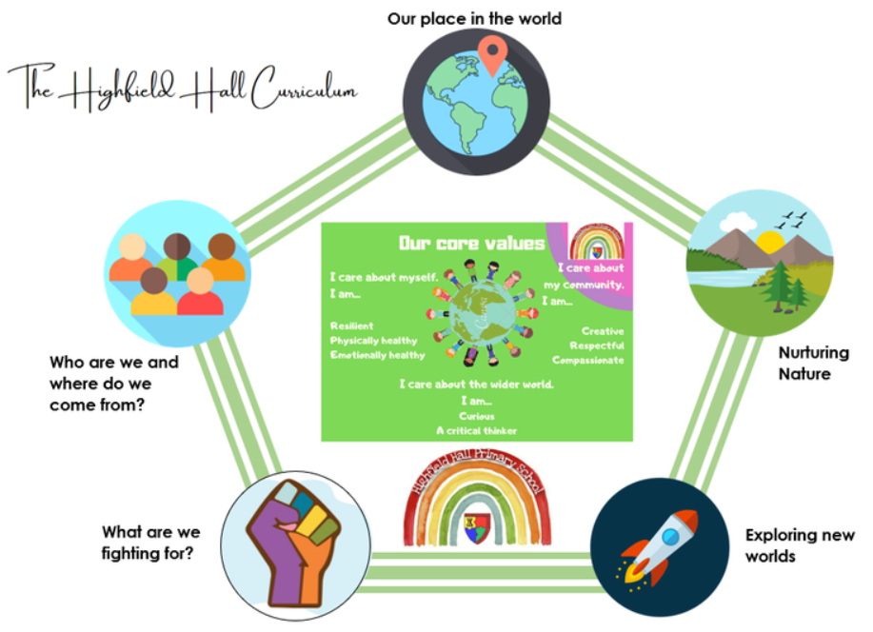
In EYFS, each term is built around our spine of fantastic books (Whole School Pathways to Write scheme) which supports all 7 areas of the EYFS curriculum, particularly early writing. Fostering a love of books and reading is at the heart of our curriculum. Our children follow the DfE accredited Monster Phonics programme and in Nursery we lay the foundations for early reading through the teaching of Phase 1 phonological awareness. Practitioners working with the youngest children are expected to focus strongly on the 3 prime areas.

We follow a blend of White Rose Maths and the Maths Mastery approach in Reception, with an emphasis on studying key skills of number, calculation and shape so that pupils develop deep understanding and the acquisition of mathematical language. Pupils learn through games and tasks using concrete manipulatives which are then rehearsed and applied to their own learning during exploration. Nursery pupils begin to develop these key skills as they explore sorting, quantities, shape, number and counting awareness. These early mathematical experiences are carefully designed to help pupils remember the content they have been taught and to support them with integrating their new knowledge across the breadth of their experiences and into larger concepts.

4.3.3 Teaching
Our approach is influenced by the work of educationalists, researchers, psychologists and practitioners who have guided our knowledge of how young children learn and how adults can support their learning. “Knowledgeable practitioners appreciate that adult-led learning offers a child something different from, but complementary to child led learning and it is one without the other that leads to an impoverished educational experience.” Fisher, 2016.

Each area of learning and development is implemented through planned, purposeful play, and through a mix of adult-led and child-initiated activities. Practitioners respond to each child’s emerging needs and interests, guiding their development through warm, positive interaction. Indoors and outdoors resources are organised to develop children’s skills in personal interaction and exploration. Resources are carefully selected to meet the development needs of the children in order to enhance potential for new learning and consolidate prior learning. Continuous provision transcends all areas of learning and provides children with the opportunity to demonstrate the three characteristics of effective learning. Children are given the freedom to make independent choices and are encouraged to be active learners and take control of their learning. As children grow older, and as their development allows, the balance gradually shifts towards more adult-led activities to help children prepare for more formal learning, ready for year 1.

In our EYFS, practitioners use the following techniques to help children learn:
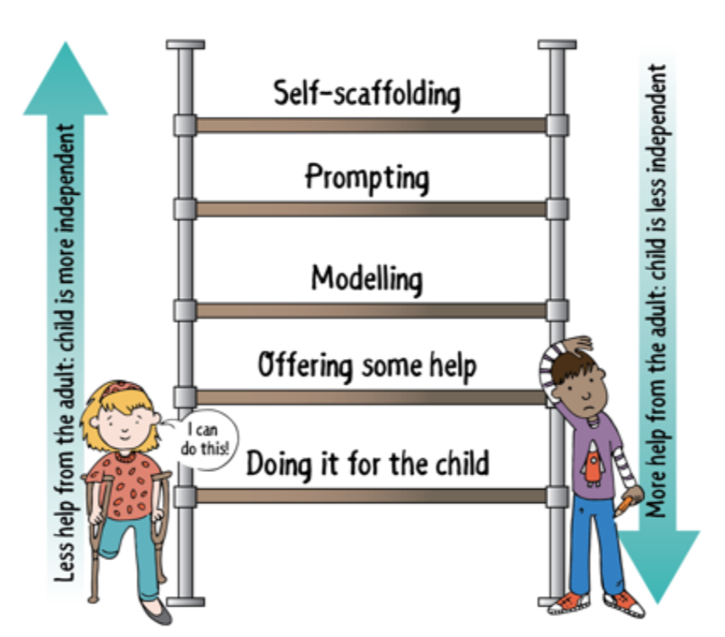
Figure: Scaffolding techniques in the early year taken from ‘Working with the revised Early Years Foundation Stage: Principles into Practice, Julian Grenier, 2020

Sustained shared thinking is an important part of our daily practice and contributes to creating a rich, language environment. This is an episode where two or more individuals work together in an intellectual way to solve a problem, clarify a concept, evaluate activities, and extend a narrative. Both parties must contribute to the thinking and it must develop and extend.
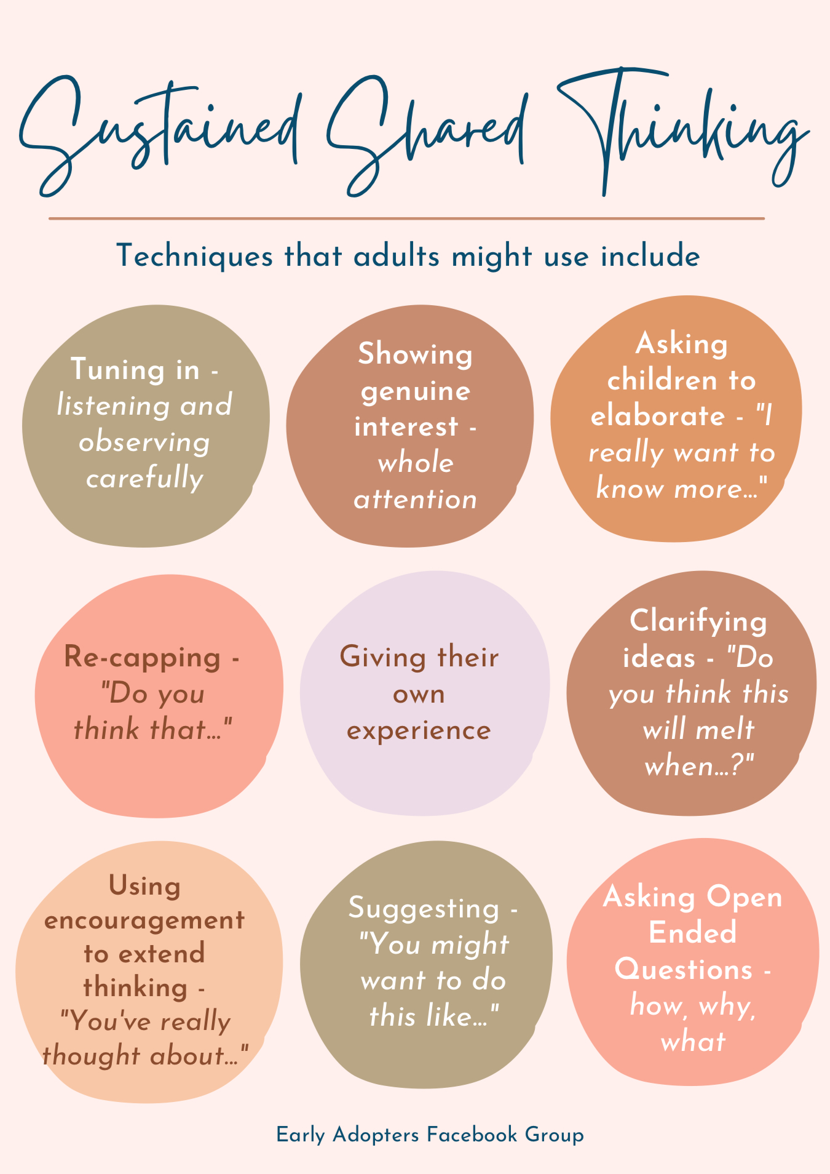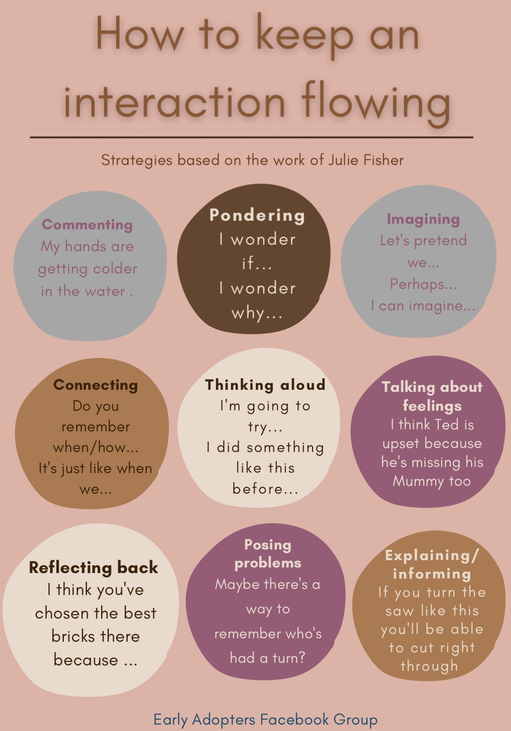

4.4. Our EYFS Curriculum Impact
At Highfield Hall Primary School, ongoing assessment is an integral part of the learning and development processes.
Observation
Observation forms a fundamental aspect of the pedagogy of EYFS at Highfield Hall Primary School.
“Young children demonstrate language, mathematics, science, creativity, physicality – sometimes all within one activity – and the task of the practitioner is to make sense of what is seen, to recognise any significant steps in learning that may have taken place and to identify where help and support are needed to make further progress” Jan Dubiel, 2014.
Observation and responding to children’s thinking inform our planning of experiences and opportunities, how we create our environment for thinking, the strategies the adults use to extend learning (modelling, scaffolding, questioning, discussion, shared sustained thinking) and how we capitalise knowledge of children’s interests to ensure high levels of engagement. We value the practitioner’s in depth knowledge of our children and engage in regular professional dialogue within our team. All adults record milestone moments – when a child does or says something that demonstrates progress or skill in a particular area, onto our Evidence Me app to share with parents.

Summative Assessments
In addition, to the continuous cycle of observation and formative assessment which informs each child’s next steps, summative assessments are carried out for phonic development, the stable order principle in number and an assessment of each child’s stage of development for each of the 7 areas of learning. These take place on entry, mid-point and at the end of the year. This informs planning of subsequent teaching and learning.

At the end of the EYFS, staff complete the EYFS profile for each child. Pupils are assessed against the 17 early learning goals, indicating whether they are:
- Meeting expected levels of development
- Not yet reaching expected levels (‘emerging’)
The results of the profile are then shared with parents and/or carers.

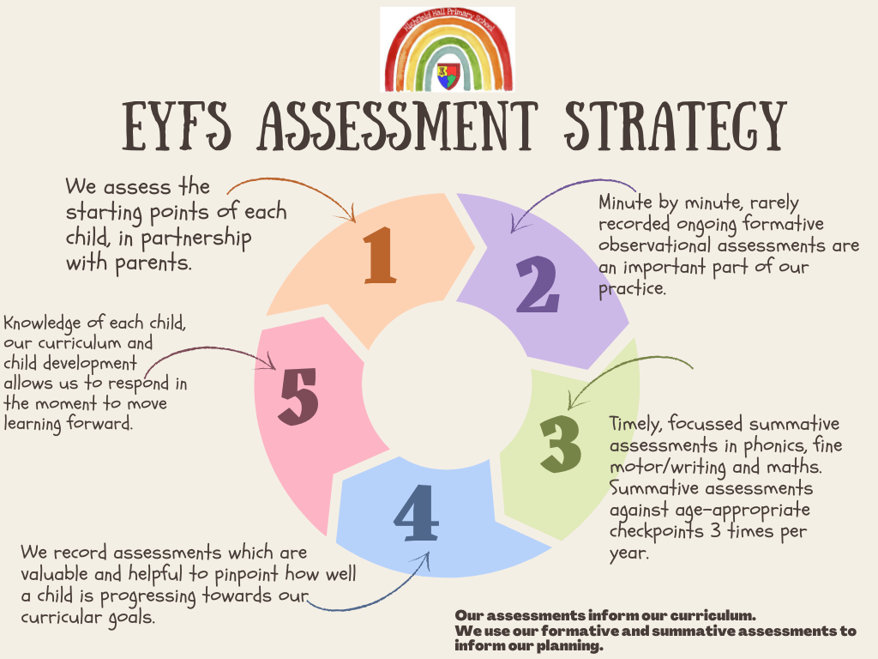

5. Working with parents
In our Highfield Hall Early Years Foundation Stage, we know that parental involvement is crucial and we learn a great deal about each child from parents. We recognise that children learn and develop well when there is a strong partnership between practitioners and parents and/or carers. That is why we invite children and parents for numerous visits prior to starting at our setting and work hard to maintain and build this vital relationship during their time with us.

In Nursery, we invite children and parents to ‘Stay and Play’ sessions to meet the Nursery staff, make new friends and become familiar with the environment. Post Covid-19, parents are invited to stay and play at the beginning of each session. This enables our nursery staff to actively build supportive and trusting relationships with our families.

In Reception, we invite children and parents in for a series of Starting School visits to meet the staff, make new friends and become familiar with the environment.

Throughout the year, parents and/or carers are kept up to date with their child’s progress and development via the Evidence Me app. The EYFS profile helps to provide parents and/or carers with a well-rounded picture of their child’s knowledge, understanding and abilities.
In Nursery, each child is assigned a key person who helps to ensure that their learning and care is tailored to meet their needs. In Reception, the key person is the class teacher. The key person supports parents and/or carers in guiding their child’s development at home. The key person also helps families to engage with more specialist support, if appropriate.

6. Safeguarding and welfare procedures
Our safeguarding and welfare procedures are outlined in our safeguarding policy.

7. Monitoring arrangements
This policy will be reviewed by Rebecca Coles, EYFS lead and the EYFS team each year. The policy will be shared and approved by the governing body. Our Early Years Foundation Stage Governor is Rebecca Coles (needs to be reviewed.

Written by Rebecca Coles, EYFS Lead
September 2024

Approved by the governing body ___________________________________________________________

