# H:\Logo.jpg

|  |
| --- |
| **Key Theme** |
|  |

Year 6 – Spring 1: The Ancient Greeks

|  |
| --- |
| **Links to past and future learning** |
| Historical studies of other periods through KS1 and lower KS2. |

|  |
| --- |
| **Key Vocabulary** |

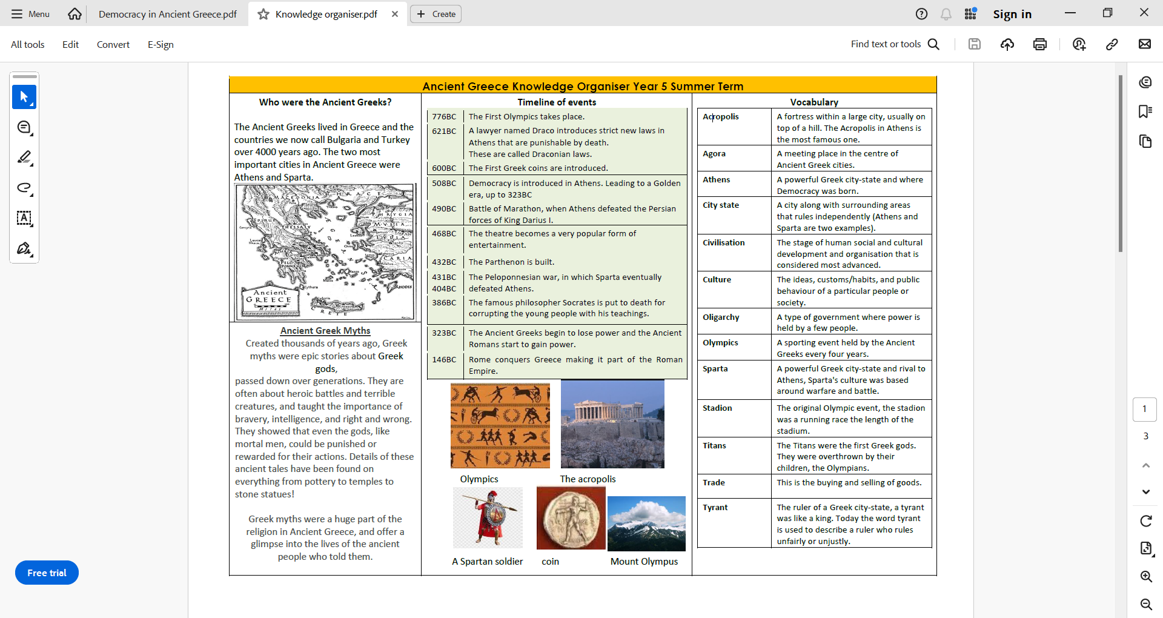

|  |
| --- |
|  |

|  |
| --- |
| **Core Value Focus** |
| Critical thinking, respect compassion. |

|  |
| --- |
| **Sticky Knowledge & Skills** |
| **Ancient Greece timeline**  1700 BC - start of the Ancient Greek empire  776 BC - The first Olympic Games  508 BC - Democracy began in Athens  432 BC - The Parthenon was finished  356 - 323 BC - Alexander The Great’s life  146 BC - The Romans conquered Ancient Greece  **Democracy**  - The Athenians invented democracy, a system that allows citizens to vote on important matters.  - In the 6th century BC, Cleisthenes helped to introduce a new political structure of demokratia or ‘rule by the people’. It was one of the earliest examples of democracy in history and is one of Ancient Greece’s most lasting legacies.  - Government officials were elected by the citizens. However women, children and slaves could not vote.  - The Assembly was made up of 60000 male citizens and made the laws of the land. The Council was made up of 500 citizens who  made up laws for the Assembly to consider.  **Education**  ● In Sparta, reading and writing was unimportant; boys learnt to be good  fighters.  ● In Athens, citizens had to be educated to take part in voting in The  Assembly.  ● Schools were not free so only the wealthy could afford to go. Greek  girls were not allowed to go to school. Athenian boys started school at  7 and stayed until they were about 14. They learned reading, writing  and maths in the mornings and went to wrestling school in the  afternoons. |

|  |  |
| --- | --- |
| History (Ancient Greece) | |
| When did the Greek empire begin?  When did the Romans conquer Greece?  What are empire, civilisation and democracy?  How was Athens ruled?  What made ancient Greek fighters so powerful?  Name 3 important Greek achievements.  What are the similarities and differences between Athens and Sparta?  How does ancient Greece still influence us today? | 1700BC  146BC  A group of countries ruled by one leader; society, culture, and way of life of a particular area; rule by the people  By democracy  They had advanced techniques for fighting; they lined up and locked their shields together with just their spears pointing over the top.  Developing democracy, the Olympic games, buildings such as the Pathenon.  The people of Athens valued art, culture, and education. The people of Sparta valued strength, simplicity, and military skills. Government Athens was a democracy, though only free men could take part in government. Sparta was primarily a military state.  The Greeks invented much of modern mathematics, sculpture, philosophy, science and even medicine. |