Year 1 – Autumn 2: Once Upon A Time
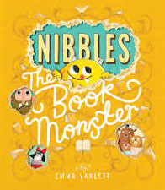
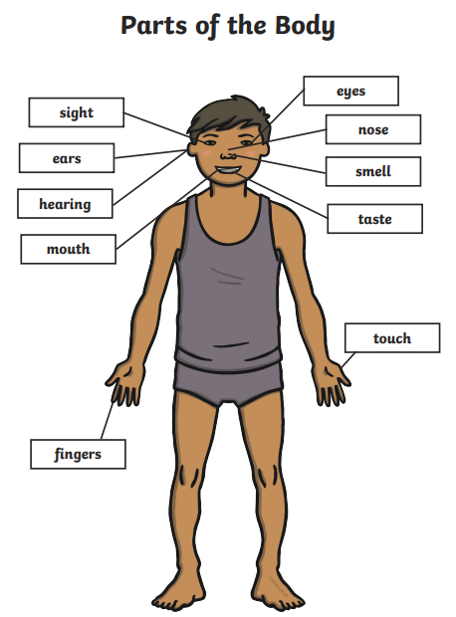
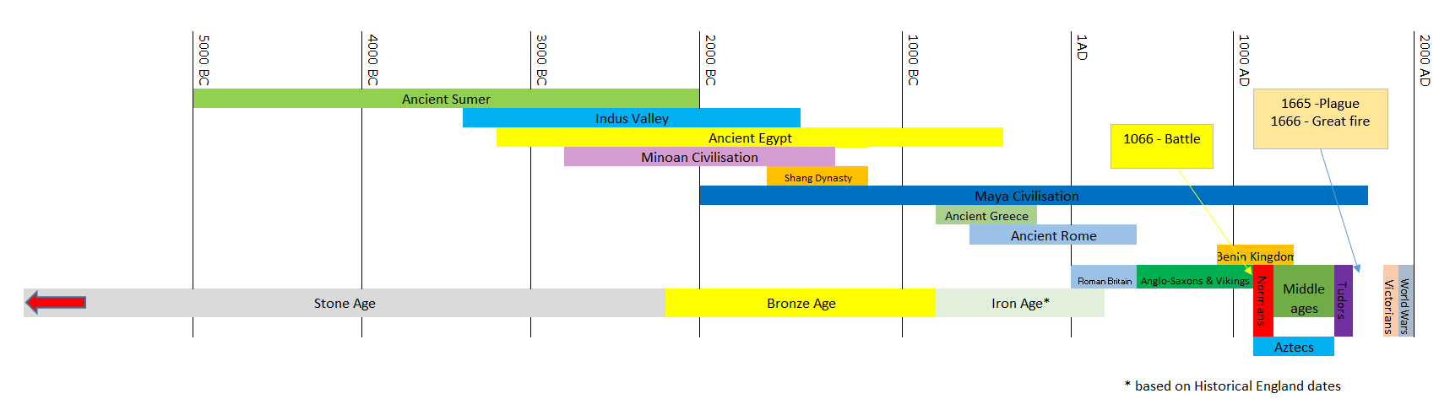
Core Value Focus
Creativity, critical thinking, curiosity, resilience, emotional heath.

Key Theme

Key Texts

Science Sticky Knowledge

History Sticky Knowledge/key questions
We know stories used to be passed down verbally.
We can retell some traditional Tales – Little Red Riding Hood; Goldilocks and the 3 Bears; The 3 little pigs.
Stories reflect life in the past – what can they tell us?
Stories have changed over time – what does that tell us about changes in national life?

Which stories do our parents remember?
Are all versions of traditional tales the same? Why not?
Are these stories the same as the stories we have shared in school?
How was life different for our parents/grandparents?

Science Sticky Knowledge – animals
Carnivore – an animal that eats meat or other animals.
Herbivore – an animal that eats plants.
Omnivore – an animal that eats animals and plants.

Key Vocabulary
adventure | An unusual, daring or exciting experience
cottage | A small house
crate | A box, usually wooden, for transporting things
curious | To be keen to learn something new
forest | A large area covered with trees
beanstalk | The stem of a bean plant
atlas | A book of maps or charts
mountain | A large bit of land that rises up to over 1000 feet.
tambourine | A percussion instrument with a drum and metal discs around the edge.

Links to past and future learning
In Reception we learnt some similarities and differences between things in the past and now. We Begin to describe a sequence of events, real or fictional, using words such as ‘first’, ‘then...’
In Year 2 we will develop our understanding of chronology. We will also learn more about animals, including humans, and what they need to survive.

History |  | Science |  | RE
 |  | What type of animal eats meat?  Which of these animals only eats plants?  Which body part do we use to see with?  Which one of these is not one of our senses?  Where would you find your elbow? | Herbivores, carnivores, omnivores  Guinea pig, shark, dog  Eyes, arm, ears  Fear, touch, smell  On your: arm, head, leg | Which religion celebrates Diwali?  Who are the people in the Diwali story who return after defeating the evil king Ravana?  How do people celebrate Diwali?  Which religion celebrates Christmas?  What is celebrated at Christmas? | Hindu  Rama and Sita  Go to the temple, share food, light diva lamps, make rangoli patterns, watch fireworks.  Christians  The birth of Jesus.

