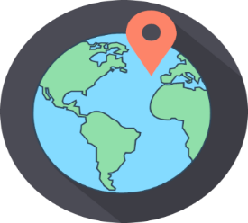
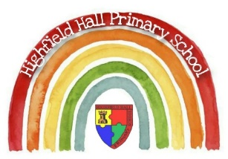
Key Theme

Year 1 – Autumn 1: Brrr!
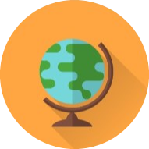
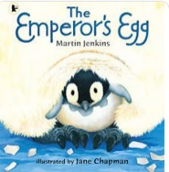
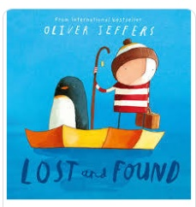
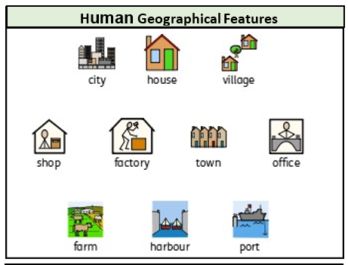
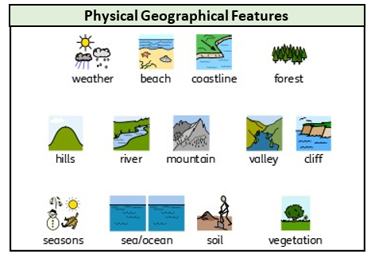
Links to past and future learning
In Reception we learnt that there are different countries in the world.
We learnt to use basic maps.
We learnt some similarities and differences between life in this country and life in other countries
In year 2 we will learn to locate the continents and oceans on a map and develop our understanding of human and physical geography in our local area.

Sticky Knowledge & Skills
- The town I live in is called Chesterfield.
- Chesterfield is in England, which is a country.
- I can name some human features of Chesterfield, (houses, shops, parks, roads) and some physical features of Chesterfield (river, woodlands).
- I can use a map to locate Chesterfield.
- I can use Google Maps to explore the local area around the school.
- I can use a key to create a map of the school, identifying geographical features 10 last year, we will be building on this.

Key Vocabulary
North Pole | The point that is farthest north on the planet Earth
South Pole | The point that is farthest south on the planet Earth
Heimsphere | Half of a sphere
Equator | The imaginary line separating the Northern and Southern Hemispheres
Continent | A large area of Earth made up of lots of countries. There are 7 continents: Asia, Africa, North and South America, Europe, Antarctica, Australasia
Ocean | A large body of water which covers a large area of planet Earth. There are the Pacific, the Atlantic, the Indian, the Southern, and the Arctic Oceans
Mountain | Land that rises up over 1000 feet
Decide | To make a choice

Core Value Focus
Creative, Critical Thinking, Curious, Resilient, Emotionally Healthy

Key Texts

Geography |  | History |  | Science |  | RE
What town do you live in?  What country do you live in?  What is the imaginary line around the centre of the world?  Which of these is a human feature and which is a physical feature?  House, tree, river, mountain, playground, road | Chesterfield  England  Equator  Human: house, playground, road  Physical: tree, river, mountain | When is Bonfire night?  Who is Bonfire night about?  What does the past mean?  What year is it?  Which year came first? | December, January, November  Guy Fawkes, Samuel Pepys, Jesus  Things are are: going to happen, have happened, are happening  2020, 2021, 2022  1936, 2020, 1899 | What type of animal is a snake: Mammal, reptile or fish?  What do you call an animal’s home: House, flat or habitat?  What type of animal has feathers: Amphibian, bird or mammal?  What type of animal gives birth to live young? Bird, reptile or mammal?  Which habitat would a fox live in: Forest, sea or savannah? | Reptile  Habitat  Bird  Mammal  Forest | Who do Christians believe in?  Where do Christians worship?  What is the name of the Christians holy book?  What do Christians learn from the parable The Lost Sheep?  What do Christians learn from the parable The Lost Son?  Why did God send a big storm when Johan was at sea? | God and Jesus  A church  The Bible  God loves everyone.  God will love you even when you make mistakes.  Jonah had disobeyed God.

