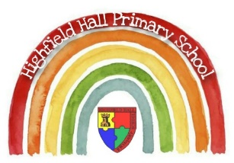
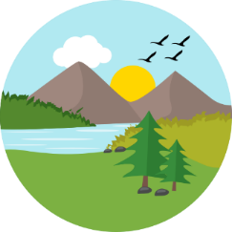
Year 4 – Autumn 2: Climate Change
Key Theme

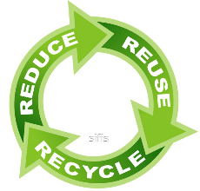
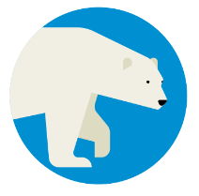
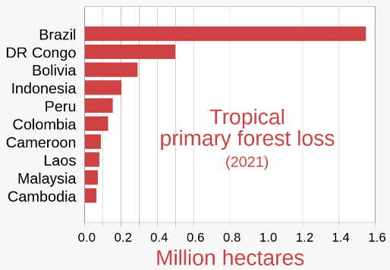
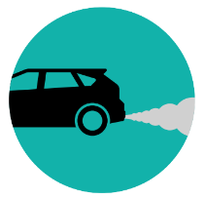
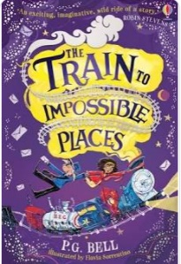
Key Vocabulary
Pollution | Something in our environment which has harmful or poisonous effects, e.g. air, water or plastic pollution
Recycling | Converting waste products into something that can be reused again
Global Warming | A gradual increase in Earth’s overall temperature caused by the greenhouse effect (too much carbon dioxide and other pollutants in the atmosphere)
Deforestation | The cutting down of a large amount of trees
Renewable Energy | Energy from a source which will not deplete over time - it can be made again and again. E.g. wind, solar or hydro power
Extreme Weather | Weather which is significantly different to what we might expect in a given climate zone, e.g. floods, hurricanes, droughts
Fossil Fuels | Resources which will eventually run out on our planet and cannot be replaced, e.g. coal, oil, gas
Energy Saving | Making economical use of a resources, e.g. using energy saving light bulbs

Links to past and future learning
In year 3 we learnt about human and physical geography, and how the world can be affected by human activity.
Last term we learnt about climate zones, which are being affected by global warming.
In Year 5 we will study more about how economic activity can impact on the physical environment and climate, when studying regions of Europe and America.

Core Value Focus
Critical thinking, emotional health, compassion.

We can help by reducing our waste, reusing things, and recycling
Air pollution is caused by cars and factories
Will they become extinct?
Polar ice caps are melting due to global warming, causing seas to rise and the loss of habitats for many animals.
Key Texts

Sticky Knowledge & Skills
- We know that global temperatures have been rising for over a century, and are now the highest on record.
- We know human activity is releasing greenhouse gases into the atmosphere.
- We know these emissions are causing the greenhouse effect – trapping heat and making the Earth warmer
- This is affecting weather patterns and habitats, plants and animals.
- Many countries are trying to reduce climate change, and signed up to the Paris Agreement (see QR code here).
- Countries meet regularly at COP conferences.
- We know we can help reduce our carbon footprint by doing things like: Reducing the amount of energy and water we use, use energy saving devices, walk, cycle or use public transport and recycle our waste.

Geography |  | Science |  | RE
What is global warming?  What is the greenhouse effect?  What is deforestation?  Where is the largest amount of deforestation happening?  List 3 types of fossil fuel  List 3 types of renewable energy  List 3 ways we can reduce our carbon footprint: | A gradual increase in Earth’s overall temperature caused by the greenhouse effect (too much carbon dioxide and other pollutants in the atmosphere)  Emissions from cars and industry (e.g. carbon dioxide) trap heat and making the Earth warmer  Cutting down a large number of trees (which take in carbon dioxide and give out oxygen)  Brazil  Coal, oil, gas  Wind, solar, hydro  Reducing the amount of energy and water we use, use energy saving devices, walk, cycle or use public transport and recycle our waste. | Name 4 appliances that run on electricity:  Label this diagram:  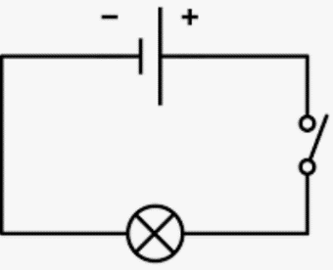  Name 3 common conductors:  Name 3 common insulators:  Will this circuit work? Why/why not?  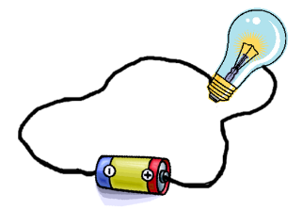 | TV, washing machine, wifi, tumble dryer, computer etc.  Wires, cell (battery), switch, bulb  Copper, aluminium, gold, silver  Glass, plastic, wood, rubber  No – the wire is connected to the insulator (glass) not the conductor (metal) | When did the last supper happen?  What did Jesus share at the last supper?  What is the name of the Christian ceremony where bread and wine is shared?  What does the bread and wine represent?  Name a Christian who helped others by their actions.  Why did ---- help others? | The day before Jesus’s death  Bread and Wine  Holy Communion  Bread = Body of Christ, Wine = Blood of Christ  TBC  TBC

