

Highfield Hall Child Friendly Safeguarding Policy

What is Child Protection and Safeguarding about?

All of the adults around you think that your health, safety and welfare are very important.



In our school, we CARE; we are Compassionate, Aspirational Respectful, and Emotionally healthy, and we want you to be these things too.

Compassion: We want everyone in the school to look after each other.

Aspirational: We do our best to help you make progress in your learning.

Respect: We treat you with kindness and help to protect your rights.

Emotionally healthy: We want everyone to have ways to cope when things are getting tricky.

We teach you how to **recognise risks and dangers** in different situations and how to protect yourself and stay safe, both in real life and online.

We provide a **safe environment** for you to learn in.

We want to help you **stay safe** at home and school.

It’s important that you **know where to go to get help** if you are worried or unhappy about something.

Need to talk?

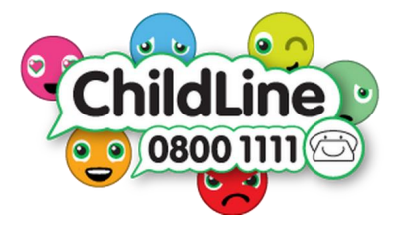You can talk to **any adult** in school, we are here to help you and we will listen to all of your concerns. If you’d prefer, **you can talk to one of the House Captains or Vice Captains**. There is also a special phone number called Childline: If you call the number they will listen to your worries and give you advice about what to do next.

Remember, ‘**speak out, stay safe**’.