Key Theme

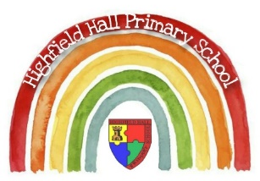
Year 1 – Summer 1: Space
Core Value Focus
Creativity, critical thinking, curiosity, resilience, emotional heath.

Key Vocabulary
spaceship | A vehicle used for space travel, controlled by people.
float | To move or hover slowly in a liquid or the air.
gravity | The force that attracts objects towards the centre of the Earth.
launch | To set in motion – to make an object move/travel.
mankind | The human race.
sphere | A round solid 3D shape.
planet | A large sphere that orbits a star.
astronaut | A person who is trained to travel in a spacecraft.
moon | A large natural object that orbits a planet, like the Earth.

History Sticky Knowledge
We understand that when we talk about the past we are talking about events which have already happened.
We can use a timeline to show the passage of time and to place events.
We can remember facts about significant people – Neil Armstrong.
Neil Armstrong was the first man to walk on the moon on 20th July 1969.
He is famous for saying “That’s one small step for man, one giant leap for mankind.”
Only 12 people have ever walked on the surface of the moon.
The first British person in space was Dr Helen Sharman.

Key Texts
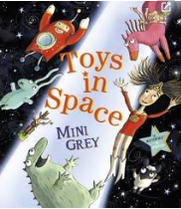

Links to past and future learning
We have already looked at timelines and have begun looking at a history of transport.
We have studied toys from the past and present.
In music, we will be using our understanding of pulse and rhythm to play a different instrument.

Artist study – Vincent Van Gogh
The Starry Night
I can evaluate the artist’s work and use elements in my own work.

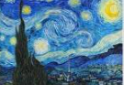

History |  | RE
Who was the first man to walk on the moon?  When was the first moon landing?  How many people have ever walked on the moon?  Which word means the human race?  What is the name of the force that attracts objects towards the centre of the Earth? | Christopher Columbus; Neil Armstrong; Tim Peake  1959; 1969; 1979  12; 15; 20  Man; mankind; people  Chocolate; friction; gravity | What is the scared place of worship called for Christians?  What is the Christian holy book called?  What scared artefacts might you see in a church?  Can you describe what a church might look like?  (Link this to the Y1 church visit) | Church  Bible  Bible, cross, font, alter, stained glass windows, challis, communion glasses, hymn books, vicar, organ.  e.g. a big building, a spire, a cross, stained glass windows.

