Highfield Hall Primary School


Attendance Policy

We believe that for our children to gain the greatest benefit from their education it is vital that they attend school regularly. Children should be at school, on time, every day the school is open unless the reason for the absence is unavoidable.
It is very important therefore that parents make sure that their child attends regularly and this Policy sets out how we will achieve this.

Why regular attendance is so important:
Any absence affects the pattern of a child’s schooling and regular absence will seriously affect their learning. Any pupil’s absence or lateness can disrupt teaching routines and may affect the learning of others in the class.
Ensuring a child’s regular attendance at school is a legal responsibility, an absence from school without a good reason is an offence in law and may result in prosecution.
Helping to create a pattern of regular attendance is everybody’s responsibility - parents, pupils and all members of school staff.

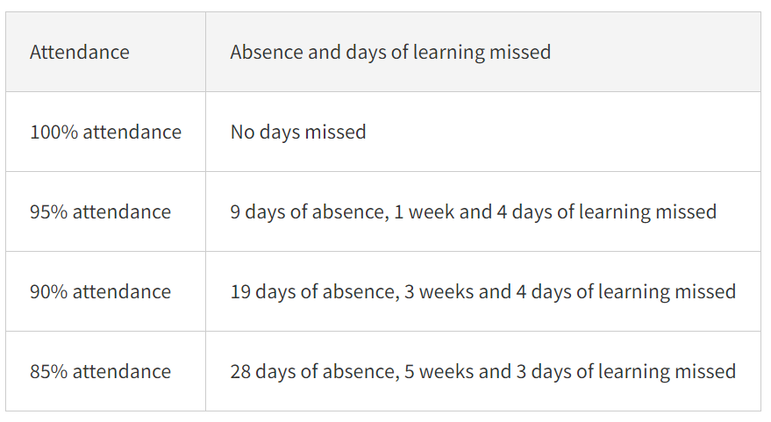

The Law relating to attendance
Section 7 of the Education Act 1996 states that ‘the parent of every child of compulsory school age shall cause him / her to receive efficient full time education suitable:- (a) to age, ability and aptitude and (b) to any special educational needs he/ she may have either by regular attendance at school or otherwise’

Roles and responsibilities
The Governing Body has overall responsibility for:
• Monitoring the implementation of this policy and all relevant procedures.
• Ensuring that this policy, as written, does not discriminate on any grounds, including, but not limited to, ethnicity/national origin, culture, religion, gender, disability or sexual orientation.
• Handling complaints regarding this policy as outlined in the school’s Complaints Procedures Policy.
• Having regard to ‘Keeping children safe in education’ (2023) when making arrangements to safeguard and promote the welfare of children.
• Ensuring there is a Children Absent from Education (Previously child missing) Policy in place and that this is regularly reviewed and updated.

The headteacher is responsible for:
• The day-to-day implementation and management of the Attendance Policy.
• All relevant procedures across the school.
• Ensuring all parents are aware of the school’s attendance expectations and procedures.

Staff are responsible for:
• Following the Attendance Policy and ensuring pupils do so too.
• Ensuring this policy is implemented fairly and consistently.
• Modelling good attendance behaviour.
• Using their professional judgement and knowledge of individual pupils to inform decisions as to whether any welfare concerns should be escalated.
• Where designated, taking the attendance register at the relevant times during the school day

The office staff are responsible for:
• Monitoring attendance data across the school and at an individual pupil level
• Report concerns about attendance to the Headteacher or his deputy.
• Arrange calls and meetings with parents to discuss attendance issues
• Work with the SLT when considering escalation to issuing fixed penalty notice
Informing the LA of any pupil being deleted from the admission and attendance registers if they:
• Are being educated from home.
• Have an authorised medical note.
• Have been permanently excluded.

Parents are responsible for:
• Providing accurate and up-to-date contact details.
• Providing the school with more than one emergency contact number.
• Updating the school if their details change.
• The attendance of their children at school.
• Promoting good attendance with their children

Definitions

The following definitions apply for the purposes of this policy:

Absence:

• Arrival at school after the register has closed.

• Not attending school for any reason.

Authorised absence:

• An absence for sickness for which the school has granted leave.

• Medical or dental appointments which unavoidably fall during school time, for which the school has granted leave.

• Religious or cultural observances for which the school has granted leave.

• An absence due to a family emergency.

Unauthorised absence:

• Parents keeping children off school unnecessarily or without reason.

• Truancy before or during the school day.

• Absences which have never been properly explained.

• Arrival at school after the register has closed.

• Absence due to shopping, looking after other children or birthdays.

• Absence due to day trips and holidays in term-time which have not been agreed. • Leaving school for no reason during the day.

Persistent absenteeism:

• Missing 10 percent or more of schooling across the year for any reason.

Absence procedures
Parents will be required to contact the school office via email as soon as possible on the first day of their child’s absence.
A telephone call will be made to the parent of any pupil who has not reported their child’s absence on the first day that they do not attend school.

The school will always follow up any absences in order to:
• Ascertain the reason for the absence.
• Ensure the proper safeguarding action is being taken.
• Identify whether the absence is authorised or not.
• Identify the correct code to use to enter the data onto the school census system.

If a pupil’s attendance drops below 90 percent without reasonable explanation, the office staff will make contact with the pupil’s parent. (See Appendix 1) Where a pupil has not returned to school for 10 days after an authorised absence, or is absent from school without authorisation for 20 consecutive school days, the school will remove the pupil from the admissions register if the school and the LA have failed to establish the whereabouts of the pupil after making reasonable enquiries.

Attendance register
Designated staff members will take the attendance register at the start of each school day and at the start of the afternoon session.
This register will record whether pupils are:
• Present.
• Absent.
• Attending an approved educational visit.
• Unable to attend due to exceptional circumstances.

The school will use the national attendance codes to ensure attendance and absence are monitored and recorded in a consistent way.

Lateness
The school will regard punctuality as of the utmost importance and lateness will not be tolerated. The school day starts between 8.45am and 9.00am.

Pupils should be in their classroom at this time. Registers are taken as follows throughout the school day: • Registers are marked by 8.50am. Pupils will receive a late mark if they are not in their classroom by this time.
• The register closes at 9:15am. Pupils will receive a mark of absence if they do not attend school before this time.
• After lunch, registers are marked between 1.00pm and 1.10pm. Pupils will receive a late mark if they are not in their classroom by this time.
• Pupils attending after 9:15am will receive a mark to show that they were on site, but this will count as a late mark.

Holidays in term time
Taking holidays in term time affects a child’s schooling as much as any other absence and we expect parents to help us by not to take children away in school time. The Government has recently made amendments to the Education (Pupil Registration) (England) Regulations 2006 which come into force on 1st September 2013. These state that Headteachers may not grant any leave of absence for holidays during the term time unless there are exceptional circumstances; in these cases it is the Headteacher who determines the number of days a child can be away from school if the leave is granted.
Parents needing leave of absence for exceptional circumstances should complete a form at least two weeks before the anticipated start date. The reason for the request should be given in detail. Applications should be made before the leave is arranged as absences will not be granted retrospectively.

In making a decision about whether to grant leave for exceptional circumstances the school will consider each application individually, including any previous pattern of leave in term time.
It is important that parents understand that leave in term time cannot be agreed by the school for the following reasons alone:
- availability of cheap holidays and cheap travel arrangements
- days overlapping with beginning or end of term
Any period of leave taken without the agreement of the school, or in excess of that agreed, will be classed as unauthorised and may attract sanctions such as a Penalty Notice. The school also has the powers to fine parents who take unauthorised holidays in term time. The Governing Body must by law use this sanction when necessary.

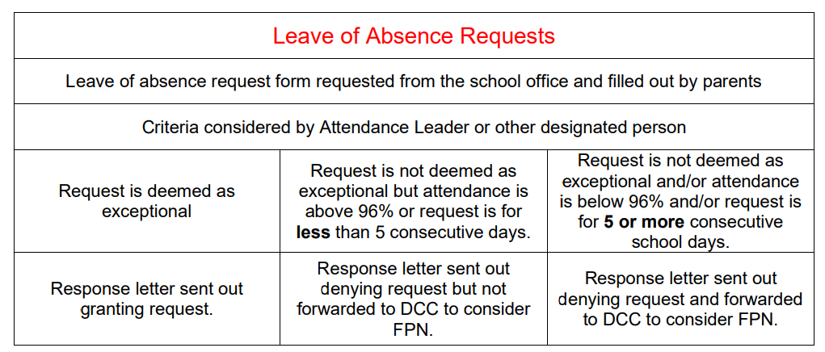

Missing children
Pupils will not be permitted to leave the school premises during the school day unless they have permission from the school.

The following procedures will be taken in the event of a pupil going missing whilst at school:
• The member of staff who has noticed the missing pupil will inform the headteacher immediately.
• The office staff will also be informed as they will act as a point of contact for receiving information regarding the search.
• A member of staff will stay with the rest of the class, and all other available members of staff will conduct a thorough search of the school premises as directed by the headteacher.
• The following areas will be systematically searched:
- All classrooms
- All toilets
- Any outbuildings
- The school grounds

• Available staff will begin a search of the area immediately outside of the school premises, and will take a mobile phone with them so they can be contacted.
• If the pupil has not been found after 10 minutes, then the parents of the pupil will be notified.
• The school will attempt to contact parents using the emergency contact numbers provided.
• If the parents have had no contact from the pupil, and the emergency contacts list has been exhausted, the police will be contacted.
• The missing pupil’s teacher will fill in an incident form, describing all circumstances leading up to the pupil going missing.
• If the missing pupil has an allocated social worker, is a looked-after child, or has any SEND, then the appropriate personnel will be informed.
• When the pupil has been located, members of staff will care for and talk to the pupil to ensure they are safe and well.
• Parents and any other agencies will be informed immediately when the pupil has been located. The headteacher will take the appropriate action to ensure that pupils understand they must not leave the premises, and sanctions will be issued if deemed necessary. Appropriate disciplinary procedures will be followed in accordance with the Behavioural Policy.

The headteacher will carry out a full investigation and will draw a conclusion as to how the incident occurred. A written report will be produced, and policies and procedures will be reviewed in accordance with the outcome where necessary.

Religious observances
The school will take advice from local religious leaders of all faiths to establish the appropriate number of days of absence required for religious festivals. Parents will be required to inform the school in advance if absences are required for days of religious observance.

Appointments
As far as possible, parents will be encouraged to book medical and dental appointments outside of school hours.

If the appointment requires the pupil to leave during the school day, they will be signed out at the school office by a parent. Pupils will be expected to attend school before and after the appointment wherever possible.

Modelling, sport and acting performances/activities
The school will ensure that all pupils engaging in performances/activities (whether they, or another person, receives payment or not), which require them to be absent from school, understand that they will be required to obtain a licence from the LA which authorises the school’s absence(s).

Additional arrangements will be made by the school for pupils engaging in performances or activities that require them to be absent from school to ensure they do not fall behind in their education – this may involve private teaching. These arrangements will be approved by the LA who will ensure that the arrangements are suitable for the pupil.

The pupil will receive education that, when taken together over the term of the licence, amounts to a minimum of three hours per day that the pupil would be required to attend a school maintained by the LA issuing the licence. This requirement will be met by ensuring a pupil receives an education:
• For not less than six hours a week; and
• During each complete period of four weeks (or if there is a period of less than four weeks, then during that period), for periods of time not less than three hours a day; and
• On days where the pupil would be required to attend school if they were attending a school maintained by the LA; and
• For not more than five hours on any such day.

Where a licence has been granted by the LA and it specifies dates of absence, no further authorisation will be needed from the school. Where an application does not specify dates, and it has been approved by the LA, it is at the discretion of the headteacher to authorise the leave of absence for each day. The headteacher will not authorise any absences which would mean that a pupil’s attendance would fall below 96 percent. Where a licence has not been obtained, the headteacher will not authorise any absence for a performance or activity

Highfield Hall Attendance Flowchart
Attendance monitored weekly by DHT and office staff. Escalation through phases decided here

Level 1: Children with attendance of below 90% receive phone call to discuss positive actions
Level 5: If attendance concerns persist, Confirmation of Penalty Notice letter sent
Level 4: If attendance concerns persist, Penalty Notice Warning letter sent
Level 3: If attendance concerns persist, Parental Responsibility letter sent
Level 2: If attendance concerns persist, parents are invited to a formal meeting attendance panel.

Office staff phone home to discuss improvement and if appropriate, next steps
Attendance improves
Attendance improves
Level 7: If attendance concerns persist, Prosecution pursued by DCC
Level 6: If attendance concerns persist, Penalty Notice issued by DCC
HHPS April 2025
Date of next review: September 2026

