# H:\2022-2023\New folder\These ones\Nature icon 1.pngH:\Logo.jpg

|  |
| --- |
| **Key Theme** |
|  |

Year 2 – Summer 2: The Great Fire of London

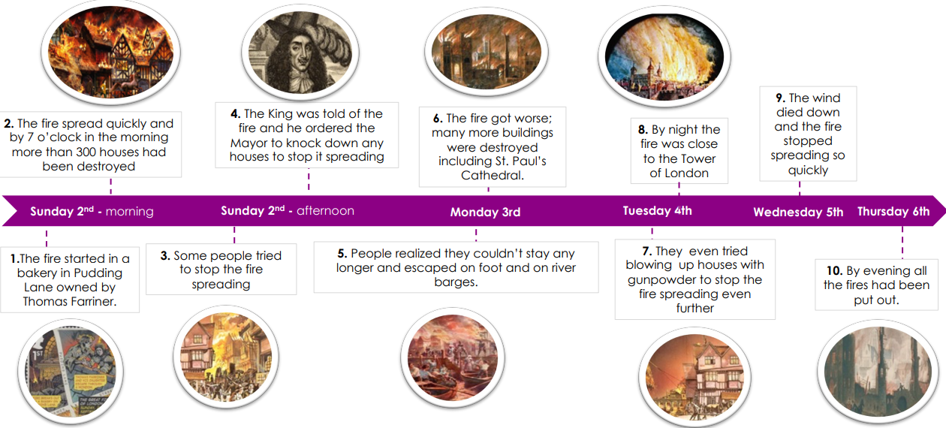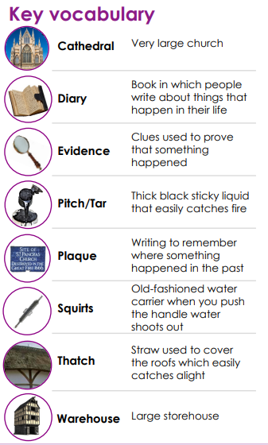

|  |  |
| --- | --- |
| **Key Vocabulary - Science** | |
| Germination | When the conditions are right, the seed soaks up water and swells, and the tiny new plant bursts out of its shell. This is called germination |
| Shoot | A shoot grows upwards from the seed or plant to find sunlight. |
| Seed dispersal | Seed dispersal is when the seeds move away from the parent plant. They can drop to the ground in the plant’s fruit or be moved by the wind or animals |
| Temperature | Temperature is how warm or cold something or somewhere is. Some plants like cooler temperatures and some like warmer temperatures |
| Nutrition | Food or nourishment. Plants make their own food in their leaves using sunlight. |
| Life cycle | The different stages of lie for a living thing |

|  |
| --- |
| **Sticky Knowledge & Skills** |
| To know about some significant people in my locality  To know about key places in my area linked to the lives of people in the past and to know why they are significant.  Know a range of human features  Know a range of physical features  Be able to name the 7 continents?  Be able to name any of the oceans. |

|  |
| --- |
| **Links to past and future learning** |
| **Science**   * In Year 1 we learnt about the parts of a plant. * In Year 3 we will learn about the lifecycle of plants and how we come to have new plants through pollination, seed formation and seed dispersal.   **History**   * In Year 1 we learnt about the Victorians and toys. * In Year 3 we will learn about timelines and significant events in history |

|  |
| --- |
| **Key Texts** |
| Grandad’s Secret Giant  By David Litchfield |

|  |
| --- |
| **Core Value Focus** |
| Critical thinking, emotional health, compassion. |

|  |  |  |  |  |  |
| --- | --- | --- | --- | --- | --- |
| History | | Science | | RE | |
| When did the Great Fire of London happen?  How do we know about the Great Fire of London?  Why did the fire spread so quickly?  How did they fight the fire?  What can we learn from this event?  How did life change afterwards?  How did the fire stop | The fire of London started in a bakery in Pudding Lane on 2nd September 1666.  Historians look at paintings, diaries, artefacts, documents and eyewitness accounts.  It hadn’t rained for months so the city was very dry. In 1666, lots of people had houses made from wood which burns easily. Houses were built too close together and there was no organised fire brigade.  They used leather buckets and squirts filled with water, axes, fire-hooks and gunpowder to make fire-breaks.  They enforced that the buildings were build further apart and the buildings had to be made of brick or stone and not wood because it is flammable.  Today we have firefighters who have access to smarter equipment.  The fire burned for 4 days. As the wind died down and changed direction the fire became under control and was finally put out. | What things do all plants need to grow well?  What is germination?  What is seed dispersal?  Give examples. | the right temperature  when a seed begins to grow and a tiny new plant bursts out of its shell  when seeds move away from the parent plant  (wind, wildlife,) | What does the bible story The Good Samaritan teach Christians about caring for people?  Jewish people look after other people by giving to other people who need help. What is this called?  What is the Golden Rule and how is it an encouragement to care?  What stories to Christians and Jewish people tell about the beginning of the world and how to treat the world? | Christians must care for everyone just like God cares for everyone.  Tzedekan  Treat other people as you would like them to treat you?  If you care for someone, someone else will care for you.  The Creation.  A human’s purpose is to look after the world.  Loving God means loving everything God created. |