

Highfield Hall Primary School

Assessment Policy

We believe that assessment is integral to the learning process.

The purpose of assessment is to monitor individual and group progress in specific areas of the n order to inform future planning, support teaching and learning and identify any gaps in performance to enable us to work towards closing them.

We accept the following purposes of assessment:
- to ensure that learning objectives are matched to ability and prior achievement
- to monitor and maintain progress
- to help us improve standards
- to inform targets

There are two forms of assessment in place at our school, formative and summative, both of which are a necessary and important part of the work that we do.

Formative Assessment
This is ongoing day to day assessment, it is the means by which progress and achievements are identified and used to enhance learning. It can:
- indicate what a pupil has learned or can do
- help to indicate why a pupil is not making progress
- inform the next steps in learning
- inform the next stage in planning
- help to evaluate the effectiveness of teaching

We believe that assessment is fundamental to effective teaching and learning and that the quality not the quantity of assessment is paramount. We also believe that a bank of assessment techniques is important; questioning, discussion, and observation are as important as marking and more formal tests.

It is important that any assessment is planned for, noted and used for future planning.

Teaching assistants will often be used for ‘same day intervention’; this is where formative assessment has shown a gap or misunderstanding in the morning, and the TAs will attempt to address this prior to the next lesson.

Teachers will review previously content regularly. The key knowledge in subjects which are more declarative will be set out in the knowledge organisers. This knowledge will be regularly assessed using low stakes testing during Flashback Fridays. The knowledge which has been retained will be ‘quizzed’ less regularly, but that retrieval will still be activated periodically.

Summative Assessment
There are 3 main ‘data points’ in the year for each class; some of these overlap with statutory data collection (e.g. SATS data). Writing is teacher assessed using the agreed assessment framework in Autumn 1, Spring 1 and Summer 1. Reading and maths are assessed using Rising Stars materials in Autumn 2, Spring 2 and Summer 2. Staff will then also give a teacher assessment. Usually this will be the same as the Rising Stars judgement, but if there is significant evidence that the child is either above or below the Rising Stars grade then this can differ.

Other checks will take place at the discretion of the teacher to inform progress and future planning, for example phonic screens, times table checks and book banding. Staff will use Insight Tracking to monitor pupil attainment and progress, and discuss actions to improve these during Pupil Challenge meetings, which take place termly with the Head.

Curriculum leaders will also monitor whether the children know more, remember more and can do more in their curriculum areas, and plan actions to address gaps in their subject leader action plans. Subject leaders will spend time in each year group termly during curriculum swap afternoons, using the knowledge and skills progression documents to ‘quiz’ pupils about what they can remember. Those subjects which are more skills-based will be assessed formatively by subject leaders through discussions with children.
.
Spring 2022
Next review Spring 2023

Appendix One: Assessment for Learning in the Foundation Stage

Why do we assess?
To gather information about a child’s knowledge, skills, understanding and attitudes in order to inform the next steps in the child’s learning to ensure progress.

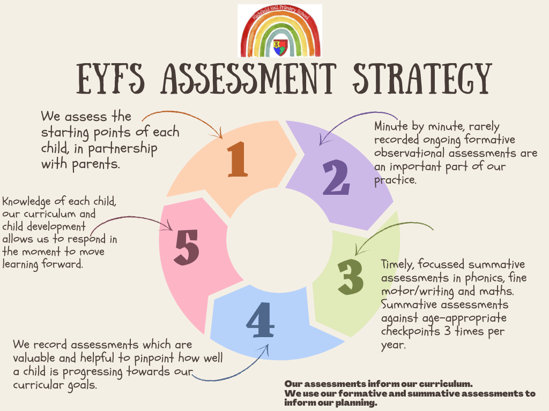

- Each child has an online Learning Journey on Evidence Me. This is a snapshot of photographic evidence, observations and achievements from their start in Nursery until they leave Reception.
- Parents are also invited to add to their child’s Learning Journey with any significant steps achieved at home.

Appendix Two: Our Rationale for Formative Assessment

Effective assessment informs planning and therefore teaching and implies the following:
- establishing a positive learning environment
- clarifying learning objectives at the planning stage
- sharing learning objectives with children- giving them the big picture
- involving children in self-evaluation against learning objectives
- focussing oral/written feedback around the learning objectives
- focussing individual target setting on previous achievement
- the employment of a bank of day to day assessment strategies
- appropriate questioning techniques
- focussing on extreme under or over achievement against the learning objective
- adjusting short term/medium term plans accordingly
- raising self-esteem through the celebration of achievement

It should involve children, include all adults, be part of the learning process and be manageable.
It is also often unplanned, spontaneous and recorded informally as part of a teacher’s sum knowledge of their pupils.

1. Establishing a positive learning environment
This implies clearly defining and establishing the ethos of the school and classroom as a place where learning takes place and where children feel secure and valued. Teachers need to consider:
- the rituals and ethos of the classroom
- the things we do to maximise the brain’s potential for learning
- the level of interaction
- the use of praise and positive affirmations
- the learning process and how children are involved in it

2. Clarifying learning objectives at the planning stage
L.O. should be unambiguous and clarified if necessary
- natural links between them should be made
- they should be centred, and appropriately weighted, on knowledge, concepts, skills and attitudes
- each L.O. should have a few activities attached to it, it is unlikely to be achieved through one activity
- they are the most important feature of, and a starting point for, planning and the focus of our teaching

3. Sharing learning objectives with children- giving them the big picture.
If this is explicitly done children will understand the difference between what we want them to do and what we want them to learn, the next step from this should be to share the assessment criteria How will we know that we have achieved this?

Learning objective:
We are going to learn to write down the numbers we can say from 1 to 10.
Activity:
Using flash cards and worksheet count the objects on each card and write the number of objects in the correct place on the sheet.
How will we know that we can do it?
Teacher holds up objects in the plenary and children write the number on their whiteboards.

These could be displayed for the children to see, read to them and read by them during the lesson or at the end. Where this approach is used children and teachers become and remain more focussed on the learning.
It is also important to remember that it is not always appropriate to share learning intentions- surprises are important too.

4. Involving children in self-evaluation against learning objectives
This could be a useful activity as part of a plenary session; it will involve skills that need to be taught through modelling questions and answers.
It could be something that is displayed in the form of a mind map.

5. Focussing oral/written feedback (marking) around the learning objectives
Research suggests that most feedback from teachers usually centres on
- presentation
- punctuation, spelling and grammar
- quantity
- effort

These are the surface features and they are the easiest to deal with, whilst these things are important they will not always be the focus of the learning objective.
Children should be reminded of previous learning and of the important features of good writing/work but to expect them to get everything right every time is to treat each piece of work as a test. When we mark work and given oral or written feedback it should be based mainly on the learning objective for the task. Feedback should include some idea of how work could be improved.
Learning objective: to write a descriptive story opening
Feedback: You need to write a better description of the prince.
This gives no clues for how to do this. It would be better to focus on how to improve the description by giving prompts… What was the prince wearing? Could you describe the prince’s face?

There are a number of types of prompt that could be used here…
- a reminder prompt (for the most able)
- a scaffolded prompt in the form of a question, directive or an unfinished sentence
- an example prompt (for the least able)… choose the best one of these…
Marking in this way has a number of implications…
- giving the children the time to read and act on the marking
- training the children to read and act on the marking
- managing a more time consuming form of marking

6. The employment of a bank of day to day assessment strategies
This would include:
questioning techniques, observation, both formal and informal, self assessment, peer assessment and scrutinising work.

7. Appropriate questioning techniques
Choosing and using the right questions to assess learning saves time and can give a lot of information to the teacher.
The following needs to be considered.
- wait time (to process the question and consider an answer)
- how answers can be arrived at, working alone, in talking partners or small groups
- how answers can be given consider alternatives to a hands up policy (written or verbal)

8. Focussing on extreme under or over achievement against the learning objective
We should be aware of the individuals and significant groups within our class. It is by focussing on their achievement at the lesson or learning objective stage that we can begin to address their overall levels of attainment.

9. Adjusting short term/medium term plans accordingly
In the light of all information gleaned from the above we need to adjust our thinking and our planning to enable our children to take the next steps forward in their learning.

10. Raising self-esteem through the celebration of achievement
We need to remember that just as success at each individual learning objective leads to higher levels of attainment overall a positive learning environment is the sum total of every positive comment and every celebration of success. Nothing succeeds like success may well be a truism.

Appendix Three: Day to Day Assessment Techniques

Questioning
Ask better questions…
- to focus attention... have you seen? can you add to that?
- to draw out comparisons...how many? how long? how often? how much?
- to get clarification...what do you mean by? can you show me? can you explain further? can you give me an example?
- to stimulate enquiry...what would happen if? what do we need to know?
- to get reasons... how do you know? why do you think that? what do you think about A’s answer? can you add anything?

…get better answers
- wait and give thinking time
- discuss in pairs and feedback - think, pair, share
- give them a choice between answers
- ask them to vote for options
- ask them to write down some answers and share a few
- if you get a wrong answer ask someone else to correct it
- if you get an ‘I don’t know’ ask someone else to convince them
- encourage reflection/generalisation/speculation
- clarify what has been said or ask someone else to
- offer observations/answers of your own as models
- recap on outcome of last lesson- ask targeted questions to those whose understanding you need to check

Listening and Observing
- watch children and listen to the discussion/responses
- make time for short planned observations of particular children
- dialogue is at the heart of AfL- make opportunities for children to talk and listen to what they say

Discussing
- to check understanding
- to follow up unexpected responses
- to sort out misunderstandings
- to follow up assessments
- to check against targets

Checking understanding
- recall tests
- planned or spontaneous questioning to check understanding

Analysing responses
Use marking to guide future work and help children know how to progress.
Share targets and ideas of where children are going next in their learning.

During the lesson teachers need to be listening to, observing and engaging with children. Through questioning and planned assessment activities we can judge how well children are applying what they have learned.
Children should be engaged in this process to enable them to judge how well they are doing.

All of this requires a clear and shared understanding of:
what is to be learned- the learning objective
why they are learning it- big picture
what we expect children to be able to do after they have learnt it – the learning outcome
how they will be learning it- learning activities
how they will know that they have achieved the L.O. -success criteria

‘Whenever these things are present there is a sense of purpose, pace and direction to a lesson. When they are shared there is a common sense of purpose.”

Throughout the lesson opportunities should be made/found (mini plenaries/hinge questions) to reinforce success criteria, check understanding and check success so far.
Marking and feedback should be used to link into next steps and future learning.

Appendix Four: Questioning Techniques

Good questioning techniques aid language development, confidence, understanding and thinking skills and take learning forward.
Good questioning uses a variety of forms from simple recall to higher order questions involving thinking e.g. strategies such as:
- offer a range of answers (e.g. simple recall- what is 3764 – 1989? reframed- discuss these answers using estimation to decide which is right and which is wrong. 5732, 1775, 1795, 2775, 2075)
- offer a statement to discuss (e.g. simple recall- which drugs are bad for you? reframed- all drugs are bad for you. Do you agree or disagree? Give reasons.)
- right or wrong (e.g. simple recall- how do you do this sum? reframed: Why is this sum right and this sum wrong?)
- giving the answer (e.g. simple recall - give an example of a complex sentence? reframed: this sentence is complex, why?)
- opposing standpoint (e.g. simple recall- what are the hazards of smoking? reframed- should smoking be a matter of choice?)

Good questioning techniques give the teacher an opportunity for assessing the process of learning.
Research has shown that while typical wait for response time is two seconds before asking someone else or giving the answer most children need five seconds to process a question and formulate an answer.
Most children leave the answering to those who can respond quickly and to the risk takers.
Having a narrow range of questioning techniques and one set way of asking/responding tends to disadvantage many of the class.
- give them time to think
- use a variety of questioning techniques
- use questions which go beyond recall
- target individuals so that you control who responds
- ask the same question in different ways to aid their understanding
- allow them to discuss the answer in pairs
- let a spokesperson speak for a group
- give them a choice of possible answers and vote on options
- get them to write answers and read out a selection
- encourage them to ask each other questions
- use questions to assess what they know
- ask them to demonstrate their thinking
- in plenary sessions use questions to summarise/distil the main points

Strategies for asking questions
- thumbs up, down, sideways – get the up children to explain to the down
- red, green, yellow cups- start green up, children can change to yellow if they think the teacher is going too fast or red if they want to ask a question- ask a yellow or green to answer the red question
- exit passes write the answer to a question- use responses as a starting point for next lesson, put names on collect them group them according to answers
- give 5 possible answers then have a finger vote- group according to fingers, ask a 1 to convince a 2 etc
- use a random way of choosing who will answer- lolly sticks (or randomiser apps on an iphone)
- give 4 possible answers ABCD cards- A why? another A same reason? B why not? (leave cards on table in front of them to use as teaching point if you want to)
- have ABCD corners- children group together- put their points- change if they want to
- have 2 possible answers (+ 3 as don’t know yet) - what does a 1 think? What does a 2 think? Who does 3 agree with? Why?
- hands down questioning – where you decide who to ask. Tell the pupils clearly “This is a hands down question – I expect you all to be able to give me an answer, even if that answer is ‘I’m not sure’”. Come back to the I’m not sure after some responses, can they summarise?
- move about the classroom. teachers seem to ask those pupils seated in a ‘shifting spotlight’ in front of them. By moving to different areas of the room you are likely to ask a wider range of pupils
- distribute slips of paper/card at the beginning of the lesson. As pupils answer a question, they hand over one of their cards. Teachers can see clearly who has still all their cards and can target an appropriate question! This technique also allows teacher to engage reluctant pupils, who may be given fewer cards.
- address a question directly to a named pupil. Keep others involved by asking them to consider what they could add/whether they agree etc (basketball- not ping pong!)
- use the ‘thinking time’ pause after asking the question to consider who has answered questions already, ask a pupil who often answers to select two or three others to answer – thus keeping them involved.
- get an observer to record on a tally chart where you direct questions in the room. This can be very revealing about distribution in terms of location and gender. A pupil may even be able to do this, and this may engage other in the discussion about who answers and why….
- teacher to distribute a numbered lolly stick to each student as they arrive. They teacher has a whole set of lolly sticks. At the first instance of question, the teacher picks a lolly stick – the student with the corresponding lolly stick must answer the question. It is important to cheat and ensure questions are differentiated and the choosing isn’t really random.

Questioning Techniques in English
The following are strategies for effective questioning from Talking in Class a NLS leaflet.
- Make suggestions ‘you could try…’
- Encourage reflection/generalisation/speculation
- Make contributions from your own experience ‘I remember when….’
- Offer information/observations of your own ‘I think…. because….’

Literal Questions
These have their place; they involve recall but make a low intellectual demand.
Examples:
- Where does the story take place?
- When does the story take place?
- Who are the key characters in the book?
- What did he/she/it look like?
- Where did he/she/it live?
- Where in the book would you find…?

Application Questions
Information/skills learned can be applied to different contexts and transferred into different situations.
- Can you think of another story which has a similar theme?
- Do you know another story that deals with the same issues?
- Which other author handles time in this way?
- Which stories have openings like this?

Analytical Questions
These require children to build on existing knowledge, identify implicit meanings and intentions and make inferences and deductions.
They ask the children to show understanding and refer to the text when explaining their view.
- What makes you think that?
- What was in the author’s mind when…?
- How do you feel about…?
- Can you explain why…?
- Do you agree with…?
- I wonder what the writer intended…?

Why were those words chosen?

How has the author used words to make it …?
- Are there any familiar patterns in the story?
- What words give you that impression?
- Can you support your view with evidence?
- Why did the author choose that setting?
Synthesis Questions
These involve children in restructuring and rewriting and in being innovative and critical.
- What is your opinion? What evidence is there to support this?
- Using all the evidence available tell me what you feel about…?
- Given what you know about … what do you think about…?
- How would the views put across in the text about …. affect your views on …?

What would this character think about…?

Evaluation Questions
These ask children to make judgements and give reasons for those judgements, they involve comparing and contrasting and the use of evidence.

What makes this a successful story?
- What evidence do you have to justify your opinion?
- Does it work?
- Could it be better?
- Is it as good as….?
- Which is better? Why? Talking in Class NLS 1

Questioning Techniques in Maths
Within the context of open-ended mathematical tasks, it is useful to group questions into four main categories (Badham, 1994). These questions can be used be the teacher to guide the children through investigations while stimulating their mathematical thinking and gathering information about their knowledge and strategies.
1. Starter questions
These take the form of open-ended questions which focus the children's thinking in a general direction and give them a starting point. Examples:
How could you sort these.......?
How many ways can you find to ....... ?
What happens when we ......... ?
What can be made from....?
How many different ....... can be found?
2. Questions to stimulate mathematical thinking
These questions assist children to focus on particular strategies and help them to see patterns and relationships. This aids the formation of a strong conceptual network. The questions can serve as a prompt when children become 'stuck'. (Teachers are often tempted to turn these questions into instructions, which is far less likely to stimulate thinking and removes responsibility for the investigation from the child).
Examples:
What is the same?
What is different?
Can you group these ....... in some way?
Can you see a pattern?
How can this pattern help you find an answer?
What do think comes next? Why?
Is there a way to record what you've found that might help us see more patterns?
What would happen if....?
3. Assessment questions
Questions such as these ask children to explain what they are doing or how they arrived at a solution. They allow the teacher to see how the children are thinking, what they understand and what level they are operating at. Obviously they are best asked after the children have had time to make progress with the problem, to record some findings and perhaps achieved at least one solution.
Examples:
What have you discovered?
How did you find that out?
Why do you think that?
What made you decide to do it that way?
4. Final discussion questions
These questions draw together the efforts of the class and prompt sharing and comparison of strategies and solutions. This is a vital phase in the mathematical thinking processes. It provides further opportunity for reflection and realisation of mathematical ideas and relationships. It encourages children to evaluate their work.
Examples:
Who has the same answer/ pattern/ grouping as this?
Who has a different solution?
Are everybody's results the same?
Why/why not?
Have we found all the possibilities?
How do we know?
Have you thought of another way this could be done?

Questioning Techniques in Science
How many legs do you think an insect has? Is better than…
How many legs has an insect? because it is more likely to get a response
Questions should follow from experience so that children can reason from evidence.
Encourage children to say if they don’t know.
When asking children why? questions consider their previous experience.
Break up questions into easier parts.
Don’t use open questions too soon.
Use attention focussing questions What can you see? What is this?
Move on to quantifying questions How many? How heavy is it?
Lead into comparison question Is it heavier than …? In what ways are they alike or different?
Suggest action questions What would happen if …?
Children are then ready for problem posing questions Can you find a way to …? What would happen if…?
J. Elstgeest Questions and Questioning

