Key Theme

Year 5 – Autumn 2: Illustrators and Illustrations
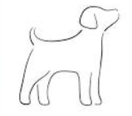
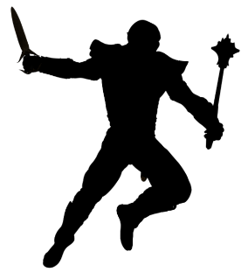
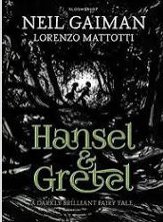
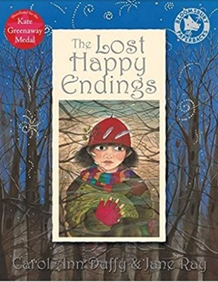
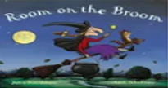
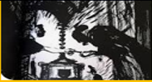
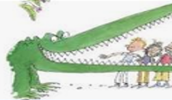
Links to past and future learning
In YX we learnt about…
In YZ we will learn about…

Key Texts

Key artists
Quentin Blake – a distinctive illustrator who uses line drawings and sketches to illustrate. Illustrated Roald Dahl books.
Lorenzo Mattotti – an Italian artist that has illustrated books, comics and graphic novels.
Axel Scheffler – a German artist best know for his cartoon-like drawing in his books with Julia Donaldson.

Sticky Knowledge & Skills
- I know that illustrators tell the story through their pictures.
- I know some key illustrators of children’s stories such as Quentin Blake, Lorenzo Mattotti, Axel Scheffler.
- I recognize that illustrators have different styles like all artists, and I can talk about the differences between them.
- I know some illustration techniques such as line drawing and silhouette.
- I know the importance of using sketch books to experiment and to plan my work.
- I can choose from the important parts of the text to form an illustration.
- I can constructively evaluate an artist’s work as well as reflect on my own and my partner’s final pieces.

Key Vocabulary
Illustration | A picture showing part of a story in a book or comic
Illustrator | Someone who creates pictures for story books or comics
Silhouette | The dark shape and outline of someone or something visible in restricted lights against a brighter background
Line drawing | A drawing done with only lines – no blocks of colour or shading
Outline | A line or set of lines enclosing or indicating the shape of an object
Sketch | A rough or unfinished painting or drawing

Core Value Focus
Creativity, resilience, emotional health, compassion.

Art |  | Science |  | RE
Name 3 successful illustrators  Whose books did Quentin Blake illustrate?  What is a silhouette?  Apart from books, what has Lorenzo Mattotti illustrated?  Create a line drawing of a cat. | Quentin Blake, Lorenzo Mattotti, Axel Scheffler  Roald Dahl  The dark shape and outline of someone or something visible in restricted lights against a brighter background  Comics and graphic novels | Name 3 different forces.  Who first explained the force of gravity?  What affects the amount of gravity acting on an object?  What unit of measurement is used for gravity?  What forces can slow moving objects?  Which direction does a compass point? | Gravitational force, magnetic, friction, air resistance  Sir Isaac Newton  The mass of the objects and the distance between them  Newtons (N)  Friction, air resistance  North | Name the 5 pillars of Islam. What does each pillar mean?  What is a  Muezzin?  Who was Bilal? Tell me about him.  Muslims take part in a ritual before? praying. Can you remember what they do?  Why do you think it would be hard to be a Muslim and pray regularly? | Shahadah – Belief that there is one god – Allah and that Muhammad is his messenger – prophet. Salah – Muslims must pray 5 times a day. Zakat – Muslims must donate some of their money to charity. Sawm – Muslims must fast during the daylight hours throughout Ramadan. Hajj – Is a pilgrimage to Mecca that Muslims must take once in their lifetime  A Muezzin is someone who calls Muslims to prayer.  Bilal disobeyed his master and refused to beat other slaves. He was locked up and beaten with rocks and left to die.  He was rescued by a friend of the prophet because he heard his voice singing – One God. He became the first Muezzin.  They complete the rak’ah – different prayer positions to prepare for prayer – they fold their arms / they bow their heads / they kneel down and touch their head on the floor  Answers could include –  difficult because you might want to playing sports; you have to get up early every day; there might not be anywhere to pray during the day – in school; you might be embarrassed in front of your friends because they might not understand that you have to pray as a Muslim

