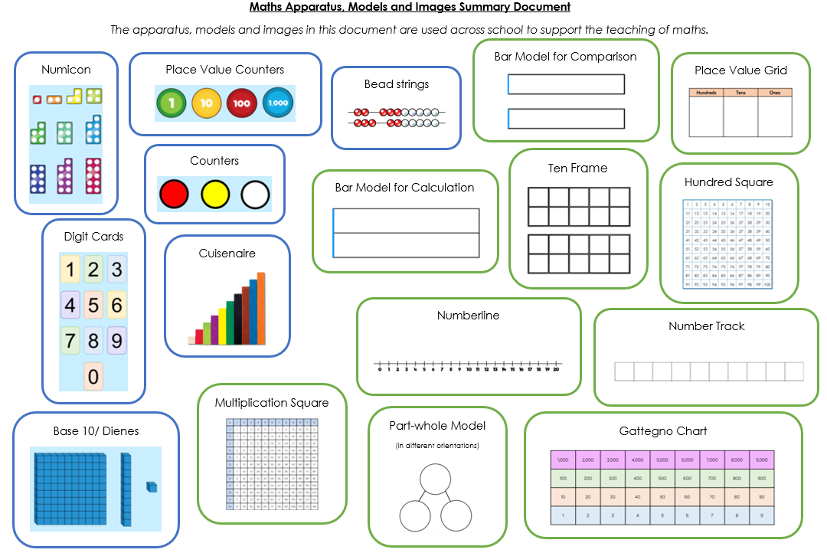

**Maths Apparatus, Models and Images**

|  |
| --- |
| **Curriculum Content** |
| In Key Stage 1 and Key Stage 2, White Rose Maths is used to form the small steps for learning. This is supplemented by other high-quality resources including Maths Shed, NCETM and I See Reasoning. We have used this approach for the last four years and it is very successful in securing mathematics learning across the school and progression across year groups. In Early Years Foundation Stage, we follow the Mastering Number programme.  Our curriculum is underpinned by ensuring that our children have a thorough understanding of their learning. We confirm that each concept is taught using concrete apparatus, and that children only move on to pictorial and abstract representations when they are secure with this.  Fluency and retrieval are built in to learning at every age and stage. Children complete retrieval on a daily basis, which targets prior learning that needs to be recalled for success during the next lesson. |
|  |
| **Pedagogy** |
| Across school, lessons begin with retrieval of prior learning. This is to ensure that children have the skills and knowledge previously taught to allow them to be successful in the next small step. Staff use this prior learning assessment to identify any gaps or misconceptions that inform their teaching.  Apparatus is available for children to use across the school. Children are well rehearsed in accessing appropriate equipment that is suitable for their needs. This is modelled by teachers and teaching assistants, using visualisers and interactive whiteboards.  Reasoning and problem solving underpins teaching. At times, fluency is taught discretely (especially when learning a new concept), but it is usually the case the all children complete reasoning and problem solving in every lesson.  Assessment informs next steps in children’s learning. Assessment is done both in the lesson, and after the lesson when marking books and planning next steps. |
|  |
| **SEND** |
| SEND children are well supported in lessons to access learning that is in line with the rest of the class, but at the correct stage for their needs. Assessment underpins this. Doodle Maths and NumBots are used at SEND interventions for target children.  SEND teaching assistants work closely with class teachers to ensure that learning meets the needs of the children. Maths interventions and next steps are planned in to SEND one-page profile meetings. |

|  |
| --- |
| **Early Years Foundation Stage** |
| The children in EYFS follow the Mastering Number programme. In their continuous provision, children are exposed to lots of different areas of maths including in real world examples. |
|  |
| **Assessment** |
| Maths progress is formally assessed three times per year, with the use of Rising Stars assessments. Small step progress is assessed throughout, and after every lesson, to ensure that all children are making progress. |
|  |
| **CPD** |
| Staff completed a lot of CPD during the implementation of the new scheme which is now well embedded. Staff are able to access CPD for any developing need through our White Rose Maths subscription. We have registered our interest to join the Maths Hub for the 2024/2025 academic year. |