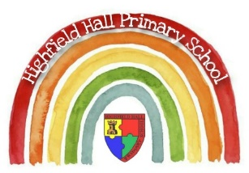
Key Theme

Year 2 – Autumn 1: Troll Swap!
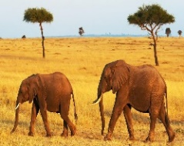
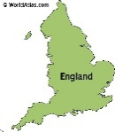
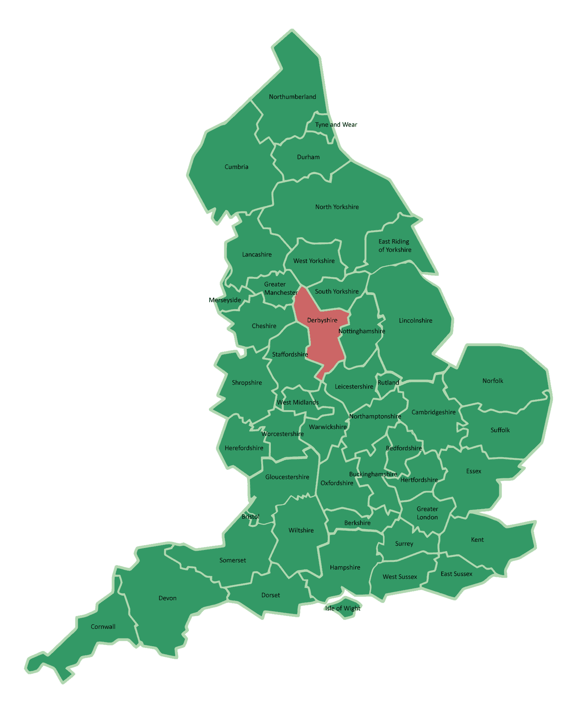
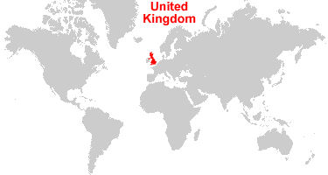
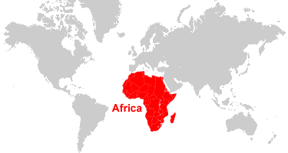
Key Texts

Savannah
Sticky Knowledge & Skills
- The village school is in is Newbold.
- Our school is in a town called Chesterfield.
- The closest city to our school is Sheffield. A city is a large town with a cathedral.
- The county our school is in is Derbyshire.
- The country our school is in is England.
- England lies above the equator; it is cold in winder and warm in summer.
- Kenya lies on the equator. It is hot, sunny and dry for most of the year.
- I know London is the capital of England and Nairobi is the capital of Kenya.

Links to past and future learning
In Year 1 we learn the 4 countries in the UK and the capital cities. We learn to describe some human and physical geography within England.
In Year 3 we develop our understanding of the world, looking at land use patterns and how physical geography changes over time. We use atlases and maps using compasses and 4- and 6-figure grid references.

Key Vocabulary
Equator | An equator is an imaginary line around the middle of a planet. It is halfway between the North Pole and the South Pole.
Human features | Human features are features such as houses, roads and bridges and other features that have been built by people or humans.
Physical features | Physical features are features that were created by nature, not humans. They would be here even if there were no people around.
Temperate | Temperate places get cooler, wet winters and warm, wet summers.
Savannah | A rolling grassland scattered with shrubs and isolated trees
Hygiene | Preventing illness through being clean

Core Value Focus
Critical thinking, resilience, emotionally healthy, compassion

Geography |  | Science |  | RE
What is the difference between the climate in Chesterfield and Kenya?  Which features in Chesterfield are human? Name 3.  Which features in Chesterfield are physical? Name 3.  Which features in Kenya are human? Name 3.  Which features in Kenya are physical? Name 3.  Which continent is Kenya located?  Chesterfield located?  What is the capital of Kenya?  England? | Kenya – Hot: sunny and dry because it is near the equator.  Chesterfield – Temperate: cooler, wet and warm because it is further away from the equator  Town, houses, shops, flats, roads.  Wood, forest, river, hills, valley  Village, town, city, offices, mud hut  Savanna, river, forest, mountain, beach  Africa  Europe  Nairobi  London | What things do humans need to survive?  What things do humans need to be healthy?  What are the stages human growth?  What is a balanced diet?  Describe the effects exercise on your body?  What is good hygiene? | Food, water, air  Balance diet, exercise, sleep  Baby, toddler, child, teen, adult  Carbs, Protein, dairy, fats, oils, sugar, fruit and veg  Raised heartrate, sweating, getting hot, out of breath, faster pulse, strong muscles  Hand washing, bathing | Who do the Jewish people believe in?  What is the name of the Jewish people worship?  What is the name of the Jewish holy book?  What day is the Jewish sabbath?  What is the Shabbat?  How do Jewish people celebrate the Shabbat?  What is Hanukkah a festival of?  What is lit each day of Hanukkah? | God  Synagogue  The Torah  Saturday  A celebration beginning on Friday evening and ending on Saturday evening  Rest, pray, share food together  A festival of light  A candle on the menorah

