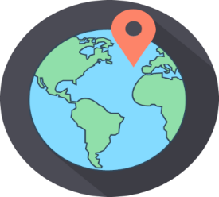Year 5 – Autumn 1: What is it like to live in a desert?

|  |
| --- |
| **Key Theme** |
|  |

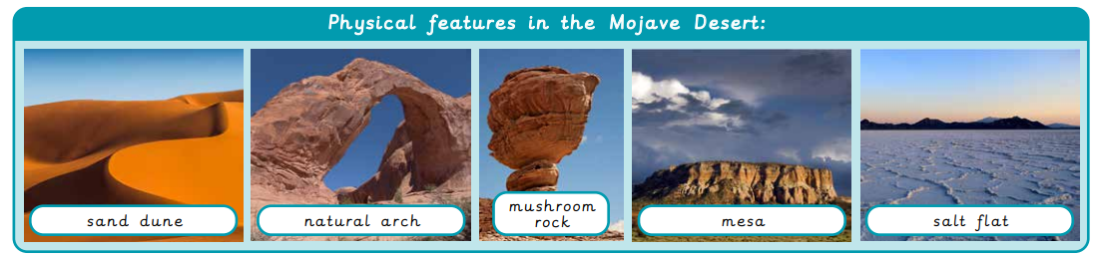

|  |  |
| --- | --- |
| **Key Vocabulary** | |
| arid | too little rain to support lots of vegetation |
| barren | land that cannot grow vegetation |
| biome | an area of the world with a similar climate and landscape where similar plants and animals live |
| climate | long term weather conditions in a specific region |
| desert | any stretch of land with little to no rainfall and extremely sparse vegetation and wildlife |
| mining | digging underground for precious metals and stones |
| rainfall | the amount of rain falling in a place over a particular time |
| ranching | keeping animals on a large farm, particularly in the Americas |
| renewable | Energy generated from a continuous source, such as wind or water. |

|  |
| --- |
| **Sticky Knowledge & Skills** |
| * We know that hot deserts can be found on the Tropics of Cancer and Capricorn. * We know the Mojave Desert is an example of a hot desert and is located in North America. * The Mojave Desert covers four states in the U.S.A. – California, Utah, Nevada and Arizona. |

|  |
| --- |
| **Key Texts** |
|  |

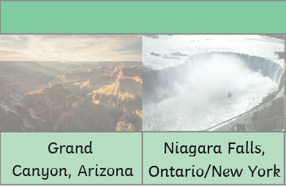

|  |
| --- |
| **Links to past and future learning** |
| In Year 4 children completed work about the formation and effects of volcanoes. They considered the positive and negative consequences of living near a volcano. Later in year 5, pupils will compare the hot desert with mountainous regions. |

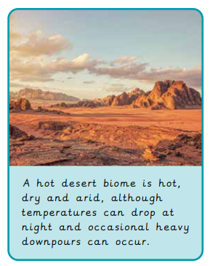

|  |
| --- |
| **CARE Values** |
| **C**ompassionate,  **A**spirational  **R**espectful  **E**motionally Healthy |

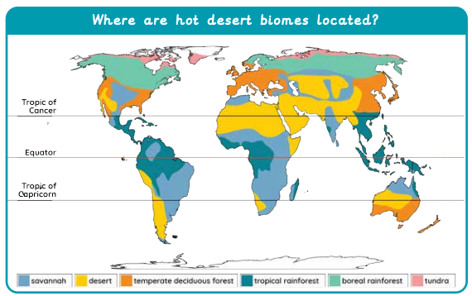

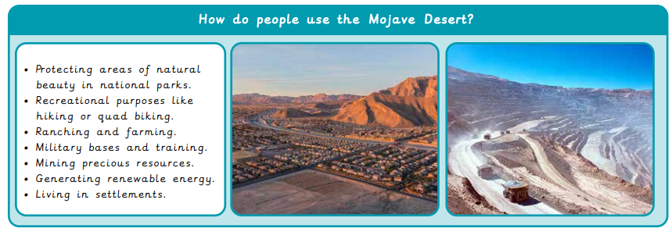

|  |  |  |  |  |  |
| --- | --- | --- | --- | --- | --- |
| Geography | | Science | | RE | |
| Where are hot desert biomes found?  What is it like in a hot desert biome?  Name three uses of the Mojave Desert. (Human features)  Name some physical features of the Mojave Desert?  Where is the Mojave Desert? | On the Tropics of Cancer and Capricorn  hot, dry and arid.  (night time temperatures can be lower)  Ranching/ farming  Recreation  Military bases  Conservation  Mining  Settlements  sand dune  natural arch  mushroom rock  mesa  salt flat  Continent: North America  Country: U.S.A.  States: California, Utah, Nevada, Arizona | What is a force?  Name 3 types of force:  Why do unsupported objects fall towards the Earth?  If there is greater friction between two surfaces they will move ________  A parachute slows someone jumping out of a plane due to what force? | Something that pushes or pulls something else.  Air resistance, water resistance, friction, gravity, magnetism  Gravity  Slower  Air resistance | What does theist mean?  What does agnostic mean?  What does an atheist believe?  Give one reason  A) Why somebody would believe in God.  B)  Is yet to decide about God  C) Does not believe in God  Define fact / opinion and belief | A theist believes in God  An agnostic cannot say if God exists or not – still to decide  An atheist does not believe in God  A1) May think there is more to life than what is on earth A2) Know that there is more than just us and their faith guides them  A3) God is unknowable  B1) May need more evidence to decide  C1) Believes in following reason and science.  C2) Needs evidence; no-one has shown them evidence of God  A fact can be proven, an opinion is something that a person thinks – e.g. Dogs are better than cats, a belief cannot be proven but is accepted as a fact – Christians believe Jesus is the son of God |