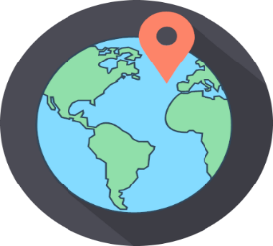
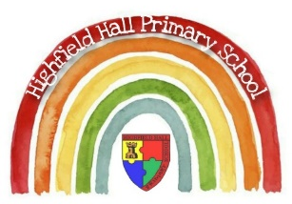
Year 3 – Autumn 1: Where my wellies take me
Key Theme

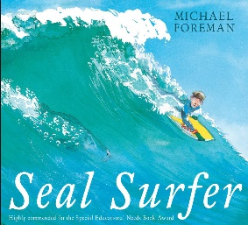
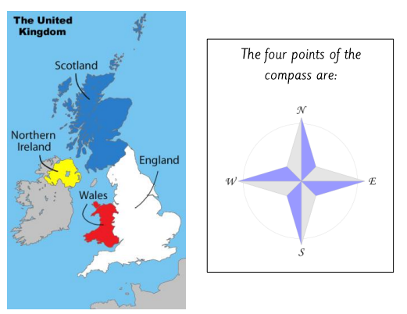
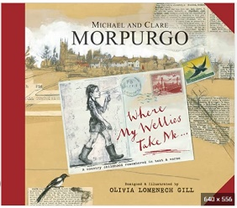
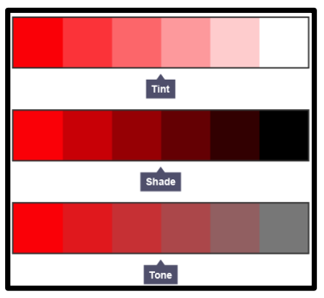
Sticky Knowledge & Skills
- I know the UK is split into 4 countries – England, Scotland, Wales and Northern Ireland, know their capital cities, and know where they are in relation to each other using the language of compass points.
- I know the difference between a physical and human feature of geography.
- I know the key geographical regions in the UK, including London and Sheffield, and some of the nearby counties including Derbyshire and South Yorkshire.
- I know Chesterfield is close to the middle of the country and far from the coast.
- I know how to use an atlas to find significant places in the UK.
- I can locate Chesterfield on a map and compare this to a coastal UK region.
- I know how to mix paint for tint, shade and tone.

Key Vocabulary
Physical feature | A physical feature is something that is on of the Earth’s natural features, for example a mountain or rivers.
Human feature | Something that would not have existed without humans, such as buildings.
Key | An inset on a map that explains the symbols and shows how big the scale is.
Atlas | A book or collection of maps.
Index | At the back of a non-fiction book, helping you find information. Information is organised in alphabetical order.
Region | A region is an area of land that has common features.
Coastal | Near the coast; where land meets a sea or ocean.
Chesterfield | The town Highfield Hall is in, near Sheffield.
Compass | A compass is a piece of equipment that can help you navigate where to go. A compass always points North, to the magnetic North Pole.
London | Capital city of England

Key Texts

Links to past and future learning
In Year 1 we studied the 4 countries of the UK and their capitals. In Year 2 we studied the Great Fire of London.
In Year 2 we investigated aspects of human and physical geography in relation to Chesterfield.
In Year 4 we will use our knowledge of the world, including latitudes, to investigate climate zones, biomes and vegetation belts.

Core Value Focus
Curiosity, critical thinking, resilience, creativity

Geography |  | Science |  | RE
What are the 4 regions in the UK called?  Name the 4 points of the compass.  Name 3 examples of human features in Chesterfield.  Name 3 examples of physical features at the coast.  What is the Capital city of England?  What is an atlas used for? | England, Ireland, Scotland, Wales  North, South, East, West  Cineworld cinema, the Crooked Spire, Queens Park  Sea, beach, cliffs  London  Locating places around the world. Looking at different areas of the world and collecting information about countries. | Name 3 natural rocks  Name 2 man-made rocks  Label the 3 layers of soil  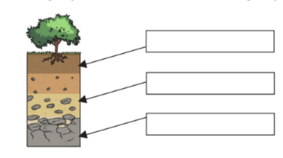  Granite is permeable – true / false  Chalk is soft – true / false  Marble is durable – true / false  Limestone is impermeable – true / false  What is a fossil? | slate / limestone / sandstone / chalk / marble / basalt / granite  bricks / concrete / coade stone  1 – top soil  2 - sub soil  3 - bedrock  False  True  True  False  Fossils are the remains or traces of animals or plants that were once alive. | Which items might you find in a Christians house?  What might a Christian family do together?  Other than praying what other activities take place in Church/ Church hall?  Why do Christians sing? | e.g. bible, children’s bible story books, palm cross, cross or crucifix, cd of Christian music, prayer cards, church notice sheet.  Say grace / prayer before meals. Pray together at home. Go to a church service together  Mums and tots groups / coffee mornings / youth club / support groups  To pray / to say thank-you / to ask for forgiveness / to ask for something

