Culture / Extra curricular / Enrichment opportunities within PE
Highfield Hall Primary School is affiliated to SHAPE partnership, this provides access to a range of opportunities from events/ festivals, Bikeability, CPD for staff, mini-leader and midday/ play leader training.

Events and festivals through SHAPE partnership are aimed at the three ability categories – INSPIRE, CONNECT and ACHIEVE, this means children can access an event that is tailored to their sporting ability.

Sporting after school clubs are offered termly to different year groups.

Assessment
Teacher assessment occurs every lesson to inform the progression or revisit of skills for the next lesson. REAL PE provides assessment opportunities through each Cog to assess skills and development.

Curriculum swap sessions give the subject leader an overview of the knowledge and skills that the children have retained, assessed against the knowledge and skills documents.

What CPD has been delivered / accessed?
All staff have received training from REAL PE staff in Sept 2019. Since then twilight refresher training has been provided when needed. All staff have access to CPD on demand through the REAL PE platform.

SEND
REAL PE is an ALL inclusive scheme. Children of all abilities can access PE lessons at their level. Adaptations to equipment are made if needed.

Through SHAPE partnership SEND children have accessed a number of events/ festivals tailored to their physical needs.

EYFS
EYFS have one timetabled PE slot a week and follow the REAL PE scheme. Physical development underpins all other areas of a child’s learning and development in EYFS and at Highfield Hall lots of physical opportunities are planned for on a daily basis.

Curriculum Content
In EYFS, KS1 and KS2, REAL PE is used as the scheme of work to follow. EYFS supplement with Move with Max. The scheme was introduced in Sept 2019. REAL PE is child-centred approach that engages and challenges every child. REAL PE develops the key abilities children need to be successful within PE and Sport and across the curriculum.

REAL PE is fully aligned with the National Curriculum requirements and builds on a progression of skills from EYFS to Y6. It develops physical literacy, knowledge, emotional and thinking skills for PE, sport and life. REAL PE focuses on agility, balance and coordination, healthy competition and co-operative learning.

Pedagogy
Staff follow the six cogs (one for each half term), these cogs are then built on each year in a progression of skills.

EYFS – Y4 lessons follow this learning model:
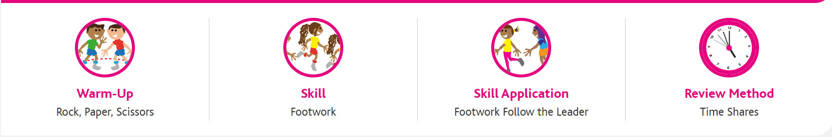

Y5/6 lessons follow this learning model:
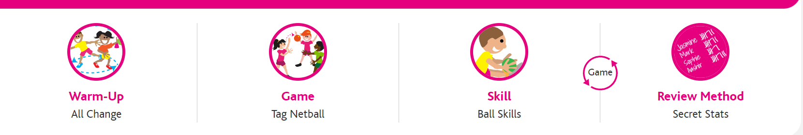

Within REAL PE every PE lessons has videos to watch of children demonstrating the skill and game. This shows children best practise and what they need to do to achieve the skill.

Differentiation within lessons happens within each cog. Children are grouped into INSPIRE, CONNECT and ACHIEVE. By grouping children this way it creates a safe space where children are working with similar skill sets.

Wi

