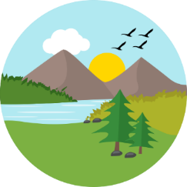
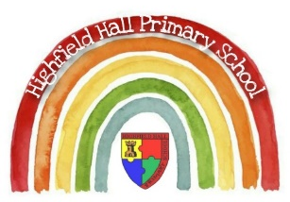
Key Theme

Year 3 – Spring 2 : What’s below the surface?
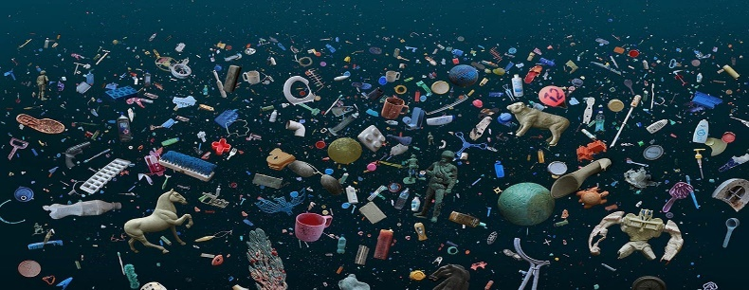
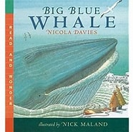
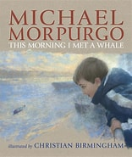
Links to past and future learning
- In year 2 we learnt all about recycling and properties of materials.
- In year 4 we will learn about living things and their habitats and how their environments can change.

From the Artist, Mandy Barker
Sticky Knowledge & Skills
- Identifying human and physical characteristics, key topographical features (including hills, mountains, coasts and rivers)
- Children should be taught about the work of a range of artists, craft makers and designers …and making links to their own work (Henri Matisse) & (Mandy Barker)
- Pupils are taught how to improve their mastery of art and design techniques, including drawing, painting and sculpture with a range of materials [for example, pencil, charcoal, paint, clay]
- I notice that some forces need contact between 2 objects, but magnetic forces can act at a distance
- Observe how magnets attract or repel each other and attract some materials and not others

Key Vocabulary
Human features  (geography) | made by humans and which humans have changed or influenced
Physical features (geography) | anything that is on the Earth naturally
Collage  (art) | art form that is made up of overlapping pieces of material
Pollution  (geography) | Pollution happens when the environment is contaminated, or dirtied, by waste, chemicals, and other harmful substances. There are three main forms of pollution: air, water, and land.
Force  (science) | a force is a push or a pull. Forces can change an object's speed, its direction, and even its shape.
Attract  (science) | pull (opposed to repel):
Repel  (science) | to force (something) to move away or apart.
Gravity  (science) | the name for a force that pulls everything down toward the centre of the Earth.
Friction  (science) | a force - the action of one surface or object rubbing against another.

Key Texts

Core Value Focus
Critical thinking, emotional health, compassion.

Geography |  | Science |  | RE
Name 3 examples of human features | Buildings, bridges, canals | What is a force? | A push or pull
Name 3 examples of physical features | Rivers, mountains, islands | Explain the meaning of attract | A pull – opposite to repel
Name the 3 main forms of pollution | Land, water, air | Explain the meaning of repel | A push away – opposite to attract
 |  | What is gravity? | A force that pulls everything down towards the centre of the Earth.

