
Highfield Hall Behaviour for Learning Policy

This policy is the Behaviour for Learning policy, as we recognise that children are learning all the time, both in the classroom and when outside. Whether the learning is academic or social, children have the same rights.

Every member of the Highfield Hall community should feel valued and respected, built on mutual trust and kindness. We should all treat each other fairly and well. The main purpose of this behaviour policy is to emphasise the importance of good relationships in helping everyone in the community to flourish. The school has number of simple rules which are set out in this document. This behaviour policy applies to all members of the school - teaching staff, support staff, pupils and parents/carers – as we recognise the importance of working together to promote a safe, happy, learning environment.

We believe in children taking responsibility for their own actions, and working closely parents to ensure high standards of behaviour. Whilst certain behaviours will be encouraged through rewards and sanctions, we hope that children will develop the intrinsic motivation to want to show good behaviour for learning. “It is intrinsic motivation, or self-motivation, that is crucial to improving resilience, achieving goals, and ultimately is the key determiner to success. Children who are intrinsically motivated achieve better and are less likely to misbehave” (Improving behaviour in schools; EEF (2019).

We recognise that behaviour may relate to wider issues and can encompass things such as safeguarding, pupil health and safety, bullying, Special Education Needs and Disabilities, and other home circumstances. This document should therefore be read in conjunction with other policies in the school, including the anti-bullying policy.

Our ethos:
- At Highfield Hall we recognise that all children are different.
- We recognise that it is important to make it clear that we will always like and care for the children in our school, even when we do not like their specific behaviour.
- Some children’s additional needs make it harder for them to adhere to the expectations for pupils in school. However, the expectations will be the same for all children, so that all children in school can be happy, safe, and can learn to the best of their ability, and therefore these expectations should not be lowered.
- The consequences and support for a child with additional needs may be different, but the expectations will be the same; being fair is not about everyone getting the same, but getting what they need.
- Expectations, consequences and support will be based on the age and stage of the child.
- Behaviour management will, as far as possible, be positive and proactive. It will be based around our core values and phrased in a positive way, with a tiered offer of support for those struggling to meet our expectations.
- Behaviour management strategies for negative behaviour (reactive) should aim to teach children how to make better choices in the future, rather than be ‘punishment’.

Our CARE Behaviour Values

At Highfield Hall we CARE! Our core behaviour values show that we are:

Communicators
Aspirational
Respectful
Emotionally Healthy.

Communicators | Aspirational | Respectful | Emotionally Healthy
We listen carefully when others are speaking.  We take turns to talk and share our ideas clearly.  We ask questions when we do not understand and to deepen our understanding.  We speak in full sentences.  We communicate appropriately with pupils, staff, and visitors. | We always work to the best of our ability  We make sure we have the right resources  We ask for help if we need it (with learning or with my emotions)  We try to be a good role model to others  If we can’t do something yet, we will work hard until we can  We complete homework on time | We say please and thank you  We hold doors open for adults  We talk kindly to other pupils and adults  We say good morning/ afternoon to adults  We look after the school building and property | We recognise and can name our own emotions  We know some things we can do to make ourselves calmer  We recognise how others might be feeling from how they act  We know what’s good about us and that we are awesome

We know that we CARE so that we and other children are happy and able to learn. We know that if you respect someone, you have a good opinion of their character or ideas. We know that being accountable means being able to be trusted to do the right things that are expected of you without supervision.

We know that pupils who do not follow the CARE behaviour values and the school rules will have a consequence for this.

The ‘Why?’
At Highfield Hall we want our children to develop all of our CARE values throughout their time with us. In order to build these values, we define the behaviours and habits that we expect students to demonstrate. We want to support our pupils to grow into adults who are communicators, aspirational, respectful and emotionally healthy. We believe that, as pupils practise these behaviours over time, they become habits that positively shape how they feel about themselves and how other people perceive them. As philosopher Will Durant states, “We are what we repeatedly do. Excellence, then, is not an act, but a habit.” (1926)

Teachers will also demonstrate these behaviours and ensure pupils have many opportunities to practise these (particularly in the first few days of each term). For example, a lining up order should be taught in the classroom but must be reinforced in different locations and times throughout the school day e.g. at lunchtime or playtime. It is expected that all pupils will know this content.

As Tom Bennett describes in ‘Running The Room’, the process for teaching behaviour explicitly is as follows - 1. Identify the routines you want to see 2. Communicate in detail your expectations 3. Practise the routines until everyone can do them 4. Reinforce, maintain and patrol the routines constantly.

It is essential that all staff know the details of this curriculum, teach it explicitly to pupils and continuously maintain the high standards we set. By doing so we support each other to create a culture where pupils feel safe and are able to learn in an optimised environment and where teachers are free to teach unimpeded.

Adaptations
While this curriculum is intended for all pupils it will be applied differently in different year groups depending on pupils’ ages and individual pupils’ SEND needs. For example, pupils who have autistic spectrum conditions may find it very uncomfortable to maintain eye-contact with adults. Sensitivity must be applied at all times when teaching the behaviour curriculum. If children’s needs mean that the whole school approaches are not appropriate for them, they will have a personalised behaviour plan. There will still be consistently applied consequences for not following rules, but the support and consequences may be adapted.

Overview of Content
Induction to school: Before children join our Nursery or Reception, or if they join mid-year, parents and children are given a full induction to the behaviour CARE values and how we show those in school. Nursery and Reception in particular spend much of the start of each term explicitly teaching these behaviours.

 | Autumn 1 | Autumn 2 | Spring 1 | Spring 2 | Summer 1 | Summer 2
All Year Groups from Nursery to Y6 | Explicit teaching of the full Highfield Hall behaviour curriculum content | Ongoing revision of content | Longer recap of the Highfield Hall behaviour curriculum | Ongoing revision of content | Longer recap of the Highfield Hall behaviour curriculum | Ongoing revision of content

Consistency
Applying high expectations, rewards and sanctions consistently is the key to a positive behaviour system in school. Staff should ensure good routines for their classroom and for when their children are around the school.

These expectations are reinforced through Monday assemblies and positive interaction with children, drawing attention to the behaviour we hope to see. Where there are routine activities (i.e. things which happen regularly) these will be as tightly defined as possible (see appendix 1 and posters). It is everyone’s responsibility to challenge children where these expectations are not met but equally to comment positively when they are.

Parental Involvement
We are very lucky in that the parent and carers of Highfield Hall are very supportive in helping children to understand the consequences of their behaviour. We will always try to be open in our communication with parents, informing them of their children’s positive behaviour in school as well as any issues (either persistent low level issues, or more serious negative behaviour).

Engagement with Learning and the Curriculum
Positive behaviour for learning will be encouraged through an engaging curriculum, pitched appropriately for the children using Assessment for Learning (AfL) strategies. Whole class strategies for engagement such as a no hands up approach and whole class responses (e.g. on mini-whiteboards), and a dialogic approach (talk for learning and talk through learning) will help to ensure that children are all engaged.

Positive Recognition
Positive behaviour (exemplifying the core values) will be recognised in a number of ways. There is evidence that a 5:1 ratio (for every criticism or complaint the teacher issues, they should aim to give five specific compliments, approval statements and positive comments or non-verbal gestures) has a positive impact on behaviour. Recognition includes:

- Genuine, specific praise – for behaviour and for learning (and learning attitudes)
- Non-verbal signals, e.g. a smile or thumbs up
- Sharing work with other adults (e.g. a year group partner, SLT member or Dr Bywaters)
- Assembly certificates
- Teachers to choose 1 behaviour to focus on for the week for the classroom (e.g. not shouting out) and one for outside (e.g. being a ‘good sport) – linked to whole class rewards.
- Whole class reward system (e.g. marbles in the jar) – once completed the class will get a reward (shorted term for KS1, e.g. weekly extra playtime, longer for KS2 e.g. half termly film).
- Class dojos
- ‘Hot chocolate Friday’ – reward for ‘always’ children (possibly quieter children who just always get on with doing the right thing).

Class dojos will be the main ‘driver’ of positive rewards in school, alongside the celebration assemblies every Friday. Dojos should be awarded for showing the core values; we will work to make sure that dojos are given out consistently across the classes.

Children earn dojos throughout the school year, and then have the opportunity to ‘spend’ these during reward times at the end of each half term. All children with dojos will participate in reward activities, however some will ‘cost’ more than others. Children can save dojos across the year to spend on larger experiences in the Summer term.

Other recognition can come from being given positions of responsibility, for example being a member of the school council, being a monitor, being a play leader, or taking on a role within class.

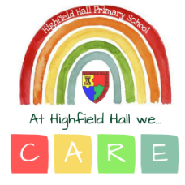
Highfield Hall Primary School Rules

Be communicators
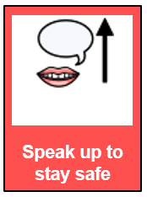 | 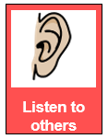 | 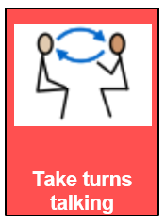 | 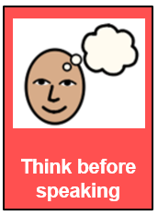 | 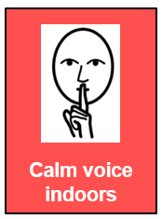

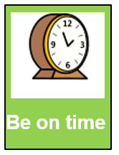 | 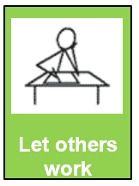 | 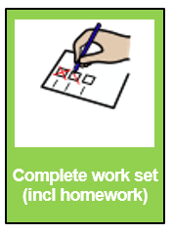 | 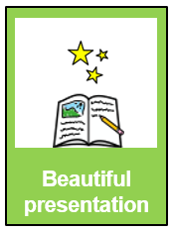 | 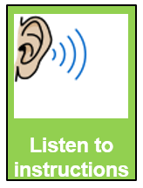

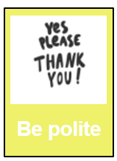 | 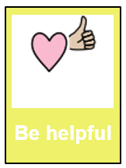 | 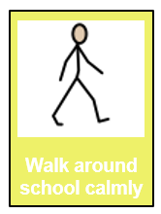 | 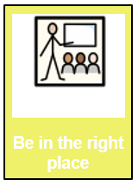 | 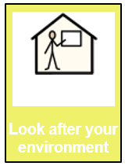

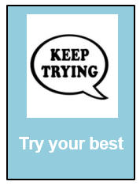 | 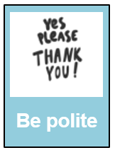 | 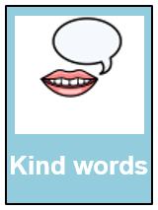 | 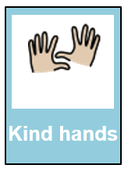 | 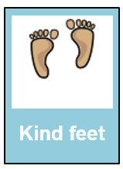

Reducing Anxiety and Social, Emotional and Mental Health Issues
We have a tiered approach to mental health and wellbeing in school. All children will complete My Happy Mind sessions weekly, with assemblies each half term to introduce these themes. All classes will also have a worry box for children to raise issues and concerns (either anonymously or named). These will be checked regularly by class teachers and either addressed individually or through whole class discussions. There is targeted supported offered through, for example, Compass Changing Lives (e.g. small group sessions). Specialist provision is accessed through Compass Changing Lives and other outside agencies e.g. CAMHS.

Some children, e.g. those with ADHD or on the ASD spectrum, or those with SEMHD needs, may need additional support to meet the school’s expectations. Teachers will identify any pupils they feel need additional adjustments (e.g. being able to use the sensory garden), and agree these with the child, the child’s parents and Mrs Higham in a proactive fashion. If issues continue, class teachers should use the internal referral system to Mrs Higham (SEND issues) or Mrs Webster (Mental Health issues) to discuss what additional support could be offered.

MindUp Areas
Each class will have a MindUp area. Children will be taught to identify when they need time to emotionally regulate and ask or be asked to use the range of resources in the MindUp area in order to ‘reset’.

Lunchtimes
Play leaders will encourage proactive positive play during lunchtimes, with a range of structured activities on offer. Positive behaviour will be rewarded with dojos. Where children need additional social support, they will be encouraged to use the Buddy Benches. Lunchtime staff will also encourage children to use the sensory areas (sensory garden and outdoor classrooms).

Negative behaviour may lead to lunchtime staff removing dojos.

Reactive Strategies
Dealing with negative behaviour:

Negative behaviour will lead to a loss of dojos. These consequences still build on relationships, and the main theory is that they are not a punishment but an opportunity to ‘turn behaviour around’ within a clear structure. They are also a way of communicating with a parent about incidents.

Reactive strategies: Dealing with negative behaviour

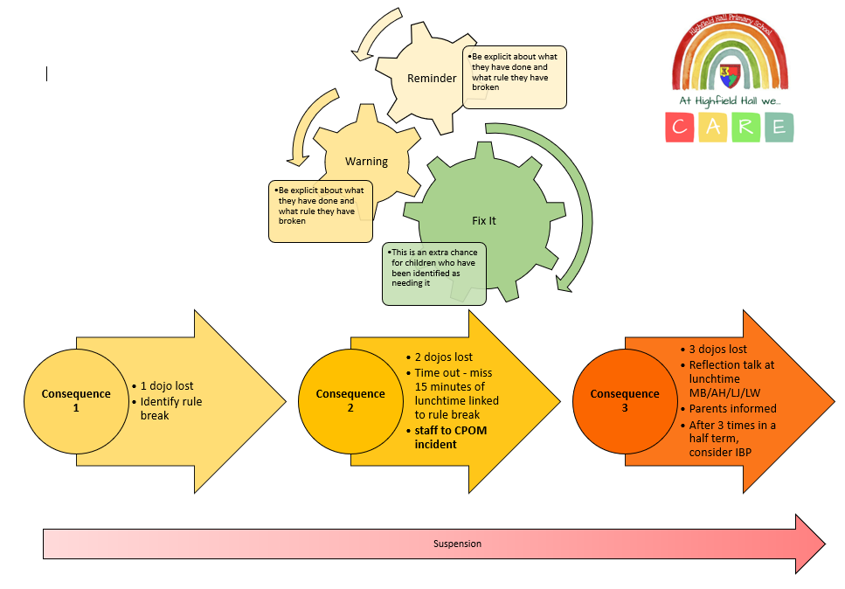

Behaviour Tracking Sheet
Name | Reminder | Warning | Fix It | C1 | C2 | C3
John Smith
Jane Doe

Amber Rule Breaks
For more significant infractions (Amber rule breaks), a consequence 3 is given immediately.
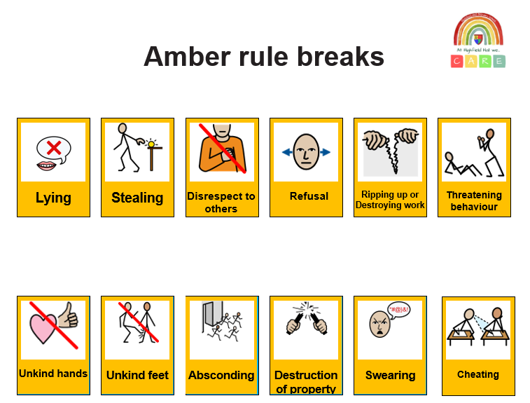

For consequences 2 (with teacher) or 3 (with Head or Deputy), there should be reflection time using the 5 key questions:

- What happened?
- How did it make you feel?
- How did it make the other person/people feel?
- What could you have done so that everyone felt safer / was able to learn?
- What will you try next time

These can be group discussions where everyone is able to talk about their actions and offer solutions.

Report Cards
A child who repeatedly fails to respond to the behaviour policy may be subject to a report card. This will be completed by the class teacher and the child will take the report card to the phase leader each day. The report card will be signed by parents each night. At this time parent/carers maybe invited to support staff and their child in discussing a Behaviour Plan.

Bullying
Please see the anti-bullying policy

Homophobic, racist or discriminatory language
Any incidents of bullying or discriminatory language (e.g. homophobia, racism or insults based on protected characteristics) must be referred immediately to Dr Bywaters, who will keep a separate record, including how the incident was dealt with. A summary of these incidents will be reported to governors at each Full Governing Body meeting.

School define racism as:
- the deliberate use of language which is perceived by the person hearing it as conveying hatred of a person’s ethnicity or country of origin;
- a physical attack on an individual as a result of that person’s ethnicity or country of origin which is intended to insult that ethnicity or country of origin.

School recognise that when children use this language, it may be due to language or attitudes they bring from outside school. These situations should be a teaching opportunity for school. Any child using homophobic, racist or discriminatory language will have a 1:1 conversation with Mike Bywaters or Anna Higham. This will focus on the reasons why this language is highly inappropriate. Where appropriate the child will apologise to the affected person (either verbally or in writing) explaining why their actions were hurtful. Mike Bywaters and Anna Higham will speak with the children’s parents.

Sexualised behaviour / language
See Child Protection and Safeguarding Policy

Repeated / Very Significant Incidents
Where there are repeated C3 incidents (3 in a half term), an Individual Behaviour Plan will be put into place. This will usually initially be supported through a behaviour report card that is shared daily with home.

Serious breaches of the behaviour policy may lead to internal suspension, formal suspension or permanent exclusion. Deliberate aggression towards a member of staff will always lead to a suspension. The decision regarding these will be taken by Mike Bywaters. If a child has a formal suspension, the child will be discussed at the weekly safeguarding meeting and there will be consideration of SEND adaptations (if appropriate), additional SEND support (e.g. inclusion funding) and other external specialist support.

Reporting
Incidents at C2 or above, or those which may indicate a pattern of behaviour, should be reported on CPOMS. Reports should include who was involved (staff and linked pupils), a summary of what happened, including the location, a verbatim report of what was said if there was a disclosure, objective facts and a clear indication if an opinion is being given (“he was shaking and it is my opinion that he was scared”), and actions taken. CPOMS will record the date, and the time should be adjusted to show when the incident happened. Relevant staff should be linked in.

High Challenge Behaviour
We recognise that there are a small number of children in school who can sometimes struggle with their emotional regulation, and display ‘high challenge’ behaviour. This may take the form of aggression towards peers or staff, or damage to property/throwing items in the classroom. Where there have been significant incidents, it is important that all pupils and staff feel supported and feel safe. Please make sure that you inform a member of SLT during or following any significant incidents.

The children who have displayed high challenge behaviour in the past have a Behaviour Strategy Passport – these are one page documents which set out approaches will may help, and things to avoid.

Whenever there has been a significant behaviour incident, the following review processes will take place:
- Members of staff dealing with incidents should call on support from SLT as soon as possible – there will usually be a member of SLT on channel 12 of the radios. If the incident is ongoing then a member of SLT will offer support.
- If the incident has been resolved, member(s) of staff who have dealt with the incident should inform a member of SLT, who will offer support, for example time out of class to get a drink or just a listening ear.

Appendix 1: Our Routines

At the start of each session we:
- Sit quietly in our seats and follow our brain break routine (this helps have a regulated and calm start to each session)

When coming into assembly we:
- Move through school following our routine.
- Wait in single file on the corridor in silence.
- Walk in in a straight line with our hands by our sides.
- Stay standing until we are told to sit.
- Sit with our legs crossed and our hands in our laps or on our knees.
- Sit facing forward, looking at the person who is talking.
- Put our hand up if we have a problem.

Adaptations for assembly include: Some children not having to attend all assemblies, ear defenders, agreed ‘fidgeting’ strategies.

On the corridor with our class we:
Know that we walk around school using ‘Fantastic Walking’
Know that Fantastic Walking means:
- Facing forwards
- Walking at a steady pace
- In a straight line, with a gap between you and the person in front
- Walk without leaning on the walls
- With hands by your sides
- Without talking unless it is to an adult.
- Say good morning or good afternoon to any adults
- Pause to allow adults through doorways

On the corridor on our own (e.g. at lunchtime) we:
Know that we walk around school using Fantastic Walking
Know that Fantastic Walking means:
- Facing forwards
- Walking at a steady pace
- In a straight line without leaning on the walls
- With hands by your sides
- Walk on the left hand side
- Say good morning or good afternoon to any adults
- Pause to allow adults through doorways

Know that when we move around school we walk on the left of the corridor, and use the hand rails when going down the stairs. Know that we use Fantastic Walking to keep everyone safe in school and to make sure the learning of other children is not disrupted as people move around school.

In the cloakroom we:
- Know where our own peg is
- Wait for a space before moving to our peg
- Hand our belongings on the peg with nothing hanging on the ground
- If we see anything on the floor we hang it on a peg

In the toilet we:
- Walk to the cubicle or urinal
- Act responsibly by not standing on the toilet seats, handles or towel holders
- Show respect by not looking over or under other cubicles
- Leave the toilet in the same state as we found it (use a small amount of toilet paper and toilets should be flushed after you have used them).
- Wash out hands
- We put paper towels in the bin, including any that have fallen on the floor

In the dining hall we:
- Queue up in a calm and polite manner
- We say please when asking for food, and thank you when we have received it
- We walk calmly to our table and sit on our chairs
- We show good manners by using a knife, fork and spoon
- We put our hand up if we have a problem
- We put our hand up to ask if we can be excused to go and play
- We tidy up after ourselves – we pick up any dropped food, and put the things we have used away (packed lunches or trays)
- We walk from the dining hall all the way to outside using Fantastic Walking.

On the playground we:
- Keep the concrete under our feet (avoid sliding down the handrails, going on the grass unless told to, or sit on the walls)
- Know that we must play safely without hurting anyone.
- Know that we do not ‘play fight’ because we may hurt someone by accident.
- Know that we must be kind, by including people in your games and sharing equipment.
- Know that someone who is kind behaves in a gentle, caring, and helpful way towards other people.
- Know that we should not scream when playing together at playtime.

End of playtime / lunchtime routine
- At the bell we tidy any toys/put balls away
- At the first whistle we freeze in silence
- At the second whistle we walk quickly and quietly to the to the line
- We find our space in the line in our order, ensuring that we are standing at a suitable distance from the person in front
- At the third whistle we stand in silence with our hands by our sides.

Classroom Routines
Each teacher will set out their classroom routines, which can be shared with any other adult who is in the classroom. These routines may differ from class to class, but each class will have an explicit routine for:
- Transition into class in the morning and the first tasks of the day.
- Routines for handing out books or equipment.
- Routines for using the toilet.
- Routines for the end of sessions, and getting ready for break and lunch.
- Routines for the end of the day.

We:
- Know the order that we always line up in.
- Know who we stand in front of and who is behind us.
- Know that we should line up without leaning against the walls while moving around school.
- Know the routine for entering the classroom and getting ready to work.
- Know where we sit in class during lessons (including ‘carpet places’)
- Know where to hang up our coat.
- Know that we should try to avoid going to the toilet during lessons.
- Know that you need to get equipment out ready for the lesson and to look after it.
- Know that any deliberate damage to school equipment will incur a consequence.
- Know the routines for responding to a question or participating in discussion.


All strategies from the QFT strands of the Whole School Provision Map are in place. All advice from outside agencies is being followed. ABC chart, Behaviour Support Plan and Risk Assessment are in place & being followed if there have been previous instances of crisis ‘behaviour’. All staff working regularly with these pupils to have access to radios
*Follow up will depend on the level of incident. All actions outlined will take place in the event of aggression towards staff.
Once regulated the staff member will:
- Complete CPOMS and attach print out to completed accident form, and return to the office.
- If Mike was not available by radio, inform him asap (or ask a colleague to).
- Consider whether they require an
Occupational Health / Counselling referral, and request this if desired.

Follow up*:
- Other staff to add to the CPOMS account as soon as possible (and within the same day)
- Mike contacted asap to consider appropriate sanction for the child (tel 07870829947). If there has been deliberate physical aggression against an adult this will always result in suspension.
- Senior leaders (Mike if available) to contact
parents asap (and within the same day).
- All relevant staff review risk assessment and
suggest any adjustments necessary.
- Review the incident in line with the risk
assessment, Behaviour Support Plan and outside agency advice—what lessons can we learn?
- Mike / Sally to consider whether additional
outside agency advice/referrals would be
beneficial, and whether additional training is
necessary.
Flowchart for Significant Behaviour Incidents
(incl violence towards member of staff)
Be aware of triggers / anxiety and defensive behaviours
Follow de-escalation strategies
Immediate crisis resolved; monitor to ensure full regulation, including recovery and possibly depression stages
Continued escalation in behaviour to ‘Crisis Behaviours’
Follow de-escalation strategies
Consider removing children & adults from classroom / space
Crisis behaviour continues
Aggression towards a member of staff (including physical violence)
Post incident reflection and follow up (consider danger of re-starting crisis; follow up could be on the next day if appropriate)
Follow de-escalation strategies, including removing those in danger of harm. Leave the child and supervise remotely (e.g. from outside the room) if safe to do so.
Radio SLT on channel 12 for a change of face (immediately in the case of aggression). If not available, find another change of face, e.g. other SLT member
Member of staff impacted by the aggression has time out of class in a staff room to
regulate themselves, and treatment of any injury
Bullying Allegation Flow Chart
If a child or parent feels that a pupil is being bullied, the following action is taken. Following a confirmed bullying incident, time is spent talking to all of the children involved, talking through the children’s actions, and discussing future behaviour and the child’s parents will again be invited into the school to discuss the situation. If bullying continues, sanctions will escalate, with fixed term or permanent exclusions being the ultimate sanction. In such cases, the Head teacher may contact external support agencies, such as CAMHS, social care etc as appropriate.
Deemed BULLYING
Deemed NOT bullying (e.g. if conflicting reports of incidents)*
Allegation of bullying made by pupil or parent (any use of the word bullying in relation to an incident in school/cyber) *
Teacher investigates that day (speak with child / witnesses/ other children) *
Deemed NOT bullying (e.g. if one off incident / friendship fallout)*

Phone call / conversation with parent about outcome. Work with child about the definition of bullying and conflict resolution by teacher / TA.
Deemed POSSIBLE bullying (e.g. if conflicting reports of incidents)*
Deemed BULLYING*
Reported to Dr Bywaters, who will allocate a named key worker, and make parents aware of key worker*. Child asked to report to key worker after lunch and at the end of the day for 5-10 days, reporting any incidents.
Reported to Dr Bywaters, who will allocate a named key worker, and make parents aware of key worker and confirmed bullying. Child asked to report to key worker after lunch and at the end of the day for 5-10 days, reporting any incidents with the child showing bullying behaviour. Parents of child showing bullying behaviour to meet with Dr Bywaters to discuss consequence. Significant consequence given.*

* Each of these stages to be recorded on the school’s behaviour reporting system. The initial incident should include where and when the bullying is alleged to have taken place. ANY allegation of bullying will be identified using the ‘bullying’ book in Dr Bywaters’ office. Once the investigation has taken place, Dr Bywaters will add one of these statements:
- ALLEGED BULLYING; NOT BULLYING BEHAVIOUR
- ALLEGED BULLYING, NOT CONFIRMED. KEY WORKER ALLOCATED.
- ALLEGED BULLYING, BULLYING CONFIRMED.
All allegations of bullying and the outcomes to be analysed and reported to governors termly.

Implementation

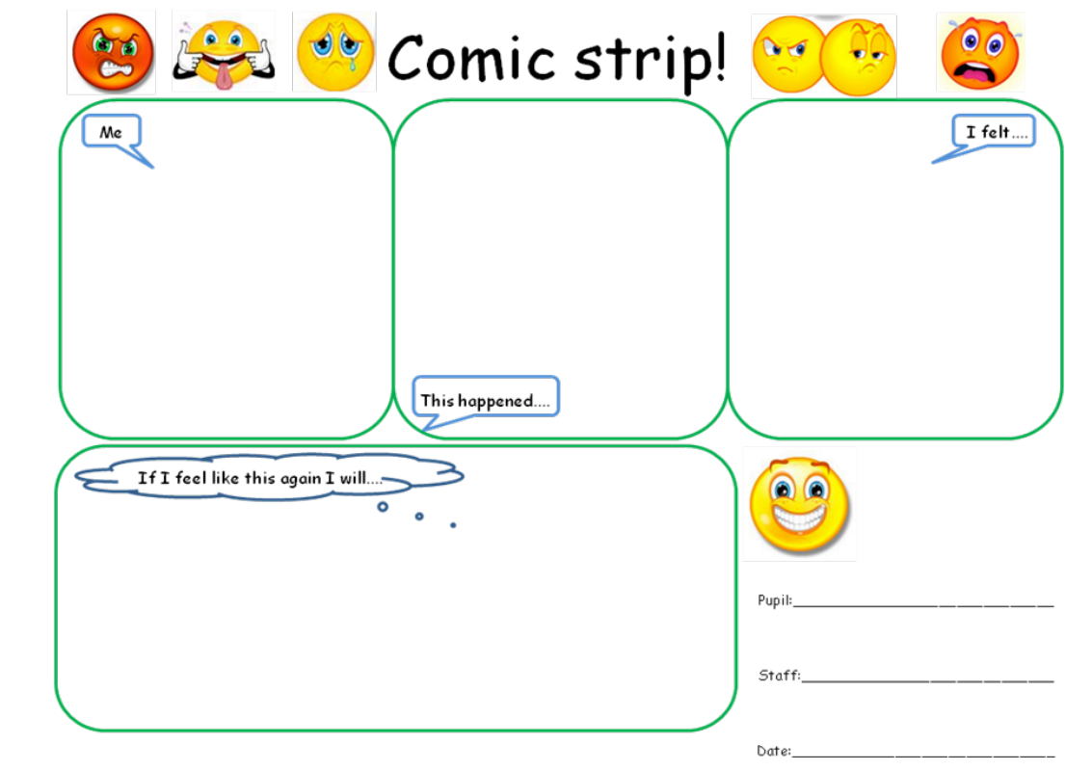
Six Stages of a Crisis
 | Stage description | Need for… | Behaviours | Positive handling responses
1 | Anxiety/Trigger | Diversion, support and reassurance. | Low Level  Shows signs of anxiety, hiding face in hands, bent over/under table, pulling at collar or hat, rocking or tapping, withdrawing from group, refusing to speak or dismissive, refusing to co-operate, adopting defensive postures. | Low Level  Read the body language and the behaviour, intervene early, communicate; ‘talk, I’ll listen’, Use appropriate humour, display calm body language, talk low, slow and quietly, offer reassurance, including positive physical prompts, assess the situation, divert and distract introducing another activity or topic.
2 | Defensive/  Escalation | Diversion, reassurance, clear limits, boundaries and choices. | Medium Level  Displays higher tension, belligerent and abusive, making personal and offensive remarks, talking louder, higher, quicker, adopting aggressive postures, changes in eye contact, pacing around, breaking minor rules, low level destruction, picking up objects which could be used as weapons, challenges; ‘I will not…’ ‘you cannot make me.’ | Medium Level  Continue to use level one strategies + state desired behaviours clearly, set clear, enforceable limits, offer alternatives and options, offer clear choices, give a get out with dignity, assess the situation and consider making the environment safer and getting help, guide the elbows towards safety.
3 | Crisis | Possibly for restrictive intervention appropriate for the service user. | High Level  Shouting and screaming, crying, damaging property, moving towards danger, climbing, tapping or threatening to break glass, moving towards weapons, picking up objects which can be used as weapons, hurting self, grabbing or threatening others, hurting others, kicking, slapping, punching. | High Level  Continue to use level 1 and 2 de=escalation responses + make the environment safer, moving furniture and removing weapon objects, guide assertively, hold or restrain if absolutely necessary, ensure face, voice and posture are supportive, not aggressive., use help protocol and save face by changing face.
4 | Recovery | Co-ordinated letting go and reassurance. | Recovery behaviours  Can easily be confused with anxiety stage. People may sit quietly in a hunched position, the difference is they can revert to extreme violence without the build up associated with the normal escalation in stage 2. | Recovery positive handing responses  Support and monitor, this may not be a good time to touch as it may provoke a reversion to crisis, give space, look for signs that the person is ready to talk.
5 | Depression | Observation, support and monitoring. | After a serious incident people can become depressed, they may not want to interact. | Depression positive handing responses  Support and monitor, respond to any signs that the person may want to communicate, show concern and care but do not attempt to resolve residual disciplinary issues at this stage.
6 | Follow up | Listening and learning. | Follow up  Listening and learning, recording, reporting and communicating, planning to avoid similar events in the future. | - Listen to views of pupil  - What can be learned from this?  - Keep appropriate record of incident and responses  - Share reports as appropriate – client’s file  - Appropriate professionals meet to discuss plan/risk assessment/care and control plan.

Examples of 5-point scales (these would be co-constructed with the child, using an area of their interest). These can be referred to by the child and adults working with them.

Point on the scale | How I feel… | What this looks like! | What could help bring me down to the next point…
5 | Very angry. I want to shout. Sometimes I might want to hurt people but I stop myself. |  | Somebody giving me a five minute timer, leaving me alone and then coming back to take me to hang off the monkey bars.  I will talk to them after five minutes if they ask me a question.
4 | More stressed. I feel boiling hot. |  | Getting some fresh air. I could open a window or go outside. I will tell an adult if I am going to do either of these things.
3 | More frustrated. My body feels quite tense, which begins to make me hot. |  | Leave the room, which is annoying me. Sit on a soft surface with something behind my back.
2 | Getting more annoyed. My body feels like I might break something. I might be stamping my feet, which might break something. |  | Sitting on my own for five minutes with a sensory toy will help me calm down to a 1.
1 | A little bit annoyed with something. I might be very quiet and trying to keep yourself calm. I might roll my eyes. |  | Having five on my own and then returning back to the situation.
0 | relaxed, happy, content, smiling. I will be like this dinosaur! | 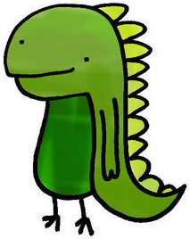 | Adults explain why they are calling me or why they are doing something.

Point on the scale | How I feel… | What this looks like! | What could help bring me down to the next point…
5 | Don’t want to do anything. Very angry. I see red and get worked up over nothing. My body feels stiff, tight and stressed. |  | Talking to someone helps me. I want the other person to listen.
4 | It makes me feel like my stomach is eating away at its self. My heart goes faster than usual. My head feels like it is getting bigger because of the stress. |  | Walking around outside helps keep me calm.
3 | More frustrated  It feels like something has happened but it doesn’t matter that much. |  | Five minutes with my ear defenders will help me go back to a 2.
2 | Annoyed  When I’m going to do something but I forget what I’m going to go. This makes me a 2. |  | Telling someone I’m annoyed will help.  Being listened to will help.
1 | A little bit annoyed with something. I don’t know what I might be annoyed with. I sometimes get woken up too early. This makes me a 1. |  | Sometimes taking deep breaths helps.  Leaving me alone with my sand timer.
0 | relaxed, ready to learn, happy |  | Explaining things in a simple way to help me understand.  Explaining why adults are doing certain things.

