Key Theme

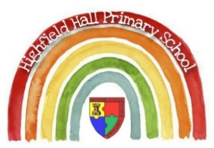
Reception – Spring 2: The Pirates are Coming
Core Value Focus
Compassion
Accountability
Respect
Emotionally healthy
Cultural/Seasonal celebrations
Spring
Easter
Ramadan
Mother’s Day
Cultural/Seasonal Sticky Knowledge
Our teachers are helping us…
- To know that the Christian celebration of Easter celebrates the death and rebirth of Jesus.
Topic Sticky Knowledge
Our teachers are helping us…
- To know a letter/card/invitation starts with ‘To’ and ends with ‘from’.
- To know that they live in Chesterfield, England.
We are also learning to…
- Be independent in our work and play
- Find our own solutions to problems
- Show respect to our teachers, peers and school environment
In Phonics we are learning …
these phonemes – oo, ow, ee, ur, ai, or

the high frequency words – look, now, down, see, going, just, have, it’s, do, so
In Maths we are learning to …
- explore the structure of the numbers 6 and 7 as ‘5 and a bit’ and connect this to finger patterns
- focus on equal and unequal groups when comparing numbers
- understand that two equal groups can be called a ‘double’ and connect this to finger patterns
- sort odd and even numbers according to their ‘shape’
- continue to develop their understanding of the counting sequence and link cardinality and ordinality through the ‘staircase’ pattern
- order numbers and play track games
- join in with verbal counts beyond 20, hearing the repeated pattern within the counting numbers

Links to past and future learning
The children will build on their knowledge of religious festivals (Christmas) when learning about Easter.
In our topic sessions we will be building on our learning about the world around us. We will link back to our work on journeys and maps.
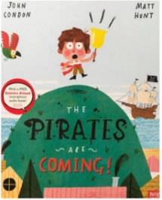
Key Vocabulary
false alarm  warnings  barrel  villager  rusty  yelled  silently | harbour  gangplank  captain  crew  ashore  narrow  skull and crossbones

Suggested Texts: fiction, non-fiction, poems & rhymes
The Pirates Next Door by Jonny Duddle

Ten Little Pirates by Mike Brownlow

How I became a Pirate by Melinda Long

Commotion in the Ocean by Giles Andreae

Peter Pan (1953 film) by Disney

Key Text

