Key Theme

Year 3 – Spring 1: Savage Stone Age!
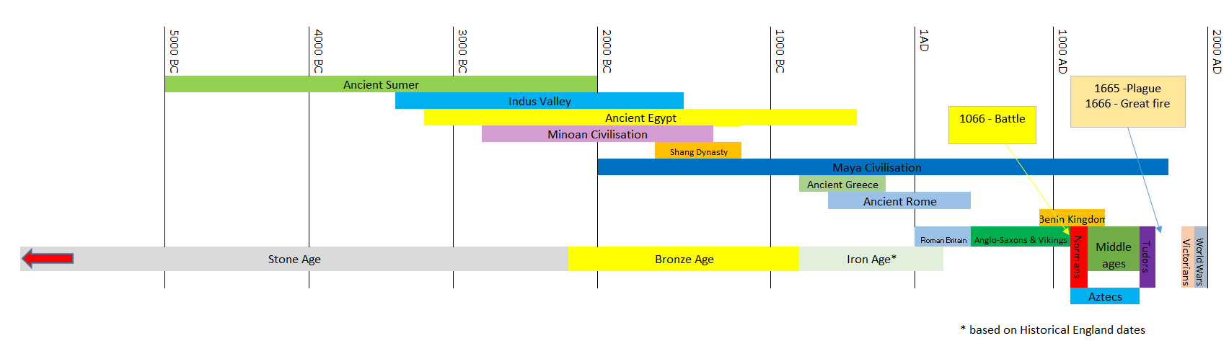
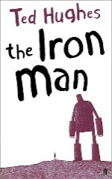
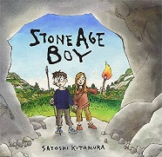
Sticky Knowledge & Skills
- Early humans may have used art as a way of helping themselves in their struggle for survival. Paintings of animals on cave walls were common.
- Palaeolithic period = People were nomadic hunters and they found food by roaming from place to place in different seasons.
- Mesolithic period = Tools were developed to become smaller and finer. The invention of canoes meant that people were better able to hunt for fish as well as animals.
- Neolithic period = People began to settle into farming villages instead of moving from place to place. People started to look after animals and grow their own crops. People started to look after animals and grow their own crops.
- I can understand that pre-history occurred before historical records were kept.
- I can explain how changes over time made an impact on the way humans survived and developed.
- I can use primary and secondary sources to find out about the past.

Key Vocabulary
Palaeolithic | The first period of time in the Stone Age.
Mesolithic | The second period of time in the Stone Age
Neolithic | The final period of time in the Stone Age.
Hunter-gatherer | - a member of a nomadic people who live by hunting and gathering food from the wild.
BC | BC is a way of dating years before the birth of Jesus. The bigger the number BC, the longer ago in history is was.
AD | AD is used to show dates after the birth of Jesus. This year is AD 2023.
Nomadic people | A group of people that move from place to place in search of food and shelter.
Artefact | an object made by a human being, typically one of cultural or historical interest.
Archaeologists | Person who learns about the past through digging up artefacts and studying them.
Prehistoric | A period of history before any historical records.

Core Value Focus
Curiosity, critical thinking, resilience, compassion.

Links to past and future learning
- In Y2 we learnt about sequencing a set of events in chronological order and give reasons for their order.
- In year 4 we will learn about how events from the past have helped shape our lives.

Key Texts

Geography |  | History |  | Science |  | RE
Which parts of their surroundings would Stone Age people use to survive?  Where is Skara Brae in geographical terms?  Describe the best climate for a Stone Age person to survive? | Caves, trees, rocks and stones, leaves, sticks, plants and animals.  West coast of Mainland, the largest island in the Orkney islands of Scotland.  Not too hot  Not too cold  Some rain for plants to grow | What is the name of the period of time before any historical records?  What do we call the first period of the Stone Age?  What do we call the second period of the Stone Age?  What do we call the final period of the Stone Age?  What is a primary and secondary source?  What does it mean if a person is described as ‘Nomadic?’ | Prehistoric  Palaeolithic era  Mesolithic era  Neolithic era  Primary source (also called an original source) is an artefact, document, diary, manuscript, autobiography.  Secondary source = is one that gives information about a primary source.  The person does not have a home, instead they move around in search of food and shelter. | Name the different food groups.  Give an example for each of the food groups.  Can you name any bones in the human skeleton?  What type of skeleton does a human have?  What is the difference between an endoskeleton and an exoskeleton?  What is the scientific name for a backbone?  What is the difference between a voluntary muscle and an involuntary muscle? | Carbohydrates, protein, oils and spreads, dairy, fruit and vegetables,  Carbs –Cereals, bread, rice and pasta.  Proteins - Fish, meat, eggs and dairy products Fats - Butter, oils and nuts Fruit and veg – apples. Broccoli etc Dairy – yoghurt, cheese  skull / clavicle / scapula / humerus / pelvis / radius / femur / fibula / tibia / ulna / vertebral column / ribcage  Endoskeleton  An endoskeleton is on the inside and an exoskeleton is on the outside of the body  The vertebral column or the spine.  A person chooses to move a voluntary muscle. Involuntary muscles move without you thinking about them – the heart and the intestines | What does the Bible teach Christians?  How many Testaments does the Christian Bible have?  How many books are there in the Christian Bible?  What is the first book in the Old Testament?  Can you name any books in the New Testament?  Why do Christians read the Bible?  What does temptation mean?  Can you name the two people from the Bible where the story is about temptation?  What does forgiveness mean? | The Bible teaches Christians about God, safety, love, life and family etc.  Two -old and new testaments  66 books - 39 books in the Old Testament 27 books in the New Testament  Genesis  Matthew / Mark / Luke and John  Think that God is speaking to them. It makes them think about their life. It tells them how to live their life.  Temptation is the desire to do something–probably appealing– which we know we shouldn't.  Adam and Eve  Forgiveness means you forget what someone has done to hurt or upset you and you are kind to them.

