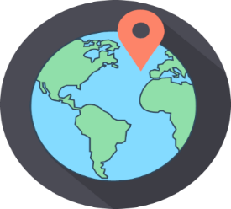
Year 5 – Autumn 1: North America
Key Theme

Core Value Focus
Creative, Critical Thinking, Curious, Resilient, Emotionally Healthy

Sticky Knowledge & Skills
- There are 23 countries in North America, with Canada being the biggest by land mass and the USA the biggest by population
- Mexico City is the largest city, with more than 9 million people living there
- Before the Europeans arrived, the indigenous native Americans lived in the continent. Today only about 2% of US Americans consider themselves as descendants from native Americans.
- Greenland is not only the largest island in North America, but also the world!
- The Missouri River is the longest in North America and flows through 7 US states. Denali is the highest mountain in North America
- Lake Superior, which borders Canada and the USA, is the third largest lake in the world and the largest in North America

Key Vocabulary
Weather | Day to day conditions in a certain place, e.g. sunny, rainy
Equator | An invisible line equidistant from the North and South poles which divides Earth into the Northern and Southern Hemispheres
Climate | Weather patterns in a certain place which are measured over a period of time
Country | An area that is controlled by its own government
Continent | A large landmass made up of many countries
Flora/fauna | Plant and animal life
Latitude | Imaginary parallel lines which circle the globe from east to west.
Longitude | Imaginary lines which run north to south across the globe from pole to pole
Biomas | Large geographical area which is home to certain plants and animals specifically adapted to suit the environ

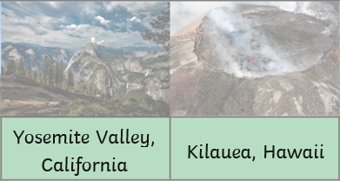
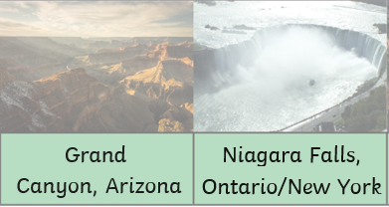
10 biggest countries in North America:
Canada, USA, Mexico, Nicaragua, Honduras, Cuba, Guatemala, Panama, Costa Rica, Dominican Republic.

Links to past and future learning
In Year 4 we learnt about climate zones, the equator and the tropics, and about the tilt of the Earth. In Year 6 we will learn about the main countries in Africa, Asia and Australasia/Oceania, and identify their main environmental regions

Key Texts

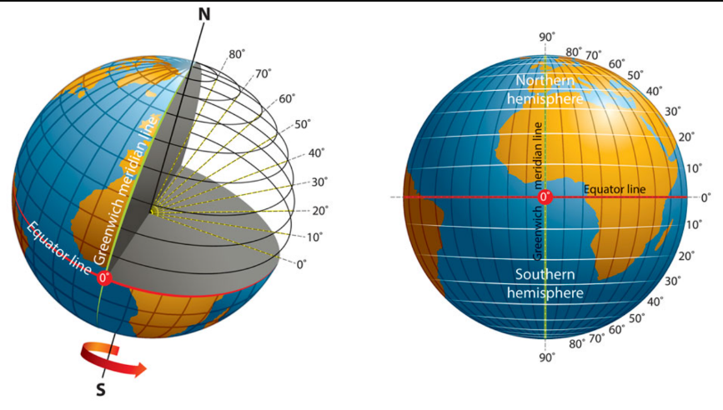

Watch a video about the longitude and latitude here!

Geography |  | Science |  | RE
How many countries are there in North America?  What is the biggest country by land mass in North America?  What is the largest city in North America and how many people live there?  What is the longest river in North America?  The biggest island in the world is in North America; what is it?  Can you name the 10 biggest countries in North America?  What is the Koppen system?  What is a climate?  What are the 5 main climate types? | 23  Canada  Mexico City; 9 million  The Missouri River  Greenland  Canada, USA, Mexico, Nicaragua, Honduras, Cuba, Guatemala, Panama, Costa Rica, Dominican Republic.  A way of classifying climates  The usual or average weather conditions over a long time.  Temperate, continental, polar, tropical and dry | What is a force?  Name 3 types of force:  Why do unsupported objects fall towards the Earth?  If there is greater friction between two surfaces they will move ________  A parachute slows someone jumping out of a plane due to what force? | Something that pushes or pulls something else.  Air resistance, water resistance, friction, gravity, magnetism  Gravity  Slower  Air resistance | What does theist mean?  What does agnostic mean?  What does an atheist believe?  Give 1 reason  A) Why somebody would believe in God.  B) Is yet to decide about God  C) Does not believe in God  Define fact / opinion and belief | A theist believes in God  An agnostic cannot say if God exists or not – still to decide  An atheist does not believe in God  A1) May think there is more to life than what is on earth A2) Know that there is more than just us and their faith guides them  A3) God is unknowable  B1) May need more evidence to make a decision  C1) Believes in following reason and science.  C2) Needs evidence; no-one has shown them evidence of God  A fact can be proven, an opinion is something that a person thinks – e.g. Dogs are better than cats, a belief cannot be proven but is accepted as a fact – Christians believe Jesus is the son of God

