# H:\Logo.jpgYear 2 – Spring 1

|  |
| --- |
| **Key Theme** |
|  |

The Dragon Machine & Why is our world wonderful

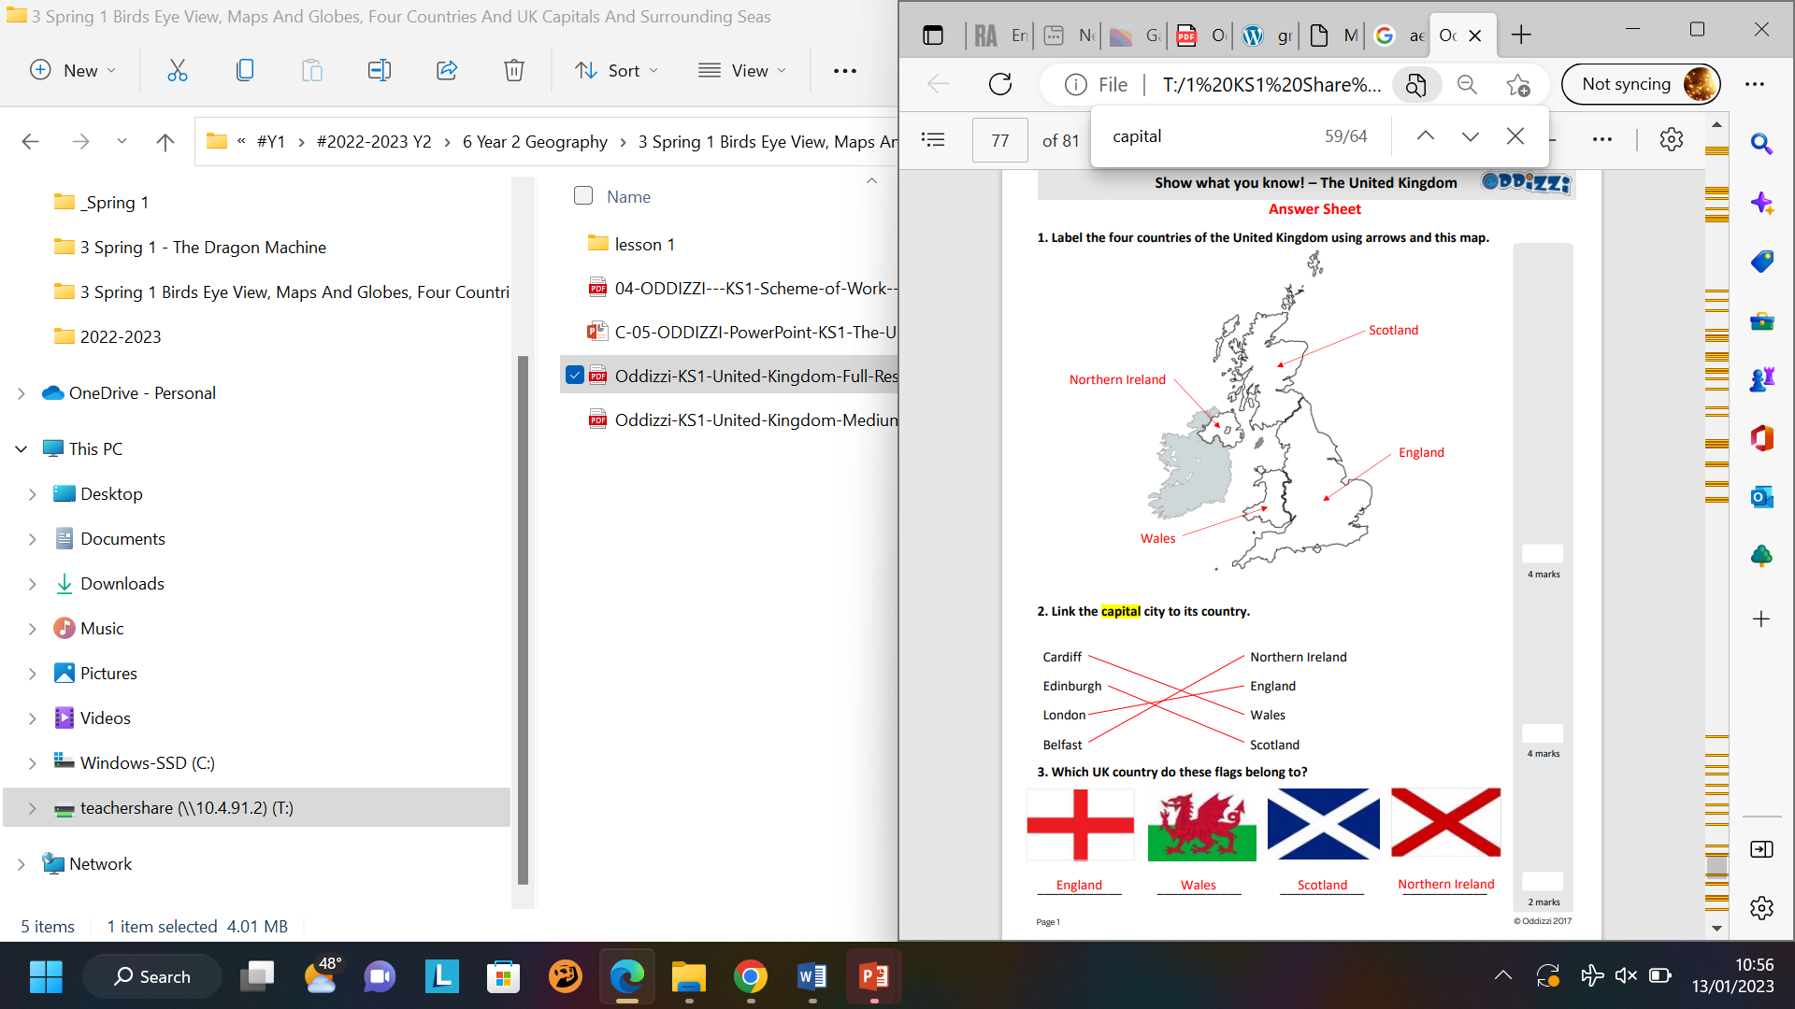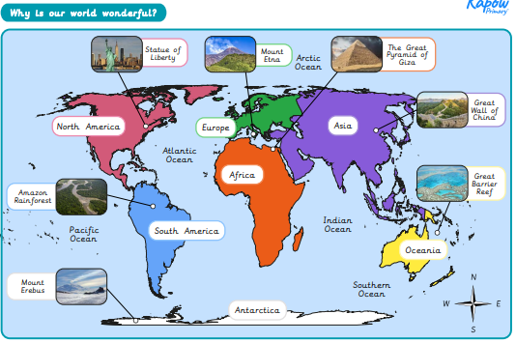 `

|  |
| --- |
| **Core Value Focus** |
| Curiosity, critical thinking, resilience, compassion. |

|  |
| --- |
| **Key Texts** |
|  |

|  |  |
| --- | --- |
| **Key Vocabulary** | |
| Machine | A device with parts that work together to perform a task |
| Troublesome | Causing worry or bother |
| Wreckage | What is left of something that has been destroyed |
| Human feature | Made by man |
| Physical feature | A natural feature |
| Aerial photograph | A photo/picture taken from above |
| Land | Part of the Earth’s surface not covered by water |
| Ocean | A body of water |
| Landmark | Landmarks are features or structures around the world that are easily recognised or unique. |
| Capital city | A capital city is where the government are based. |
| Country | An area of land with its own borders. |

|  |
| --- |
| **Links to past and future learning** |
| In Y1 we learnt about   * hot and cold places and the equator * the seasons   In Y2 we have learnt about   * our place in the world (me, my town, the nearest city, my country, my continent, the world)   In Y3 we will learn about   * the counties and cities of the UK (geographical regions) * their human and physical features |

|  |
| --- |
| **Sticky Knowledge & Skills** |
| What is a human feature?  Can you give 3 examples?  What is a physical feature?  Can you give 3 examples?  Can you name the 7 continents?  Which of them do you live in?  Can you name any of the oceans? |

|  |  |  |  |  |  |
| --- | --- | --- | --- | --- | --- |
| **Geography- Why is our world wonderful?** | | **Science – Plants (light and dark)** | | **RE- Who is a Muslim and what do they believe? (part 1)** | |
| What are the 5 oceans?  What are the 7 continents?  Which continent do we live in?  What are the capital cities of the United Kingdom?  What are the oceans and seas around the United Kingdom?  Name 3 human geographical features  Name 3 geographical physical features | Atlantic, Pacific, Indian, Southern and Arctic  Asia, Africa, North and South America, Antarctica, Europe, Australasia  Europe  London, Edinburgh, Cardiff and Belfast.  Atlantic Ocean, North Sea, Irish Sea and Channel  E.g. house, village, road, school, bridge  E.g. Forest, mountain, beach , river | What grows into new plants?  What do plants need to grow healthily?  What is germination? | Bulbs and seeds  Water, light and a suitable temperature  When seeds begin to turn into plants | Who do Muslims worship?  What is the Muslim holy book?  Whose teachings do Muslims follow?  Who gave the messages of the Qur'an to Prophet Muhammad?  How many pillars of Islam are there?  What is the pillar of Islam about belief? | Allah (pbuh)  The Qur'an  Prophet Muhammad  Angel Jibril  5  The Shahadah |