|  |
| --- |
| **Core Values** |
|  |

# H:\Logo.jpgReception – Autumn 1; All About Me

|  |
| --- |
| **Key Theme** |
|  |

|  |
| --- |
| **Cultural/Seasonal celebrations** |
| Autumn  Harvest Festival |

|  |
| --- |
| **Cultural/Seasonal Sticky Knowledge**  **Our teachers are helping us…** |
| * To know that leaves change colour and fall off trees in Autumn. |

|  |
| --- |
| **Topic Sticky Knowledge**  **Our teachers are helping us…** |
| * To know similarities and differences between themselves and others. * To know what makes a healthy bedtime routine – brushing teeth, story, sleep. |

|  |
| --- |
| **We are also learning to…** |
| * Be more independent   + put our own coat on   + manage my own toileting needs |

|  |
| --- |
| **In Phonics we are learning …** |
| these phonemes – **s, a, t, p, i, n, m, d, g, o, c, k, ck, e, u, r**  these high frequency words – **a, as, at, in, it, I, an, and, dad, am, to, into, go, no, the, can, got, on, get, not, cat, dog** |

|  |
| --- |
| **Links to past and future learning** |
| The children will build on their personal, social and emotional development gained from previous early education or nursery settings to enable them to leave their main carer confidently, build new relationships within school and learn new routines. |

|  |
| --- |
| **In Maths we are learning to …** |
| * subitise (represent the number in a given set using different objects; name quantities with number words; match sets to numerals; make own arrangements to subitise) * count (developing 1:1 correspondence, by counting numbers at the same time as moving or tagging the objects) * know how numbers can be composed of 1s * compare 2 sets of objects using more than, fewer than * represent and compose numbers 2, 3, 4, 5 * sort and match objects |

|  |
| --- |
| **Key Texts** |
|  |

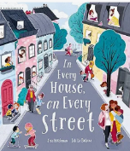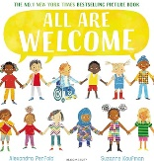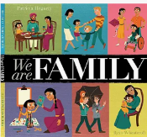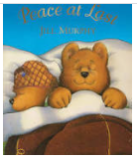

|  |  |
| --- | --- |
| **Key Vocabulary** | |
| Different  Special  Likes  Family  Home  Town/village/city  Bedtime  Tired | Similarities  Interests  Siblings  Community  Journey  Routine  Peace |

|  |
| --- |
| **Suggested Texts: fiction, non-fiction, poems & rhymes** |
| Home by Carson Ellis  My Map Book by Sara Fanelli  A Place Called Home by Kate Baker  Starting school books e.g.  The Colour Monster  The Everywhere Bear  Seasonal books e.g.  Leaf Man,  Red Leaf, Yellow Leaf |