# H:\Logo.jpgYear 1 – Spring 1: The Lion Inside

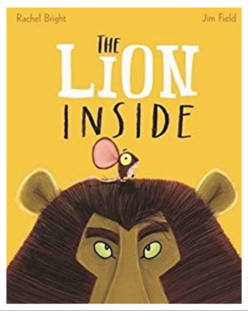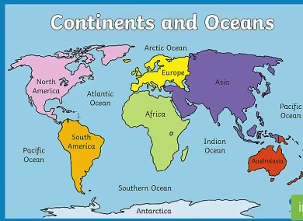

|  |
| --- |
| **Core Value Focus** |
| Creativity, critical thinking, curiosity, resilience, emotional heath. |

|  |
| --- |
| **Art and D&T Knowledge/ Key questions** |
| * Artists living at different times can be inspired by similar stories and themes. * A 3d work of Art is called a sculpture. Masks are a type of sculpture.   Designers create to meet a design criteria.  Artists and designers choose the materials that they think will work best for their design. These help it look how they want and work how they want.  Paper can be changed from 2D to 3D by folding it, rolling it and scrunching it.  Paper can be shaped by cutting it and folding it.  Artists and designers using folding, layering and joining to make materials stronger, stiffer and to add stability to what they are making.  Artists and designers need to think about how to glue paper to make 3D structures. They also think about how they arrange materials to add interest.  Artists and designers use a variety of techniques such as paper spirals, zigzags and tubes.  Artists and designers think about and choose which tools to use and choose certain tools for a reason.  Artists paint with good technique and coverage to make work of high quality. |

|  |
| --- |
| **Science Sticky Knowledge/key questions** |
| We have named the parts of the human body.  Can you name a mammal and one of their features?  Can you name a fish and one of their features?  Can you name an amphibian and one of their features?  Can you name a bird and one of their features?  Can you name a reptile and one of their features?  Can you say which group a given animal belongs to?  What does a carnivore eat?  What does a herbivore eat?  What does an omnivore eat?  Can you give an example of a carnivore?  Can you give an example of a herbivore?  Can you give an example of an omnivore? |

|  |
| --- |
| **Geography Sticky Knowledge** |
| We have looked at the compass directions to navigate a map.  Can you point to the UK on the map of the world?  Can you name and point to the 4 countries in the UK on a map?  Can you name the 4 capital cities linked to the 4 countries in the UK?  Can you name the 4 seasons and talk about sign you might notice during each season?  Can you name an appropriate item of clothing you would wear in each season? |

|  |
| --- |
| **Key Theme** |
|  |

|  |  |
| --- | --- |
| **Key Vocabulary** | |
| toothsome | Tasty or attractive. |
| slumber | To sleep lightly. |
| whimper | To make a series of low, small sounds showing fear, pain, or unhappiness. |
| foe | An enemy or opponent. |
| mane | Long hair on the neck of a horse, lion, or other mammal. |
| continent | Any of the world's main continuous expanses of land. |
| atlas | A book of maps or charts |
| week | A period of seven days beginning with Sunday and ending with Saturday. |
| plain | Not decorated or elaborate; simple or basic in character. |



|  |
| --- |
| **Key Texts** |
|  |

|  |
| --- |
| **Links to past and future learning** |
| In Reception we learnt to make observations of animals and we started learning what seasons are and key changes related to the seasons. In Y1 we are developing a broader awareness of these changes and explaining the changes that come from these.  In Reception have explored that modelling materials can be shaped using hands or tools. We have explored the properties of malleable materials such as dough and clay and can represent things in real life. We have created sculptural works using found objects during our forest sessions. We have explored techniques for joining paper and card. |

|  |  |  |  |  |  |
| --- | --- | --- | --- | --- | --- |
| Geography | | Science | | RE | |
| What are the 4 seasons?  What is the weather like in the different seasons?  What are the countries of the United Kingdom?  What are the capital cities of the United Kingdom?  Can you find the swimming pool, KS1 building and the football pitch on an aerial photo of the school?  Can you draw a simple map of the classroom? | Spring, Summer, Autumn, Winter  Spring: Windy, wet. Summer: Hot. Autumn: Colder, wet. Winter: Cold  England, Scotland, Wales and Northern Ireland  London, Edinburgh, Cardiff and Belfast. | Can you point to your head, neck, arms, elbows, legs, knees, face, ears, eyes, hair, mouth, teeth  What are the 5 most common senses?  Can you identify whether these are fish, amphibians, reptiles, birds or mammals?  Snake, mouse, penguin.  Which of these are carnivores, herbivores and omnivores? Human, shark, sheep  How are cats, fish and birds the same and different?  Can you name a fish, amphibean, reptile, bird and mammal.  Can you name a carnivore, herbivore and omnivore? | Child can point to the correct body parts  Taste, touch, sight, hearing, smell  Snake (reptile), mouse (mammal), penguin (bird).  Human (omnivore), shark (carnivore), sheep (herbivore)  Bones, feathers, fur etc.  E.g. goldfish, frog, gecko, sparrow, human  Carnivore: e.g. lion, tiger, leopard. Herbivore: e.g. goat, horse. Omnivore: e.g. human, pig, bear. | What is the symbol of Judaism?  What is the Jewish holy book?  What is a Mezuzah?  What is Shabbat?  What is Chanukah?  How may days does Chanukah last for? | The Star of David  The Torah  A parchment with part of the Torah on it  The Jewish day of rest  The Jewish festival of lights  8 |