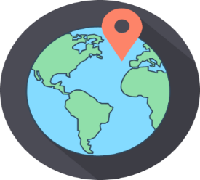
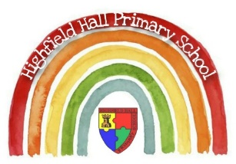
Year2 – Autumn 2:
Key Theme

The Owl Who Was Afraid of the Dark
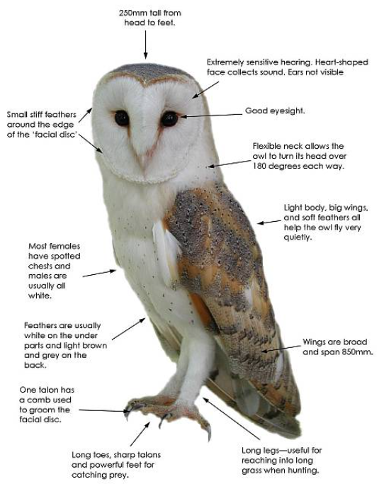
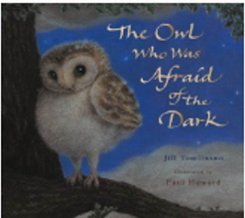
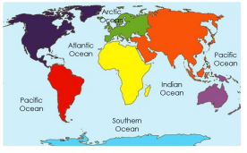
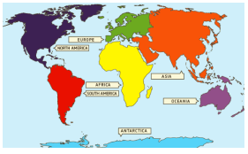
Key Texts

Find out more about barn owls here!
Core Value Focus
Compassion, critical thinking, curiousity

Links to past and future learning
In Year 1 we named the four countries of the UK and the surrounding seas. In Year 1 we learnt about chronology and that things change over time.
In Year 3 we will build on our knowledge of the UK and the wider world. We will begin to study how modern Britain came to exist

Sticky Knowledge & Skills
- The world is made up of many countries. Countries can be grouped into continents.
- Large amounts of water between each continent are called oceans
- Some of the continents are joined by land, and others are separated by oceans
- There are 7 continents: Asia, Africa, North and South America, Antarctica, Europe, Australasia/Oceania
- There are 5 oceans: Pacific, Atlantic, Indian, Southern, Arctic
- Physical features are created by nature
- Human features are created by people

Key Vocabulary
Barn owl | A type of owl, which is a bird of prey
Telescope | A tool to make distant objects, like stars and planets, appear nearer
Startled | Feeling or showing shock
Campfire | An open air fire used for cooking and heat
Supper | An evening meal (usually a small one)
Bleary | Feeling unfocussed due to sleep or tiredness
Enormous | Big, huge, massive, gigantic!
Necessary | Needing to be done

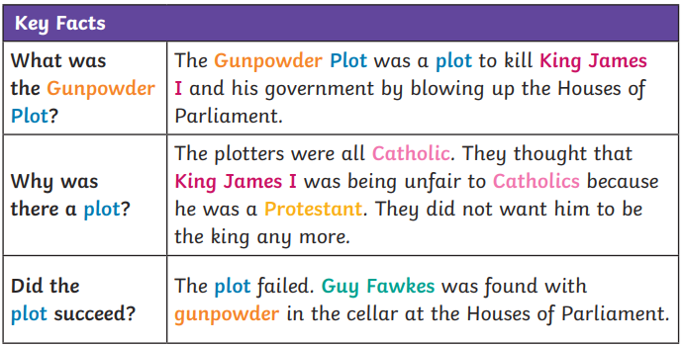
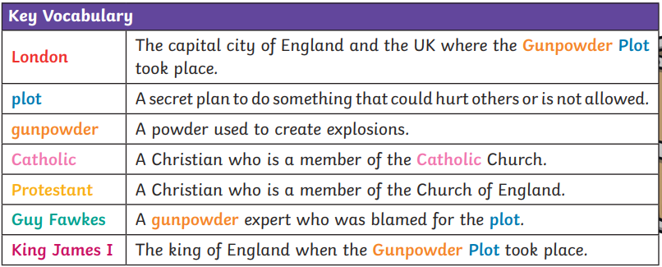
Events Beyond Living Memory: The Gunpowder Plot
Watch a video about the Gunpowder Plot here!

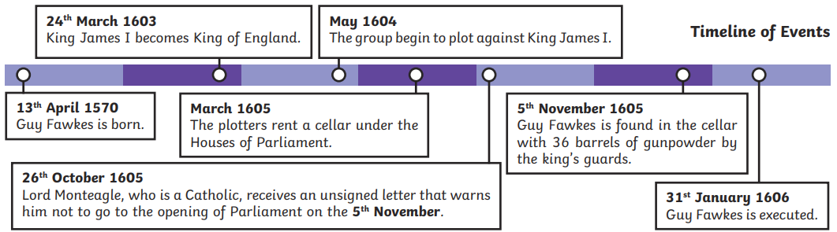

Geography |  | Science |  | RE
What are the 7 continents of the world called?  What are the 5 oceans of the world called?  Where is England on a world map?  Which continent is England in?  Name a human feature of each continent.  Name a physical feature of each continent. | Asia, Europe, Australasia, South America, North America, Antarctica.  Pacific, Atlantic, Indian, Southern, Artic.  Locate on a map.  Europe.  Asia – Taj Mahal, The Great Wall of China  Europe – Eiffel Tower  Africa – pyramids  Australasia – Sydney Opera House  South America – Statue of Christ the Redeemer  North America – The Statue of Liberty  Artic – Science base  Asia – Mount Everest  Europe – The White Cliffs of Dover  Africa – Victoria Falls  Australasia – Coral Reef  South America – Amazon Rain Forest  North America – The Grand Canyon  Artic – ice sheet/snow | Can you name 3 animals and their offspring?  What are the 5 different animal groups?  What is the life cycle of a frog?  What is the life cycle of a bird?  What is the life cycle of a butterfly?  How do the adult and young differ? | Cow/calf, Frog/tadpole, Goat/kid, Owl/Owlett, caterpillar/Butterfly Swan/signet  Reptiles, amphibians, Birds, Fish, Mammals  Frogspawn, tadpole, froglet, frog  Egg, hatchling, chick, adult  Egg, caterpillar, chrysalis, butterfly  Accept a range of answers showing understanding linked to the animal of choice. | Which religion celebrates Passover?  What does Passover celebrate?  Which religion celebrates Eid?  What do Muslims do during Ramadan? | Judaism  Moses leading the Jewish people to freedom from slavery.  Islam, Muslim  Fasting from sunrise to sunset, pray more, donate  money to charity, do good deeds.

