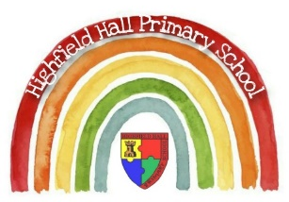
Year 2 Major Glad, Major Dizzy
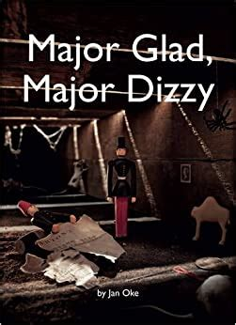
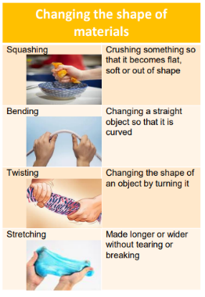
Knowledge & Skills
Science
- We can look at how the shape of objects can be changed
- What skills can we use to change the shape of an object?

Key Vocabulary
adventurous | To explore new experiences
fortunate | Lucky, well off
empire | A group of countries ruled by a single monarch
sampler | An embroidered piece using different stitches to show skill
horseless carriage | A car
axle | A rod which passes through he centre of a wheel or wheels
mechanism | A group of parts working together in a machine
wheel | A circular object that revolves on an axle. Found on a vehicle or machine

Links to past and future learning
- In History we learnt about Guy Fawkes.
- Then we have learnt about the Great Fire of London.
- In Music we learnt about popular music in the 60s.
- This term we will learn about key events in history such as queen Victoria becoming queen, WW1, WW2, Space Travel.
- We will look at interesting vehicles from the past and use our modelling skills to create them from recycled materials thinking about how to join materials together.
- We will learn what the key parts of a vehicle are.

Knowledge and Skills
History
- Place key events in history on a timeline.
- Use words such as before, after, past, present, now and then to describe.
- Use the words past and present correctly.
- To recall some interesting details about the key events on the timeline.

Key Texts

Key Theme

Core Value Focus
Curiosity, critical thinking, resilience, compassion.

History |  | RE
What key events happened in Victorian times?  What was life like in Victorian times?  What key events happened in the 1910s?  What was life like?  What key events happened in the 1940s?  What was life like?  What key events happened in the 1960s?  What was life like in the 1960s?  What key events happened in 2010s?  What was life like? | Queen Victoria was queen. Hospitals were not hygienic. Florence Nightingale helped to change nursing and hospitals.  Railways were new. Girls and boys played with different toys.  WW1.  Children helped with the war. War toys were popular like toy soldiers, teddy bears in national uniform, red cross dolls, cannons, aeroplanes, battleships and tanks. There was no TV and few radios  WW2 or The Blitz  There were blackouts where people had to turn out their lights during the air raids. Children were evacuated to the countryside. They weren’t able to take many toys.  In the 60s film and music was very popular. The space race and moon landing was a key event.  Travelling to space was becoming more and more possible. Children enjoyed playing with space toys. People listened to new music like the Beatles music on record players.  The Summer Olympics happened in London. The Queen Elizabeth Olympic Park was built. There were many forms of transport. | What do Christians believe in?  What do Christian believe about God?  Can you retell a story from the bible that shows what Christians might think about God? Challenge: Suggest what the story might mean?  EASTER  Why did Jesus die at Easter? | Christians believe in God and follow the example of Jesus.  All-powerful, loving, forgiving, close to every person.  Retell either: The Lost Sheep or The Good Samaritan.  To restore people’s broken friendship with God.

