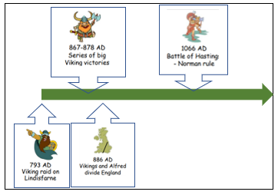
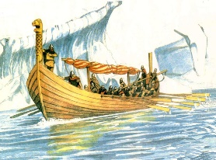

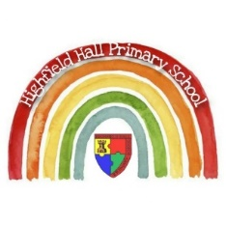
Year 5 – Spring 1: Who were the Vikings?
Links to past and future learning
In year 4 we learnt about the Romans Invasion and the impact it had on life in England
In Year Autumn 2 we learn about the Anglo Saxons
In year 6 we will learn about the modern conflict which impacted Britain; WW2.

Sticky Knowledge & Skills
- I know the Vikings arrived in England in the late 8th Century starting with a raid on Lindisfarne – a holy settlement.
- The word Viking means raider but they were also traders and settlers.
- For many years they fought hard against the Saxons for control of England but were stopped by Alfred. They then settled in the East with some becoming kings of England at the end of the Saxon period.
- They did not worship a single god but made offerings to a large number such as Odin (Wednesday named after him) Thor ( Thursday )and Freya (Friday). As time went on, many converted to Christianity.
- I can explain why different people had a different image or opinion of the Vikings

Viking Longships
- for trading, exploring and raiding
- used oars and sails
- dragon head to intimidate enemies and ward off evil spirits

Key Vocabulary
danegeld | Money paid by Saxons to bride the Vikings into not attacking their land.
Danelaw | A large part of Eastern England where the Danes settled in the late 9th Century with their own laws and cultures
heathen | A person that does not accept a religion that says there is only one God.
hoard | Hidden collection of treasure
pagan | A person who believes in more than one god
runes | Viking alphabet
saga | Long story about Viking heroes, spoken at first but later written down

Key Theme

CARE Value Focus
Aspirational
Respect

Key Texts
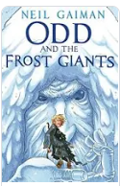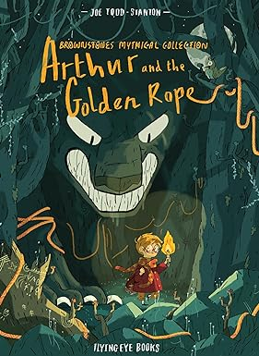

Science |  | History |  | RE
What is gravity?  What exerts a gravitational pull?  What impact does gravity have on things on the Earth?  What is friction?  What effect does friction have?  Smooth surface usually generate _____ friction than rough surfaces  What is a mechanical advantage?  What benefit does a mechanical advantage have? | The force of attraction by which a planet or other body draws objects toward its centre  Anything with a mass  Earth's large mass exerts a gravitational pull on all objects on Earth, making dropped objects fall to the ground.  A force between two surfaces as they move over each other.  It slows a moving object  Less  A measurement of how much a simple machine multiplies the force that we put in.  The bigger the mechanical advantage, the less force we need to apply. | What is a priory?  Who lived on Lindisfarne?  When did the Vikings attack Lindisfarne, and what happened?  Why did the Vikings attack Lindisfarne?  When did the Vikings attempt to conquer England?  Name some of the kingdoms that 'England' was split into before 927AD  What was Danelaw?  Name some of the Viking gods  What is the Viking version of heaven? | A place where monks and nuns live  Monks  In 793, the Vikings attacked Lindisfarne, stole from the local people and burned down their buildings.  Because the priory was full of precious religious objects  From around 868 to 1044  E.g. Wessex, Northumbia, Mercia  The name of the area of England that officially belonged to the Vikings after 878  E.g. Odin, Thor and Freya  Valhalla | 1.What is meant by the term ‘code for living’  2.What does moral mean?  3.What is a Humanist?  4.What is the Humanist code for living?  5.What codes for living do Christians follow?  6.Who were Adam and Eve?  7.What did Adam and Eve do that displeased God? | 1.a set of principles /rules you follow when deciding how to behave  2.To do with what is right and what is wrong in how a person acts.  3.Humanists do not believe in a god.  They do not follow a holy book.  Humanists value things like reason and rely on science to explain the way things are.  4.Be honest, use your mind, tell the truth. Do to other people what you would like them to do to you.  5.Love, forgiveness, peace between people and God, honesty, prayer, worship and togetherness.  6.Adam and Eve were the first man and woman and were made by God on the sixth day of Creation.  7.They sinned by eating the forbidden fruit from the tree of knowledge.

