# H:\Logo.jpg Year 6 –

# Autumn 1: Is it ever right to fight?

|  |  |
| --- | --- |
| **Sticky Knowledge & Skills** | |
| 1939 | * Hitler invades Poland * Britain declares war on Germany |
| 1940 | * Rationing begins * Dunkirk evacuation * Battle of Britain * Blitz begins |
| 1941 | * Blitz ends |
| 1944 | * D-Day (6th June) |
| 1945 | * Germany surrenders * V.E. Day (8th May) * V.J. Day (15th Aug) |
| 1954 | * Rationing ends |

|  |
| --- |
| **Key Theme** |
|  |

|  |
| --- |
| **Core Value Focus** |
| Curiosity, critical thinking, resilience, compassion. |

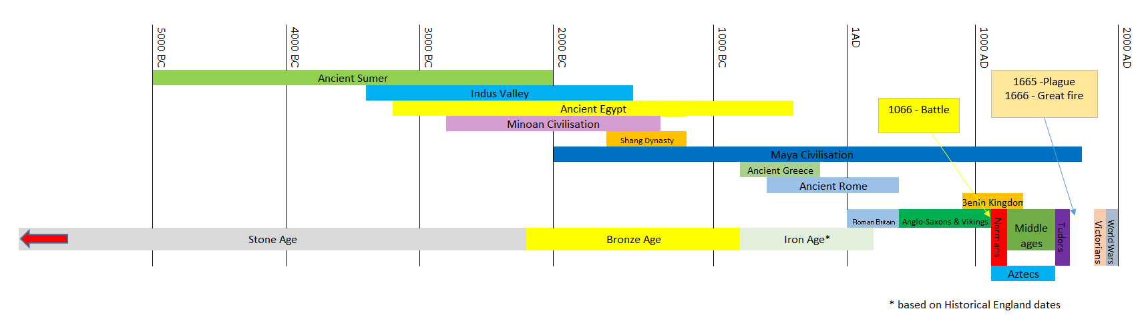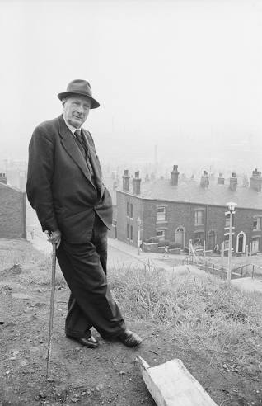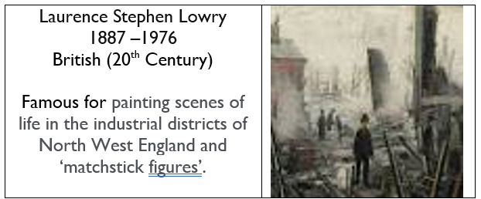

|  |
| --- |
| **Key Text** |
|  |

|  |  |
| --- | --- |
| The Allies | The Axis |
| * France * Great Britain * United States * Soviet Union * China | * Germany * Italy * Japan |

|  |  |
| --- | --- |
| **Key Vocabulary** | |
| Blitz | the heavy bombing of British cities by German aircraft |
| Dictator | a person who rules with total power and often in a cruel manner |
| Evacuation | to evacuate someone means to send them to a place of safety |
| Invasion | to try and take over a place by force |
| Jew | a person who is of Jewish heritage or who has converted to the Jewish religion |
| Nazi | a member of the far-right political party in Germany |
| Prime Minister | the leader of the government |
| Rationing | The controlled distribution of scarce resources (mainly food & clothing) |

|  |  |  |  |  |  |
| --- | --- | --- | --- | --- | --- |
| History | | Science | | RE | |
| What were the dates of World War II?  Match the individuals to their role?     |  |  | | --- | --- | | Lilian Bader | Spy and Resistance Agent for the British Government | | Neville Chamberlain | British Prime Minister (end of war) | | Winston Churchill | British Prime Minister (outbreak) | | John ’Polly’ Flinders | One of the first women in the British Armed Forces | | Adolf Hitler | German dictator- leader of Nazi Party | | Noor Iniyat Khan | Local Spitfire and Hurricane Pilot who participated in the Battle of Britain |   Name the axis and allies countries  Name a law that was applied to the Jewish people in the build up/ beginning of the war and explain how this affected their rights? | 1939-1945   |  | | --- | | Lilian Bader  - One of the first women in the British Armed Forces | | Neville Chamberlain - British Prime Minister (outbreak) | | Winston Churchill - British Prime Minister (end of war) | | John ’Polly’ Flinders  Local Spitfire and Hurricane Pilot who participated in the Battle of Britain | | Adolf Hitler - German dictator- leader of Nazi Party | | Noor Iniyat Khan - Spy and Resistance Agent for the British Government |   Axis: Germany, Italy, Japan  Allies: Great Britain, United States, Soviet Union, China, France   * Cannot drive cars * Cannot own pets * Can be thrown out of home at any time * Cannot attend university * Cannot own a radio | **Light**:  Light travels in a ________________ line.  C:\Users\mike.bywaters\AppData\Local\Microsoft\Windows\INetCache\Content.MSO\9B2ADA1E.tmp  C:\Users\mike.bywaters\AppData\Local\Microsoft\Windows\INetCache\Content.MSO\3E562BDC.tmp  Describe what happens and what is created when an opaque object is put in front of a light source.  Describe how the size of the shadow changes as an opaque object is moved closer to the light source. | Straight  C:\Users\mike.bywaters\AppData\Local\Microsoft\Windows\INetCache\Content.MSO\7ADF6A4A.tmp  C:\Users\mike.bywaters\AppData\Local\Microsoft\Windows\INetCache\Content.MSO\4DF928E8.tmp  A shadow is formed/ created. The opaque object blocks the light from the source.  The closer the object is the larger/ bigger the shadow | Revision  What are the names of the Gospel Writers?  **The sermon on the mount**  What is a sermon?  What might the parable of the house builders teach Christians?  Matthew 22: 36-40  What are the two commandments that Jesus gave? | Matthew, Mark, Luke and John  A sermon is a talk where the person speaking tells others about God and how they should live their lives  When Christians do not obey Jesus, they are foolish. When they do, they are wise.  Love the Lord your God with all your heart and with all your soul and with all your mind.  Love your neighbour as you do yourself |