Pupil premium strategy statement 2024-2027

This statement details our school’s use of pupil premium (and recovery premium for the 2021 to 2022 academic year) funding to help improve the attainment of our disadvantaged pupils. It outlines our pupil premium strategy, how we intend to spend the funding in this academic year and the effect that last year’s spending of pupil premium had within our school.

School overview
Detail | Data
School name | Highfield Hall Primary School
Number of pupils in school | 379
Proportion (%) of pupil premium eligible pupils | 2025-2026: 33.6% (112 pupils)  2024-2025: 29.6% (106 pupils)  2023-2024: 32.7%  2022-2023: 31.9%
Academic year/years that our current pupil premium strategy plan covers (3 year plans are recommended) | 3 years (2024-2027)
Date this statement was published | September 2024
Date on which it will next be reviewed | September 2026
Statement authorised by | M Bywaters
Pupil premium lead | M Bywaters
Governor / Trustee lead | S Yeowart
Funding overview
Detail | Amount
Pupil premium funding allocation this academic year | £172,686
Recovery premium funding allocation this academic year | £0
Pupil premium funding carried forward from previous years (enter £0 if not applicable) | £0

Part A: Pupil premium strategy plan

Statement of intent
Ultimate Objectives
At Highfield Hall we want all of our pupils to leave us as rounded individuals who have a broad range of attributes. Whilst we want to narrow the attainment gap between disadvantaged and non-disadvantaged pupils, and on average for disadvantaged pupils in school to exceed nationally expected progress rates, we also want them to CARE (be compassionate, aspirational, respectful and emotionally healthy).

When making decisions about using Pupil Premium funding we consider the context of our school and the subsequent challenges faced. The Education Endowment Foundation guidance (2019) states; "Closing the attainment gap between disadvantaged children and their peers is the greatest challenge facing English schools. The gap is stubborn because its causes are entrenched and complex, and most lie beyond the control of schools and educators. However, it is clear that schools can make a difference." Added to this, there has been a widening of the attainment gap since the COVID pandemic (from 19% in 2019, to 21% in 2023 and 2024 for KS2 outcomes).

Common barriers to learning for disadvantaged children can be: less support at home, weak language and communication skills, lack of confidence, more frequent behaviour difficulties and attendance and punctuality issues. There may also be complex family situations that prevent children from flourishing. The challenges are varied and there is no “one size fits all”.

School use evidence-based approaches when spending the pupil premium funding. Impact is discussed termly. We used a tiered approach to supporting our disadvantaged pupils, with the primary focus being on the quality of teaching, supplemented by targeted academic support, and strategies to support with wider outcomes (see the EEF Guide to the Pupil Premium, 2019 – see below). Our teacher appraisal model has been based around staff carrying out supported experiments (action research projects). The focus for these is supporting our disadvantaged pupils.

Our curriculum is designed to give children the cultural capital to prepare them for their future success. Our curriculum is sequenced to support children in developing their key knowledge and skills, aligned to our core and British values (see https://www.highfieldhall.derbyshire.sch.uk/our-curriculum/).

Principles
• We ensure that teaching and learning opportunities meet the needs of all the pupils
• We ensure that appropriate provision is made for pupils who belong to vulnerable groups, this includes ensuring that the needs of socially disadvantaged pupils are adequately assessed and addressed
• In making provision for socially disadvantaged pupils, we recognise that not all pupils who receive free school meals will be socially disadvantaged
• We also recognise that not all pupils who are socially disadvantaged are registered or qualify for free school meals. We reserve the right to allocate the Pupil Premium funding to support any pupil or groups of pupils the school has legitimately identified as being socially disadvantaged.

Demography and School Context
Highfield Hall Primary is a community school located in Newbold, Chesterfield. Children can join our nursery from the term after their third birthday, and there are two classes in each year group from Reception to Y6.
The IDSR shows that the school is above average for FSM, above average for pupil base deprivation and well above average for school location deprivation.

The map below is colour coded according to which national decile they belong to: decile 1 being the most deprived and decile 10 being the least deprived (IMD rankings). Although there are areas near to the school which have lower than average levels of deprivation, many of the pupils come from the most lowest deciles, indicating high levels of deprivation. The school itself sits in the 2nd IDACI decile (Income Deprivation Affecting Children Index), indicating 80% of schools sit in less deprived areas than Highfield Hall.

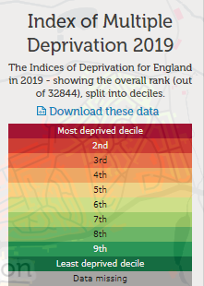
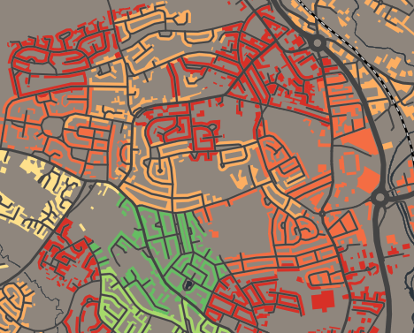
School

Challenges

This details the key challenges to achievement that we have identified among our disadvantaged pupils.
Challenge number | Detail of challenge
1 | Weak language and communication skills  On entry school, there is a gap between the speaking and communication skills of our disadvantaged vs non-disadvantaged pupils. By the end of EYFS, speaking was the area with the widest gap between the two groups (22% difference).
2 | Academic Attainment  Internal data show that attainment among disadvantaged pupils is significantly below that of non-disadvantaged pupils. IDSR found a significant difference between the attainment of FSM children at KS1 in reading and writing, and combined attainment at KS2.
3 | Phonics  Our data show that disadvantaged pupils did not achieve as well as non-disadvantaged pupils in the phonic screening assessments. This negatively impacts their development as readers.
4 | Early development  On entry to Reception class our disadvantaged pupils arrive below age-related expectations compared to non-disadvantaged pupils in the majority of the EYFSP areas. This gap closed by the end of Reception, but was still present. Assessments, observations, and discussions with pupils indicate underdeveloped oral language skills and vocabulary gaps among many disadvantaged pupils.
5 | Self-regulation  Our assessments and observations indicate that there has been an increase in social and emotional difficulties over the past few years, particularly among our more disadvantaged pupils. Self-regulation (cognition, metacognition and motivation) are reported by teachers to be an issue with a large number of our disadvantaged pupils.
6 | Attendance & Punctuality  Absence (overall and PA) has historically been higher than the national average. Whilst there has been an improving trend (PA went from being in the highest 20% in 2022, to not significant in 2023, and comparisons with similar levels of deprivation showed no significant difference in 2023), this is still a priority for school. Absence of disadvantaged pupils was higher than non-disadvantaged pupils last year.

Intended outcomes
This explains the outcomes we are aiming for by the end of our current strategy plan, and how we will measure whether they have been achieved.
Intended outcome | Success criteria
High levels of speech and communication skills for our disadvantaged pupils | There is a significant reduction in the gap between disadvantaged pupils and other pupils by the end of Reception, compared with starting points.
Consistent high attainment for disadvantaged pupils at the end of KS2.  For our disadvantaged pupils to make greater than average progress year on year in maths and English. | KS2 outcomes in all subjects show that percentage of disadvantaged children at Highfield Hall reaching the expected standard is above the national result for all children.  Sustained accelerated progress in the assessment data of our disadvantaged pupils, demonstrated by: teacher assessments every year, and National tests in Reception, Year 1, Year 4 and Year 6.
Phonics | Every year, the percentage of our disadvantaged children reaching the expected standard for their age is at or above the national result for all children in the Year 1 phonics check
Early development | The gap between children working at teh expected standard in all areas of the EYFS profile narrows through EY. Disadvantaged pupils’ GLD attainment is in line with ‘other’ pupils nationally by the end of Reception.
To achieve and sustain improved emotional wellbeing for all pupils in our school, particularly our disadvantaged pupils. | Sustained reduction in arguments and behaviour related to social and emotional difficulties, demonstrated by: Boxall profiles, data from CPOMS, qualitative data from student voice, parent surveys and teacher observations
Children attend well | Attendance at school is in line with or above national averages (overall and PA) for all groups

Activity in this academic year
This details how we intend to spend our pupil premium (and recovery premium funding) this academic year to address the challenges listed above.

Teaching (for example, CPD, recruitment and retention)
Budgeted cost: £13773
Activity | Evidence that supports this approach | Challenge number(s) addressed
Improving teaching and learning, particularly feedback, through coaching model / Walkthrus | Delivered through weekly professional development meetings, embedding formative assessment & peer coaching  Feedback (+6 months) | 2,4
Embedding dialogic activities across the school curriculum. These can support pupils to articulate key ideas, consolidate understanding and extend vocabulary.  We will fund release time for collaborative cpd. | There is a strong evidence base that suggests oral language interventions, including dialogic activities such as high-quality classroom discussion, are inexpensive to implement with high impacts on reading.  EEF – Oral Language Interventions  EEF – Collaborative Learning Approaches | 1,2,4
Continued implementation of Monster Phonics - a DfE validated Systematic Synthetic Phonics programme to secure stronger phonics teaching for all pupils. Training for all staff new to FS, KS1 or LKS2.  Ongoing development to ensure consistency and accuracy of the approach through work with the English Hub. | Phonics approaches have a strong evidence base that indicates a positive impact on the accuracy of word reading (though not necessarily comprehension), particularly for disadvantaged pupils.  EEF - Phonics | 2,3,4
Explicit teaching of reading fluency | Evidence shows that reading speeds need to be at a minimum level for good comprehension. Reading comprehension strategies +6 months | 2
Social and emotional teaching through My Happy Mind | Social and emotional learning (SEL) interventions seek to improve pupils’ decision-making skills, interaction with others and their self-management of emotions, rather than focusing directly on the academic or cognitive elements of learning. Metacognition and self-regulation +7 months / social and emotional learning +4 months | 2,4,5,6
Update Pathways to Read | Reading comprehension strategies +6 months | 2
Access to high quality text in every classroom | In Improving Literacy in KS2, the EEF report that reading books aloud and discussing them is a purposeful speaking and listening activity to develop pupils’ language capability to support their reading and writing. | 1,2
Use of Monster Phonics, TT rockstars and Doodle for homework | Homework linked to classroom work +5 months | 2
ISAS training around supporting children with SEND needs | CPD to support staff with in class adjustments to support children with SEND needs | 2,5
CPD around mastery learning in maths | Mastery learning +5 months | 2
Additional TA sessions before school | Extending school time +3 months | 2

Targeted academic support (for example, tutoring, one-to-one support structured interventions)
Budgeted cost: £134185
Activity | Evidence that supports this approach | Challenge number(s) addressed
Small group tuition to allow teaching to be tailored to the particular strengths and needs of a small group of children, with the goal of accelerated progress in core English and Maths skills. | Studies in England have shown that pupils eligible for free school meals typically receive additional benefits from small group tuition (+4 months). | 1,2,3,5
Additional Monster Phonics sessions targeted at disadvantaged pupils in Key Stage 1 who require further phonics support (particularly bottom 20%).  Targeted intervention sessions for KS2 children who did not pass the phonic screen | Phonics approaches have a strong evidence base indicating a positive impact on pupils, particularly from disadvantaged backgrounds. Targeted phonics interventions have been shown to be more effective when delivered as regular sessions over a period up to 12 weeks:  EEF - Phonics | 2,3
Teaching assistant interventions | EEF toolkit: “Teaching assistants can provide a large positive impact on learner outcomes (however, how they are deployed is key)” + 4 months. We run “same day interventions” to support all children to plug gaps in order that they can access learning at the same level as their peers the next day. | 2,3
ELKLAN & NELI & Speech and Language oral language interventions | EEF toolkit: On average, oral language approaches have a high impact on pupil outcomes of 6 months’ additional progress.
Nurture provision to support some of the most vulnerable learners, identified through the Boxall Profile | Specialised programme of social and emotional learning (SEL) interventions seek to improve pupils’ decision-making skills, interaction with others and their self-management of emotions, rather than focusing directly on the academic or cognitive elements of learning  Metacognition and self-regulation +7 months  Behaviour interventions +4 months | 2,5
SEMH staffing e.g. forest schools | There is extensive evidence associating childhood social and emotional skills with improved outcomes at school and in later life (e.g., improved academic performance, attitudes, behaviour and relationships with peers)  Social and emotional learning +4 months | 1,2,3,5
Additional support for disadvantaged SEND pupils | Individualised instruction for SEND pupils over and above the High Needs Funding allocated by the Local Authority +4 months | 1,2,5
Reading plus intervention for targeted children in Y5 and Y6 | Reading comprehension strategies (+6 months), individualised instruction (+4 months) | 2

Wider strategies (for example, related to attendance, behaviour, wellbeing)
Budgeted cost: £24728
Activity | Evidence that supports this approach | Challenge number(s) addressed
Employ new Child and Parent Support Worker | Attendance monitoring. Early Help support from the Local Authority has ceased; parents still requiring additional support around attendance and signposting to other support services. | 5, 6
Embedding principles of good practice set out in the DfE’s Improving School Attendance advice.This will involve training and release time for staff to develop and implement new procedures and appointing attendance/support officers to improve attendance. | The DfE guidance has been informed by engagement with schools that have significantly reduced levels of absence and persistent absence. | 6
Improve the quality of social and emotional (SEL) learning through expanding the provision of MyHappyMind | Evidence suggests that children from disadvantaged backgrounds have, on average, weaker SEL skills at all ages than their more affluent peers. SEL interventions in education are shown to improve SEL skills and are therefore likely to support disadvantaged pupils.  EEF – Social and Emotional Learning | 3, 4
Free breakfast club and/or soft starts for those struggling with emotional regulation during transition / with social care involvement | Anecdotally this has made the ‘bridge’ between school and home easier, and allowed children to be settled and regulated before starting learning | 2,5,6
Subsidised costs for visits / wider curriculum opportunities | National research show a variety of experiences and opportunities can support learning at all levels. | 2,6
Behaviour interventions | EEF toolkit: Both targeted interventions and universal approaches have positive overall effects (+ 4 months). | 5
Contingency fund for acute issues. | Based on our experiences and those of similar schools to ours, we have identified a need to set a small amount of funding aside to respond quickly to needs that have not yet been identified. | All

Total budgeted cost: £169423

Part B: Review of outcomes in the previous academic year

Pupil premium strategy outcomes
This details the impact that our pupil premium activity had on pupils in the 2025 to 2026 academic year.
High levels of speech and communication skills for our disadvantaged pupils. There is a significant reduction in the gap between disadvantaged pupils and other pupils by the end of Reception, compared with starting points.
For Listening, attention and understanding, disadvantaged pupils increased from 22% at EXS at baseline, to 55% by the end of reception, an increase of 33%. However the gap between disadvantaged pupils and others did not close (non-disadvantaged also made a 36% increase).
In speaking, disadvantaged pupils increased from 33% at EXS at baseline, to 78% by the end of reception, an increase of 45%. Additionally, the gap between disadvantaged pupils and others closed significantly (45% increase for disadvantaged vs a 30% increase for non-disadvantaged).
Consistent high attainment for disadvantaged pupils at the end of KS2. For our disadvantaged pupils to make greater than average progress year on year in maths and English. KS2 outcomes in all subjects show that percentage of disadvantaged children at Highfield Hall reaching the expected standard is above the national result for all children. Sustained accelerated progress in the assessment data of our disadvantaged pupils, demonstrated by: teacher assessments every year, and National tests in Reception, Year 1, Year 4 and Year 6.

Context: Across school, 33% of disadvantaged pupils are also SEND. In Y6, 33% of disadvantaged pupils were SEND (11% had EHCP and 22% SEN K).

Attainment
Attainment was 44% for disadvantaged pupils, however this was an increase of 33% from baseline.

Phonics attainment was 82% for disadvantaged pupils, above the national average.

Attainment at KS1 was 80%, 67% and 80% for disadvantaged pupils for reading, writing and maths respectively (broadly in line with or above national averages).

KS2
 | DAP | All | Difference
Reading EXS | 53 | 64 | 11
Writing EXS | 65 | 73 | 12
Maths EXS | 53 | 75 | 22

Phonics. Every year, the percentage of our disadvantaged children reaching the expected standard for their age is at or above the national result for all children in the Year 1 phonics check.

In Phonics, 82% of pupils passed the screening check. This is higher than the national average for all pupils. Only two disadvantaged children did not pass; one scores 26 and one score 28, giving them an excellent chance of passing in Year 2.

 | Nat (all) | All | Girls | Boys | PP | SEND | EAL | Social Care | 96%+ | 90%-95.9% | PA
GLD | 68 | 70 | 91 | 55 | 44 | 40 | 40 | 40 | 95 | 59 | 43
Phonics Y1 | 80 | 88 | 95 | 83 | 82 | 80 | 100 | 100 | 96 | 81 | 75
KS1 R EXS |  | 74 | 74 | 75 | 80 | 50 | 100 | 50 | 76 | 70 | 63
KS1 W EXS |  | 66 | 78 | 54 | 67 | 20 | 100 | 25 | 67 | 65 | 63
KS1 M EXS |  | 77 | 74 | 79 | 80 | 40 | 100 | 25 | 81 | 75 | 63
KS1 R GDS |  | 15 | 9 | 21 | 13 | 0 | 17 | 0 | 21 | 19 | 10
KS1 W GDS |  | 9 | 4 | 13 | 7 | 0 | 17 | 0 | 10 | 10 | 0
KS1 M GDS |  | 19 | 13 | 25 | 13 | 0 | 33 | 0 | 29 | 10 | 13
MTC | 37 | 45 | 47 | 44 | 29 | 30 | 100 | 11 | 52 | 50 | 0
KS2 R EXS | 75 | 64 | 64 | 63 | 53 | 56 | 100 | 30 | 65 | 67 | 60
KS2 W EXS | 73 | 73 | 75 | 69 | 65 | 56 | 100 | 30 | 68 | 83 | 80
KS2 M EXS | 75 | 75 | 68 | 88 | 53 | 56 | 100 | 20 | 74 | 58 | 100
Combined GDS | 63 | 55 | 57 | 50 | 47 | 44 | 100 | 10 | 52 | 58 | 60
KS2 R GDS | 31 | 23 | 29 | 13 | 18 | 22 | 50 | 0 | 23 | 17 | 20
KS2 W GDS | 13 | 7 | 11 | 0 | 6 | 11 | 0 | 0 | 10 | 0 | 0
KS2 M GDS | 27 | 14 | 14 | 13 | 24 | 33 | 100 | 0 | 13 | 17 | 20
Combined GDS | 8 | 5 | 7 | 0 | 6 | 11 | 0 | 0 | 6 | 0 | 0

Early development. The gap between children working at the expected standard in all areas of the EYFS profile narrows through EY. Disadvantaged pupils’ GLD attainment is in line with ‘other’ pupils nationally by the end of Reception.
For context, a third of the disadvantaged children (3/9) had social care involvement during Reception, with one child being taken into care. 56% of the disadvantaged children also had SEND needs (4 at SEN Support and 1 with an EHCP), with 2 others on the ‘monitoring’ register.

At Baseline, 11% of the children were on track for GLD (1/9). By the end of Reception 44% met GLD (4/9). 77% of children closed the gap during Reception, showing accelerated progress.

To achieve and sustain improved emotional wellbeing for all pupils in our school, particularly our disadvantaged pupils. Sustained reduction in arguments and behaviour related to social and emotional difficulties, demonstrated by: Boxall profiles, data from CPOMS, qualitative data from student voice, parent surveys and teacher observations.
Boxall profiles reveal a significant improvement in all of the children who have access Nurture provision across the year.
Parent questionnaires revealed the vast majority of parents thought their children enjoyed school, were safe, that school understands their child’s needs, that children were encouraged to help others,
There were 6 children suspended, for a total of 7 days in 2025-2026. Five out of 6 children were disadvantaged. However none were suspended more than once (6 suspensions in total).
This is a significant reduction from 2024-2025 where 10 children were suspended with a total of 19 suspensions, and a total of 23 days. Eight of the children were disadvantaged. This in turn is a significant reduction from 2023-2024 (12 children suspended, with 32 suspensions and a total of 49.5 days, 9 disadvantaged children).
Children attend well. Attendance at school is in line with or above national averages (overall and PA) for all groups.
Systems and processes for monitoring and supporting families with attendance have been regularly reviewed (externally and internally) and have been found to be robust. However overall PP attendance was 91%. Removing 3 children from the analysis (1 with significant chronic fatigue, one who did not attend at all due to SEND needs and another with very low attendance due to SEND needs), this rises to 93%. Attendance remains a high priority for school for 2026-2027.

This details the impact that our pupil premium activity had on pupils in the 2024 to 2025 academic year.
To raise standards and promote outstanding progress for learners in all subjects with a special focus KS2
At the start of Reception in 2024, disadvantaged pupils were significantly behind their non-DAP peers in English and Maths. By the end of the year, DAP pupils outperformed non-DAP pupils in all areas except for number (2% difference). Disadvantaged pupils also outperformed non-DAP pupils in achieving GLD (67% vs 58%).
 | DAP  Autumn | Not DAP Autumn | DAP Summer | Not DAP Summer | DAP change | Not DAP change
Comprehension | 44% | 56% | 89% | 78% | 45% | 22%
Word Reading | 33% | 53% | 78% | 67% | 45% | 14%
Writing | 33% | 50% | 67% | 64% | 34% | 14%
Number | 56% | 61% | 67% | 69% | 11% | 8%
Numerical patters | 44% | 58% | 67% | 67% | 23% | 9%

In phonics, all children made accelerated progress, but this was particularly true of DAP pupils. With regards to the Phonic Screening Check, 71% of DAP pupils passed (compared with 79% of non-DAP pupils).

We set a target of 75% of DAP children achieving EXS at KS2; unfortunately we did not achieve these outcomes:
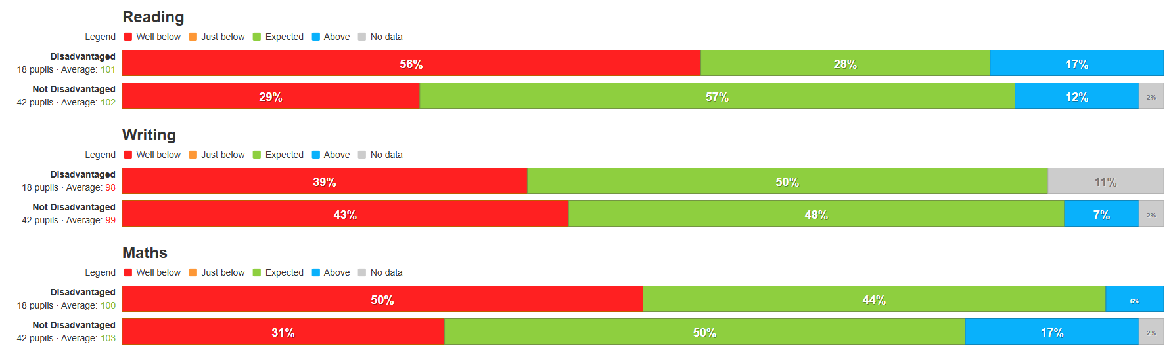

Children have improved oracy, including having a wide knowledge of age-appropriate tier 2 words.
Reception start of the year
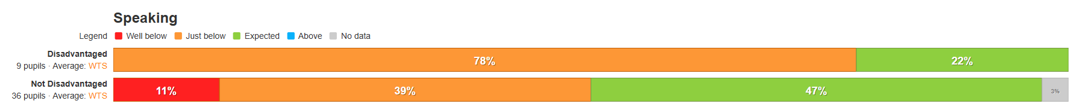
Reception Summer
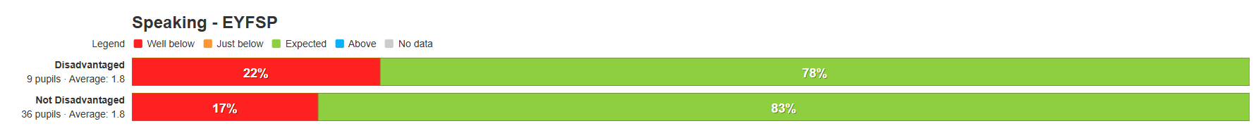Tier 2 vocabulary is displayed in all classrooms, and pupil interviews reveal that children know and can use a wider range of these words.
Phonics
As stated above, in phonics, no disadvantaged children were at ARE at the start of the year, and only 11% of not-DAP children were. By the end of the year, 78% of DAP pupils were, vs 89% of not-DAP (accelerated progress of 78% for both groups).
Start of the year
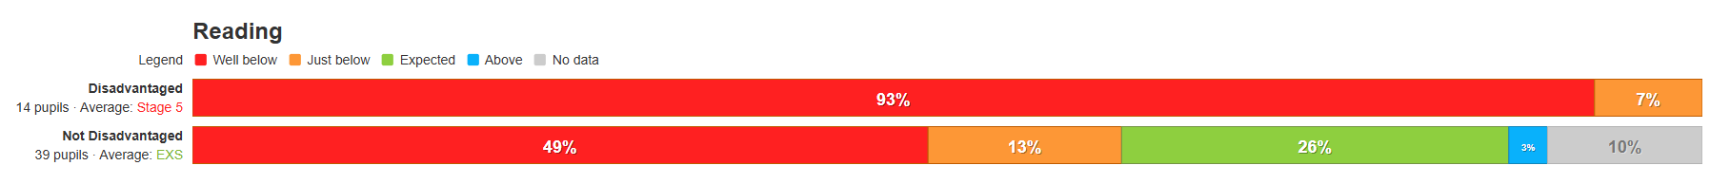Summer
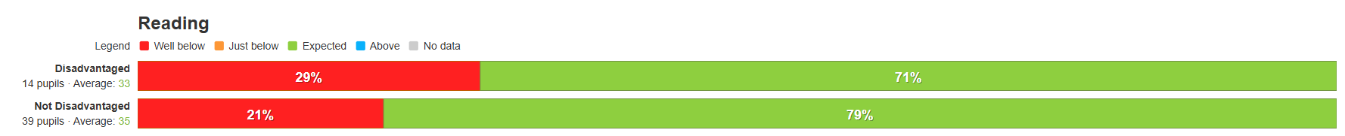
Children are happy and emotionally well regulated
We have completed the first year of MyHappyMind and have well established, tiered support (see here: https://www.highfieldhall.derbyshire.sch.uk/web/wellbeing/663266 ).
Anecdotal evidence is that, while children are often no emotionally well regulated, they have strategies to help them to re-regulate. Questionnaires showed that the majority of children felt safe and happy in school, and that they liked their teachers.
Attendance at school is encouraged whenever it is safe to be in school.
Attendance for DAP pupils is lower than that of not-DAP pupils (this is with the part time timetable children removed). This is despite the robust system in place to encourage attendance in school. However the gap between the attendance of DAP and non-DAP pupils narrowed, and there was a significant increase in DAP attendance year-on-year (+2.4%).
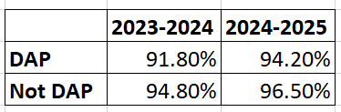

Externally provided programmes
Please include the names of any non-DfE programmes that you purchased in the previous academic year. This will help the Department for Education identify which ones are popular in England
Programme | Provider
Pathways to Read | The Literacy Company
Pathways to Write | The Literacy Company
Kapow | Kapow
MyHappyMind | MyHappyMind

Service pupil premium funding (optional)
For schools that receive this funding, you may wish to provide the following information:
Measure | Details
How did you spend your service pupil premium allocation last academic year?
What was the impact of that spending on service pupil premium eligible pupils?

Further information (optional)
Use this space to provide any further information about your pupil premium strategy. For example, about your strategy planning, or other activity that you are implementing to support disadvantaged pupils, that is not dependent on pupil premium or recovery premium funding.

Over the past year we have been working with the Behaviour Hub (now completed), and the English Hub on our early reading and phonics provision (ongoing)

