Core Values
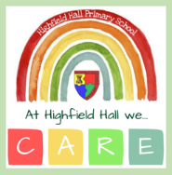

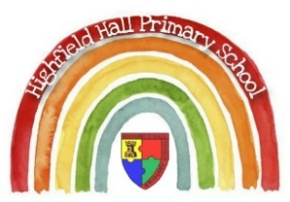
Reception – Autumn 1; All About Me
Key Theme
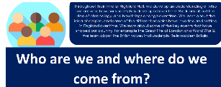

Cultural/Seasonal celebrations
Autumn
Harvest Festival
Cultural/Seasonal Sticky Knowledge
Our teachers are helping us…
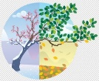
- To know that leaves change colour and fall off trees in Autumn.
Topic Sticky Knowledge
Our teachers are helping us…
- To know similarities and differences between themselves and others.
- To know what makes a healthy bedtime routine – brushing teeth, story, sleep.
We are also learning to…
- Be more independent
  - put our own coat on
  - manage my own toileting needs
In Phonics we are learning …
these phonemes – s, a, t, p, i, n, m, d, g, o, c, k, ck, e, u, r

these high frequency words – a, as, at, in, it, I, an, and, dad, am, to, into, go, no, the, can, got, on, get, not, cat, dog
Links to past and future learning
The children will build on their personal, social and emotional development gained from previous early education or nursery settings to enable them to leave their main carer confidently, build new relationships within school and learn new routines.
In Maths we are learning to …
- subitise (represent the number in a given set using different objects; name quantities with number words; match sets to numerals; make own arrangements to subitise)
- count (developing 1:1 correspondence, by counting numbers at the same time as moving or tagging the objects)
- know how numbers can be composed of 1s
- compare 2 sets of objects using more than, fewer than
- represent and compose numbers 2, 3, 4, 5
- sort and match objects

Key Texts

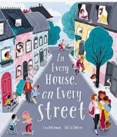
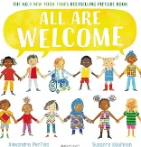
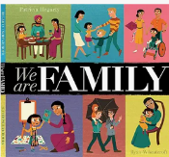
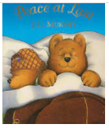
Key Vocabulary
Different  Special  Likes  Family  Home  Town/village/city  Bedtime  Tired | Similarities  Interests  Siblings  Community  Journey  Routine  Peace

Suggested Texts: fiction, non-fiction, poems & rhymes
Home by Carson Ellis
My Map Book by Sara Fanelli
A Place Called Home by Kate Baker

Starting school books e.g.
The Colour Monster
The Everywhere Bear

Seasonal books e.g.
Leaf Man,
Red Leaf, Yellow Leaf

