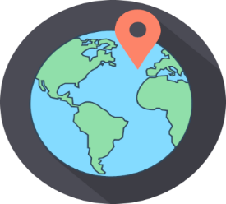
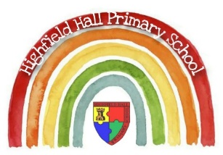
Key Theme

Year 6 – Autumn 2: Endangered Species
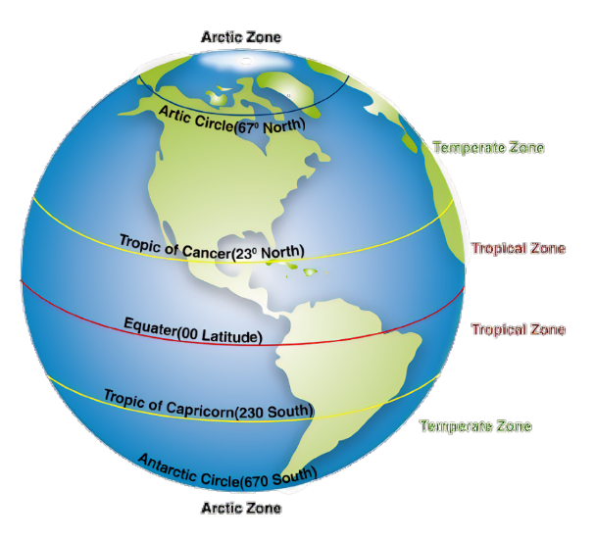
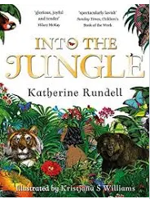
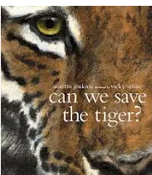
Links to past and future learning
In Year 4 and 5 we began to learn about longitude and latitude, and how they affect climate zones and biomes. In KS3 we will learn to understand how human and physical processes interact to influence and change landscapes, environments and the climate; and how human activity relies on effective functioning of natural systems.

Core Value Focus
Respect, compassion, critical thinking

Asia in Numbers
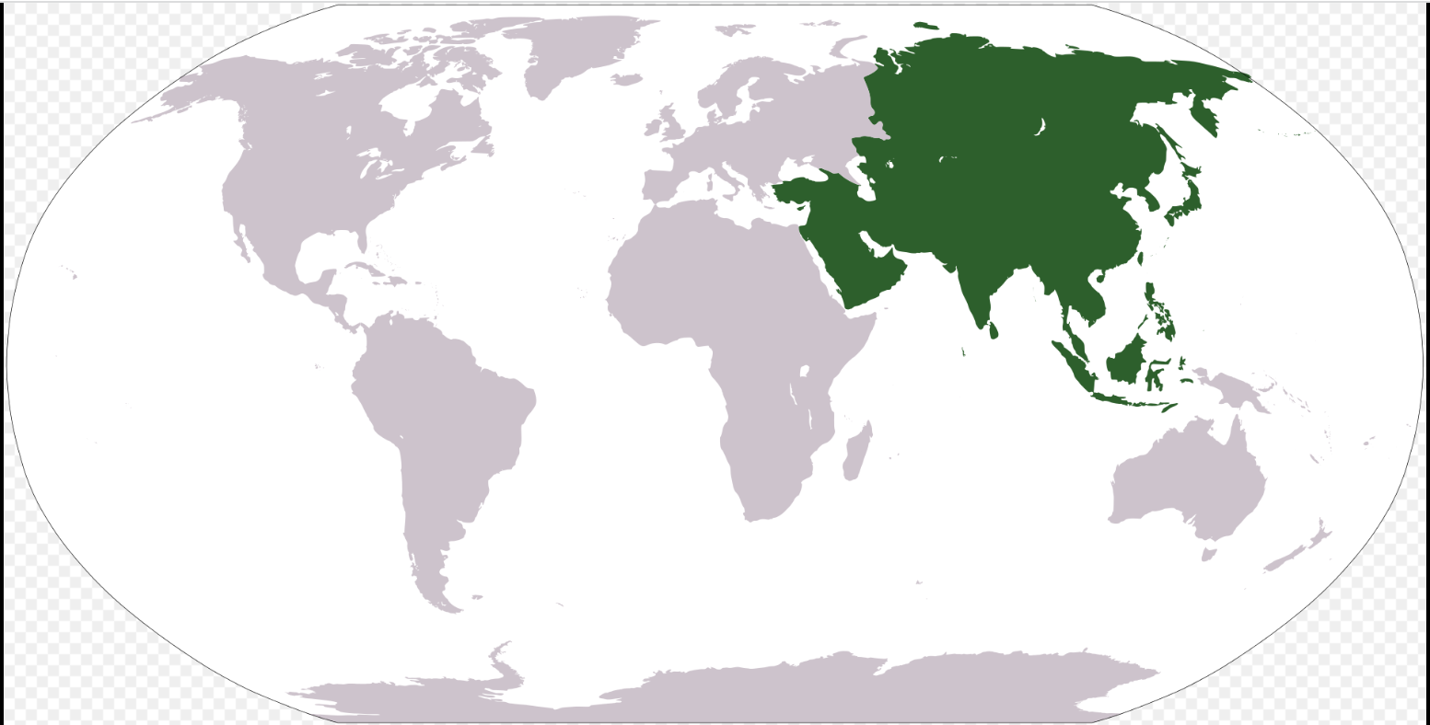
49 countries
4.7 billion people
6,300 km - River Yangtze (3rd longest in world)
8849km - Mount Everest (world’s highest mountain)

Key Texts

Sumatran Tiger
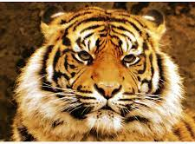
Smallest tiger species
400—600 left in the wild
Critically endangered

Sticky Knowledge & Skills
Flashback Facts:
- There are seven continents in the world. In order of size they are: Asia, Africa, North America, South America, Antarctica, Europe, Australasia/Oceania
- Land is used for a variety of purposes: Urban- housing or industry, Rural- forestry or farming
- There are five major types of biomes: aquatic, grassland, forest, desert, and tundra

Key Vocabulary
Biome | Areas of the planet with a similar climate and landscape, where similar animals and plants live
Climate | Average weather patterns and conditions of a place over an extended period of time
Conservation | The protection of things found in nature.
Continent | A mass of land on the Earth’s surface, surrounded by sea, consisting of different countries
Deforestation | When huge areas of the rainforest are cut down for timber
Endangered | An animal or plant that is at risk of becoming extinct
Extinction | The dying out of a species
Habitat | An area that is lived in by a particular species of animal.
Latitude | Lines of latitude (also known as parallels) circle the Earth from east to west.
Longitude | Lines of longitude or meridians of longitude run from the north to the south of the Earth.
Rainforest | Dense, hot forests found between the Tropic of Cancer and the Tropic of Capricorn
Weather | Short-term conditions of the atmosphere

Geography |  | Science |  | RE
Name the 7 continents in order of size:  What are the five major types of biomes:  How does climate affect biomes?  Where are rainforests found?  What is the longest river and highest mountain in Asia?  What does critically endangered mean?  How has human behaviour made extinction more likely? | Asia, Africa, North America, South America, Antarctica, Europe, Australasia/Oceania  aquatic, grassland, forest, desert, and tundra  The average weather patterns and conditions affect the types of plants which can grow in a place  Between the Tropic of Cancer and the Tropic of Capricorn  River Yangtze, Mount Everest  There are very few of a species left – they are almost extinct  Deforestation has removed their habitat, and they are killed by poachers for their skin, bones and teeth. | Living things and their habitats:  What do you call the special qualities or appearances that make an individual or group of things different to others?  - species B) characteristics C) key  What is the Linnaeus system?  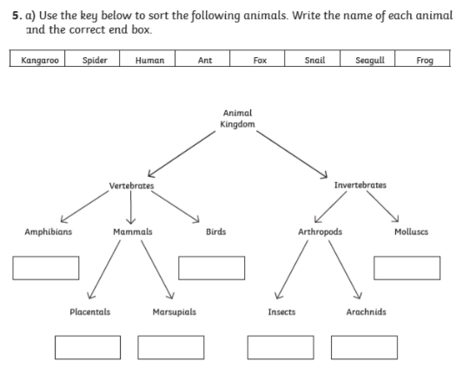  What is this a definition of?  Very tiny living things that can only be seen using a microscope. They can be found in and on our bodies, in the air or on objects around us.  - Species B) micro-organism C) bacteria  Name one of the conditions that mould will grow well  Name the three types of micro-organisms | Characteristics  A system to classify all living things  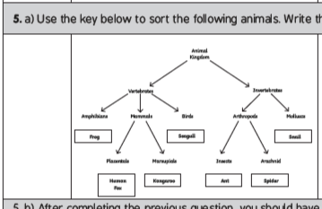  Micro-organism  Warmth, Damp, Stagnant air, Food/something to grow on  Bacteria, Fungi/fungus (not mould), Virus | Describe what Ahimsa means to Hindu believers  Describe what grace means to Christian believers  Describe what the Ummah means to Muslim believers  Who was Gandhi?  Who was Archbishop Desmond Tutu? | Living a life of kindness and compassion – for yourself, others, and the world around you  Something that is given to someone by God when it is not necessarily deserved or earned  Community of believers bound together with a common purpose- to worship God and with a common goal to advance the cause of Islam  Hindu  Indian  Non-violent Protest- Salt March  Assassinated  Christian  South African  Apartheid  Nobel Peace Prize

