Early Years Foundation Stage
myHappymind in EYFS uses books to encourage talk and education around mental health. Each EYFS class has a collection of character teddies, conversation cards and posters to support teaching and learning.
EYFS staff filter mental health education in to their everyday teaching to develop these skills further. Children are able to use their free play time to practise and develop their knowledge and skills in different contexts.
Assessment
We do not formatively assess our mental health education. However we have clear systems in place for when children need additional mental health support.
This diagram identifies the different levels of support available to children in our school:
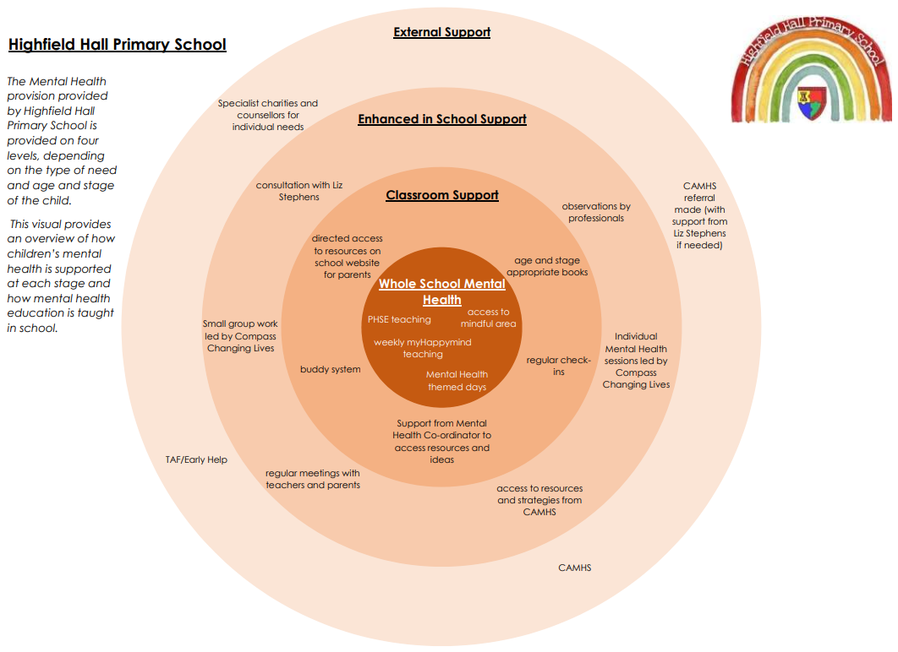
CPD
The myHappymind programme includes CPD for staff at the start of each term.
Curriculum Content
All children receive a taught mental health education for 30 minutes every week. This uses the myHappymind programme. myHappymind is additional to PSHE lessons, and is planned to be taught in every classroom on a Monday.
At the start of each unit (the start of each term), the whole school comes together for an assembly, where the new learning is introduced and foundations are set out.
The children then complete weekly work in class, completing their journals each week to document their ideas. The Year 6 curriculum focuses on transition and preparation for secondary school.
The curriculum is supported by other resources that allow for children to practise Happy Breathing at different times throughout the school day.
Parents have access to a mental health app which explains and supports what the children have been learning in school.
Pedagogy
Our Mental Health Education includes videos, retrieval, true/false statements, opportunities for discussion and journaling. Children’s learning is grouped in to five areas:
- Meet your brain
- Appreciate
- Celebrate
- Relate
- Engage
Staff award certificates at the end of each module to celebrate the children’s learning.
SEND
All children access our mental health education. Adjustments are made so that all children can discuss and record their learning.
Children with additional mental health needs can access small group or 1:1 support through Compass Changing Lives.
Further Resources and Support
https://www.highfieldhall.derbyshire.sch.uk/web/myhappymind/664832

