
Highfield Hall Primary School

We all have a statutory duty to “safeguard and promote the welfare of children” (Working together to safeguard children, DfE) up to the age of 18 years.
If you have any concerns about the health and safety of a child or young person at this education setting or feel that something may be troubling them, you should share this information with an appropriate member of staff straight away.
Some issues such as a child’s appearance, hygiene, general behaviour, can be shared with any teacher or member of support staff in this setting. Do not worry about reporting small matters – we would rather that you tell us things which turn out to be small than miss a worrying situation.
However, if you think that a child, a young person or an adult who cares for them has been or might be harmed; please talk to one of the people below immediately.
You can ask any member of staff to find them and ask them to speak to you straight away about a confidential and urgent matter.

The people you can talk to are:

Our Designated Safeguarding Lead is:
Name: Mike Bywaters
His office is located next to the Y6 classroom
His tel. no is: 01246 273534

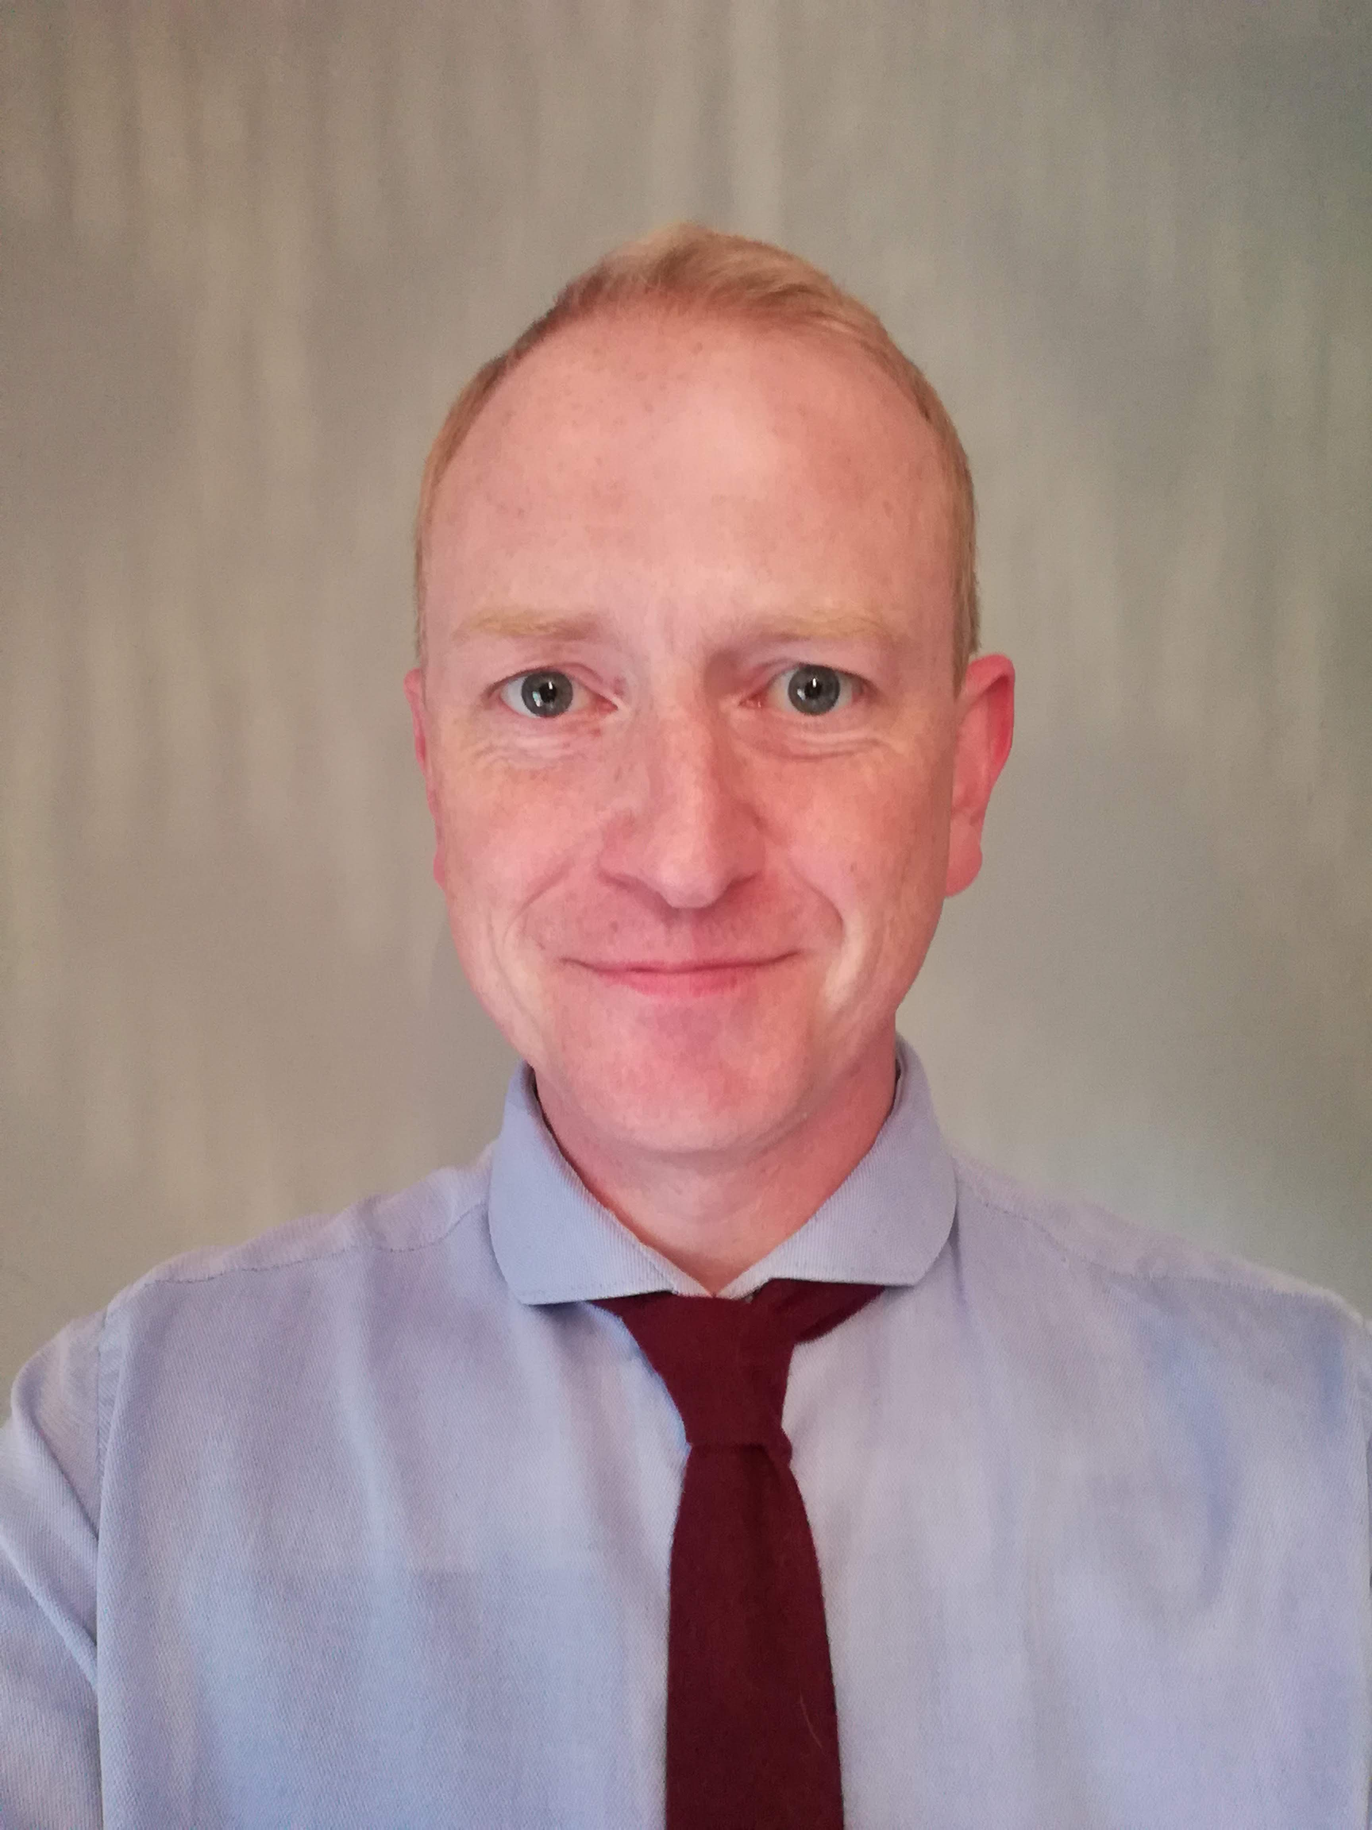e

Our Designated Safeguarding Deputies are:
Name: Anna Higham & Laura Webster
Their tel. no is: 01246 273534

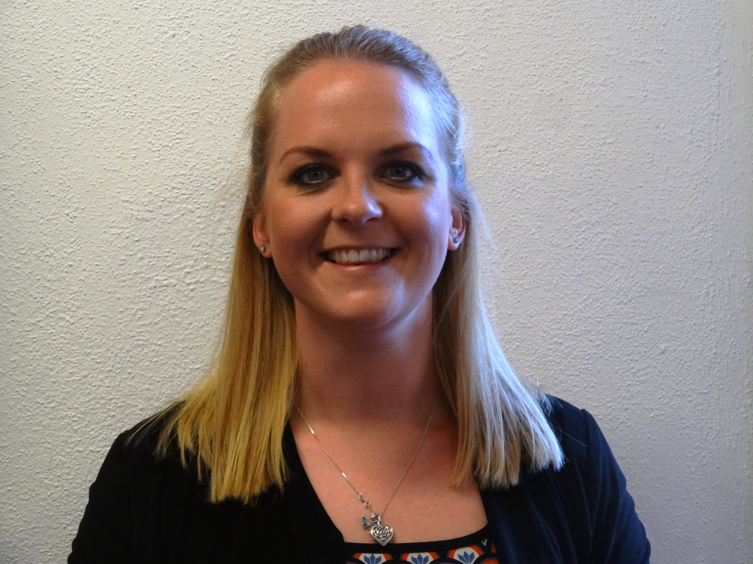
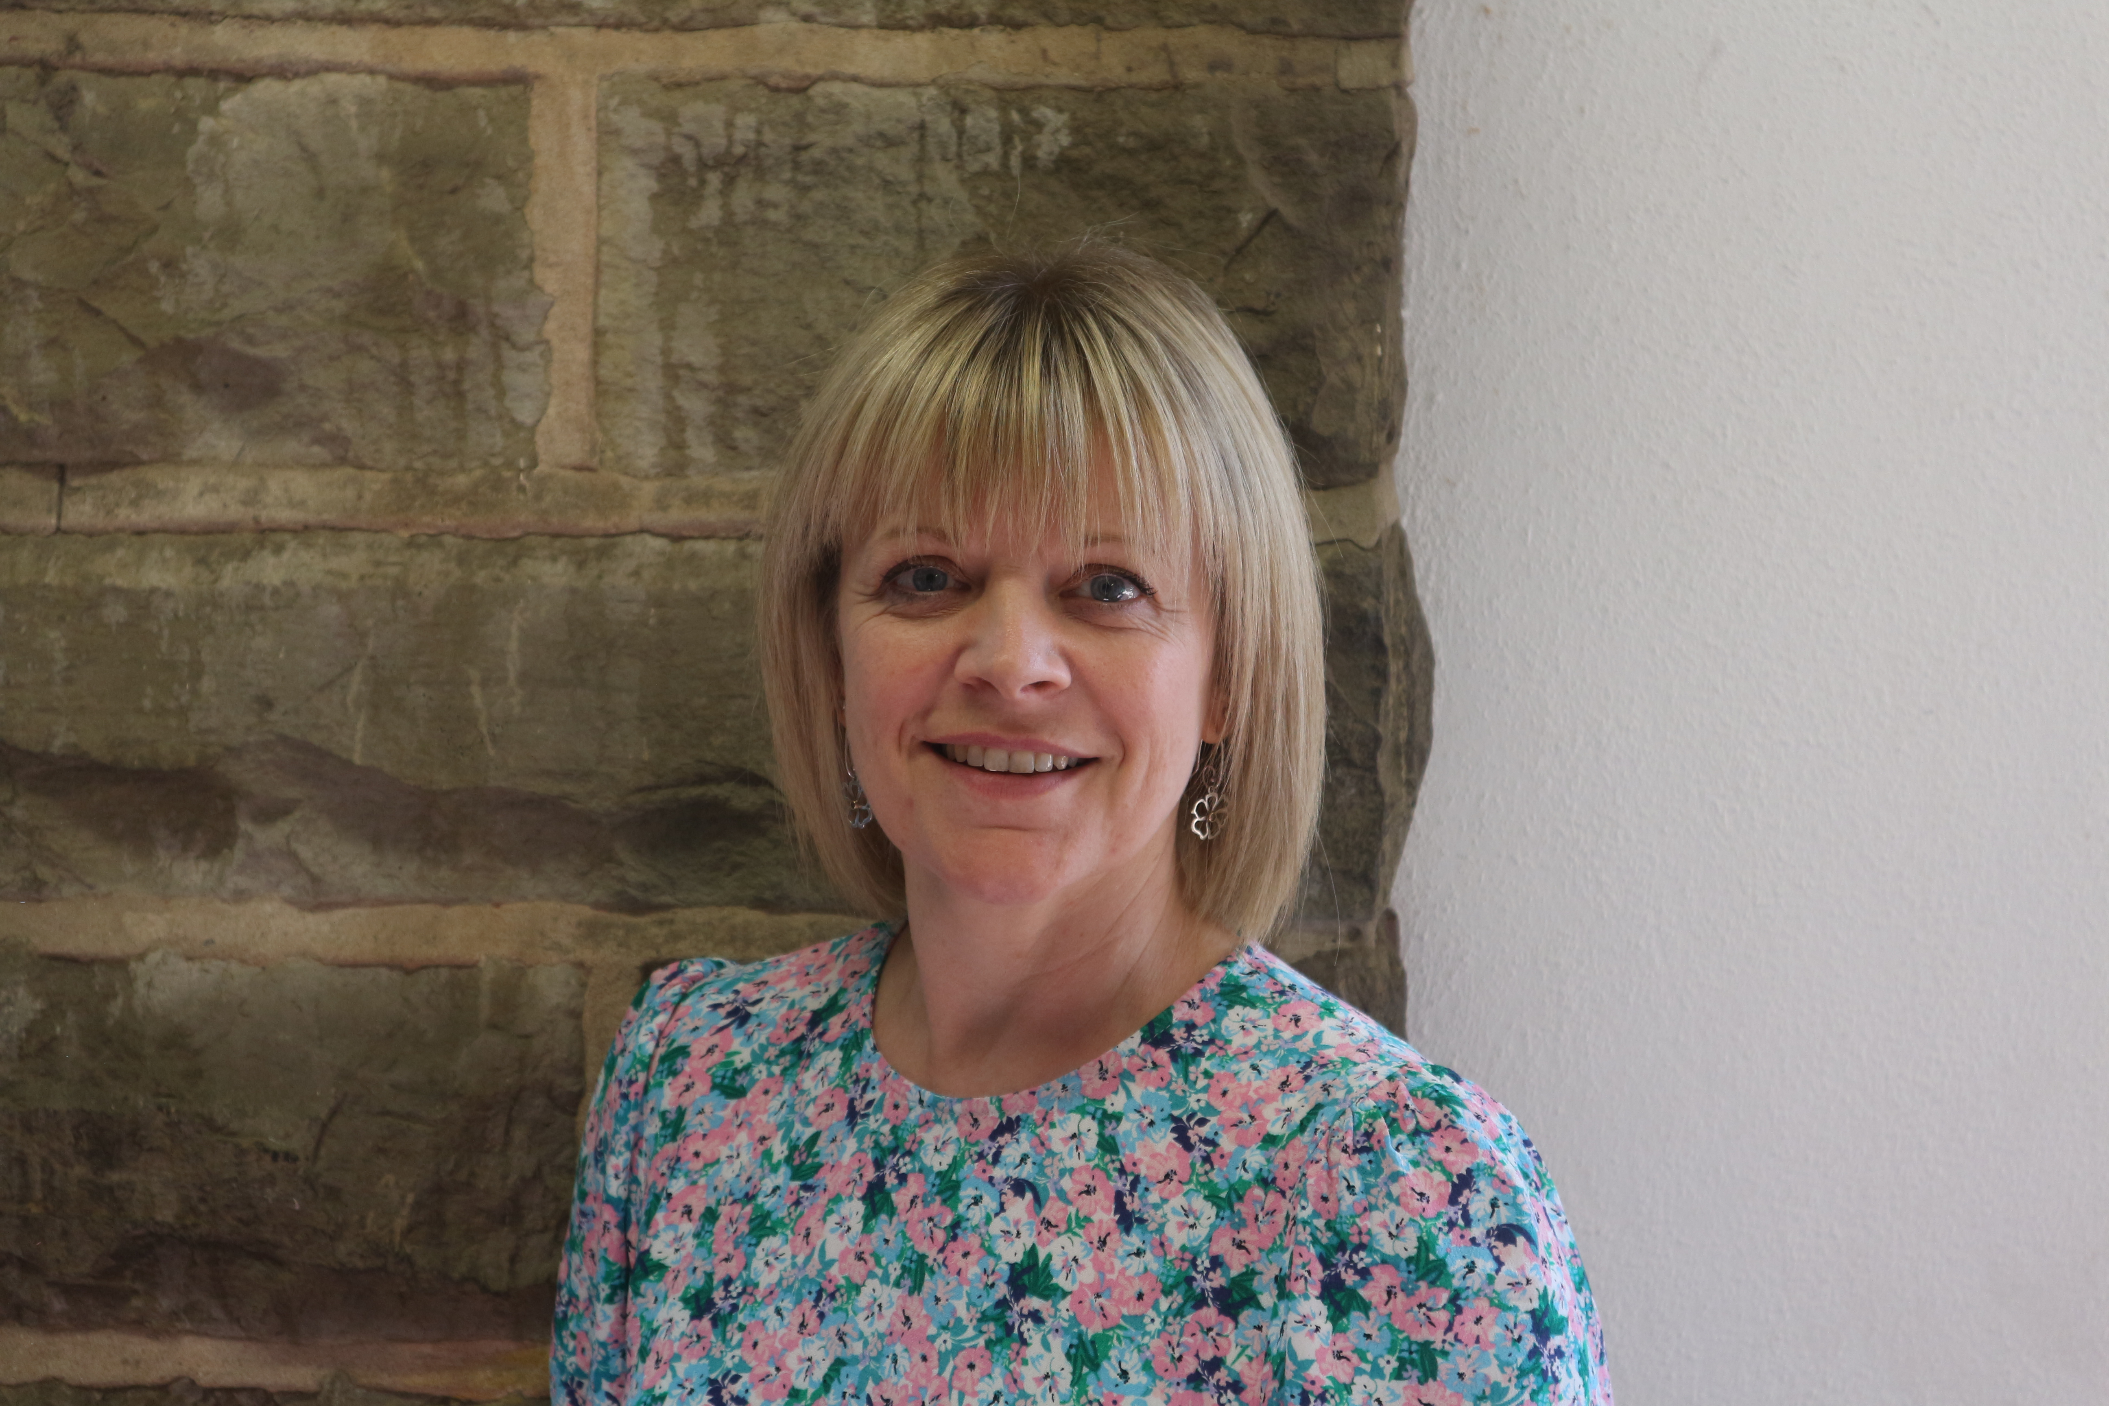

An allegation or disclosure of abuse involving someone working with children or adults in a paid or unpaid capacity must be reported directly to the Headteacher, unless it involves them and then it should be reported directly to the Chair of the Governing Body.


The Safeguarding Children Team at Highfield Hall includes:
Name: Dr. Mike Bywaters Tel no: 01246 273534
Head Teacher: responsible for implementing policies & procedures, allocating resources to the safeguarding team & addressing staff safeguarding concerns.
Designated Safeguarding Lead (DSL): teaching or pastoral staff from senior leadership team, responsible for all safeguarding issues, advising & supporting staff, liaising with the local authority & other agencies.
Child Sexual Exploitation (CSE) Lead: support for pupils & staff to understand CSE & related topics & how to refer
Looked After Children Designated Teacher: promotes the education of ‘looked after’/previously ‘looked after’ children
Online-Safety Coordinator: develops & maintains a safe online culture within a setting
Name: Mrs Anna Higham Tel no: 01246 273534
Designated Safeguarding Deputy (DSD): a teacher, support or pastoral worker, in a post which requires assessment of children, deputises for the DSL.
Special Educational Needs & Disabilities Coordinator (SENDCo): support for pupils with special education needs & disabilities as well as their parents & carers, staff & other agencies working with said pupils
Name: Mrs Laura Webster Tel no: 01246 273534
Designated Safeguarding Deputy (DSD): a teacher, support or pastoral worker, in a post which requires assessment of children, deputises for the DSL.
Mental Health Lead: a teacher responsible for overseeing the provision of mental health support in school.
Name: Mrs Sarah West Tel no: 01246 273534
Child and Parent Support Worker: a pastoral support worker, office advice and signposting to families.
Highfield Hall Safeguarding Children Team also links in with the school governors:
Name: Nicki Salt Tel no: 01246 273534
Safeguarding/Child Protection Governor: ensures there are appropriate policies & procedures in place, that they are being implemented & followed, & challenges deficiencies & weaknesses that are identified.
SENDCo Governor: link between the SEND Co-ordinator (SENDCo) and the governing body
Name: Stuart Yeowart Tel no: 01246 273534
Chair of Governors/Management Committee: leads on safe recruitment & allegations of abuse against Head Teacher & other staff & liaises with Local Authority

