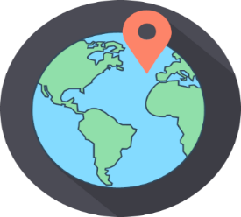
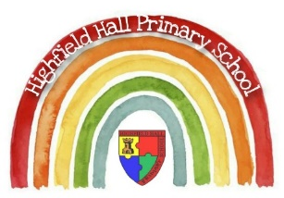
Key Theme

Year 3 – Autumn 2: One Little Drop
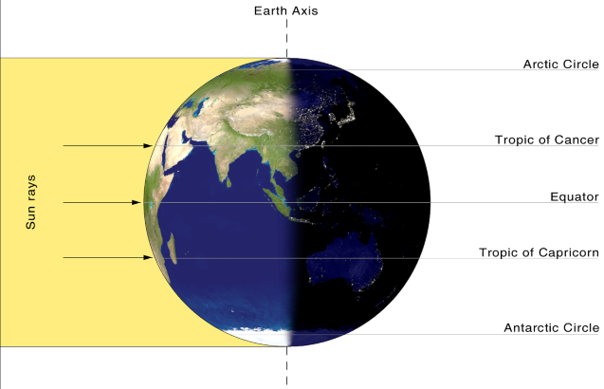
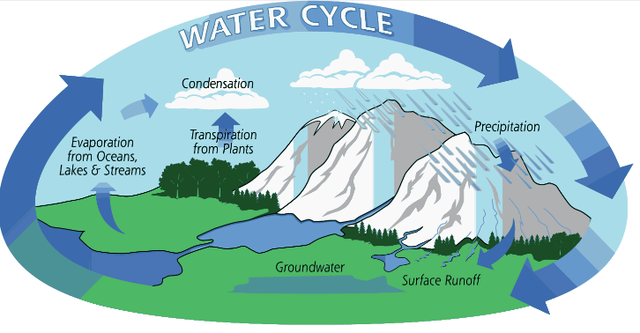
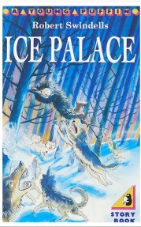
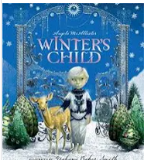
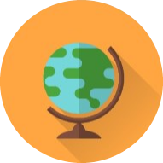
Links to past and future learning
In Year 2 we learn about the world’s continents and oceans. We learn the difference between human and physical geography. Last term we learnt about compass points.
In Year 4 we learn more about the climate zones in different parts of the world, and biomes, how the Earth is tilted on its axis, and how this can affect the climate.

Key Vocabulary
Ridges | A long, high stretch of mountain with slopes on either side
Summit | The top of a mountain
Valley | A long low area between two mountains or hills. Usually a U or V shape
Evaporation | The process of turning a liquid into a gas
Condensation | The process of turning a gas into a liquid
Precipitation | Rain, snow, sleet or hail
Collection | In the water cycle, where precipitation gathers together in oceans, lakes, rivers or streams
Equator | The imaginary line around the centre of the Earth, closest to the sun
Northern / Southern Hemisphere | The half of the globe above / below the equator
Antarctic / Arctic Circle | The Arctic Circle is located at 66.5°N latitude and the Antarctic Circle is located at 66.5 °S latitude.

Sticky Knowledge & Skills
- I know that the world in split into the Northern and Southern Hemisphere and that the equator goes around the centre of the Earth.
- I know the location of the Arctic and Antarctic Circles, and the climate there.
- I can explain the water cycle.
- I can describe the key features of a mountain: I know that a mountain has steep, sloping sides, sharp or rounded ridges and a high point called a summit.
- I know that D&T design has to have a purpose and an audience.

Core Value Focus
Critical thinking, curiosity, compassion, creativity

Key Texts

Geography |  | Science |  | RE
What is the name for the top half of the world?  What is the name for the bottom half of the world?  What is the name of the invisible line that goes around the centre of the Earth?  Where in the world is the Arctic circle, what would you need to wear for the climate and why?  Where in the world is Antarctica, what would you need to wear for the climate and why?  What are the 4 stages of the water cycle?  What happens in each stage of the water cycle?  What is the name of the highest point of a mountain?  What is the name of a dip in between 2 mountains? | Northern Hemisphere  Southern Hemisphere  Equator  At the top of the Northern Hemisphere. Warm clothes because it is freezing there.  At the bottom of the Southern Hemisphere. Warm clothes because it is freezing there.  Precipitation, Collection, Evaporation, Condensation  Precipitation = rain, slow or sleet that falls on the ground  Collection = when water that falls from the clouds as rain, snow, hail or sleet, collects in the oceans, rivers, lakes, streams  Evaporation = when water is heated and turns into a gas  Condensation = when the water cools back down and begins to turn back into water droplets.  Summit  Valley | What is a fossil?  Name 2 types of fossils.  Explain how fossils are formed. | Fossils are the remains or traces of animals or plants that were once alive.  Trace fossils / body fossils or mineralisation fossils  1- An animal dies and is covered with sediment.  2 – The soft parts rot away and the bones remain making a mould.  3 - Sediment enters the mould to make a cast fossil.  4- Over time the sediment hardens into rock and forms a fossil.  5 – Erosion and weathering cause the rock to become exposed. | What items would you find on a puja tray?  What are the items on the puja tray used for?  What does karma mean to a Hindu?  What does moksha mean to a Hindu?  What does Dharma mean to a Hindu? | Bell / Flowers / Diva lamp / Water / Spoon / Sweets or sugar / incense burner and sticks / Murtis – statues of Gods or images of Gods  Bell- to wake the deity up for worship  Flowers- represents the beauty and fragrance of the created world  Diva lamp- for aarti (Aarti- symbolises that worship removes darkness) Water in a pot-represents life  Spoon-used to give water to worshippers after it has been blessed  Murti-to worship  Sweets or sugar - an offering of food for the deity  They believe life is a cycle of birth, death and rebirth, with our actions in this life, our “karma”, affecting what happens in the next life  The end of the cycle of death and rebirth  A person's duty / religious or moral duty – duty as a father or mother

