Knowledge Organiser

P2W The Three Little Pigs / Christmas

Season: | Winter |  | Cultural or religious festivals: | Christmas
Suggested texts:  Fiction, non-fiction, poems & rhymes | The Three Little Pigs traditional story  The Three Ninja Pigs by Corey Rosen Schwartz  The Three Little Pigs from Revolting Rhymes by Roald Dahl  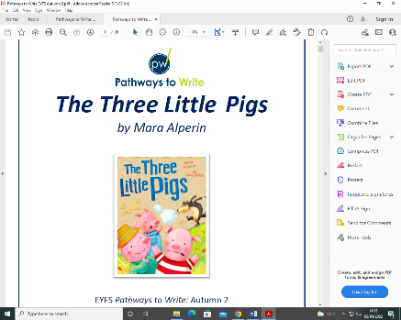  The Three Little Wolves and The Big Bad Pig by Eugene Trivizas  There’s a pig up my nose by John Dougherty  Little Red Riding Hood by Mara Alperin |  | Christmas books  The Christmas Story  The Night Before Christmas  Santa Claus is Coming to Chesterfield
Vocabulary: |  |  | Sticky knowledge:  Our teachers are helping us…
Tier 1 |  | Tier 2
Pig |  | Snout | - To know and name some traditional stories.  - To be able to describe some features of a traditional story.
Wolf |  | Beware
House |  | Beady eyes
Bricks |  | Warning
Sticks |  | Growled
Straw |  | Teeny tiny
How can you help at home? |  | Retell the story of The Three Little Pigs  Build houses out of different materials (junk modelling, Lego, sticks) and talk about the properties.  Talk about Christmas traditions in your family.  Go on a walk and talk about the changes you can see happening in nature.  Share a bedtime story together, regularly throughout the week.  Help your child to dress themselves - putting on and taking off jumpers/shoes; getting on wellies and puddle suits  Help them to go to the toilet and wash hands independently

