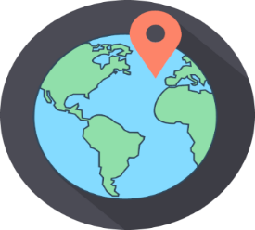
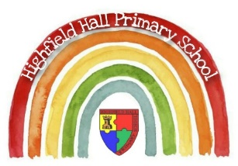
Year 6 – Spring 2: Amazon- The River and Rainforest
Sticky Knowledge & Skills
- Both the Amazon River and the Amazon Rainforest are located in South America.
- South America is made up of 12 countries and is mostly located in the southern hemisphere
- The Amazon Basin contains 20% of the World’s freshwater.
- Many natural resources are grown or sourced in the Amazon rainforest and are traded with other countries. Some of the main exports are: beef, chocolate, coffee, bananas and timber.
- Roughly an area the size of a football pitch is destroyed through deforestation in the Amazon reach minute! Some reasons for deforestation are: cattle ranching, farming land for crops, logging and mining.
- The rainforest is also home to a large number of indigenous tribes who still follow a traditional way of life — some tribes have never been contacted
- Member of the BRICS countries- Brazil, Russia, India, China and South Africa- fast economically developing countries that may dominate by 2050.

Key Theme

Key Vocabulary
Amazonia | The area within the Amazon Rainforest and around the Amazon River.
deforestation | Clearing or cutting down forests for purposes such as mining and farming.
indigenous tribes | People who are native to a place, such as tribes in the Amazon rainforest.
push factor | something that makes people want to leave a place
pull factor | reasons that encourage a person to move to a place
sustainability | Using natural resources in a way which means they won’t run out and can be used for a long time.
trade | Buying and selling goods with another country.
urbanisation | the increase in the proportion of people living in towns and cities.

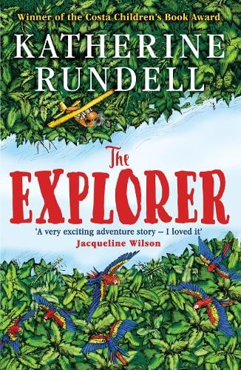
Core Value Focus
Critical Thinking, Curious, Resilient, Emotionally Healthy
Core Text

Key Places
Amazon Rainforest | Amazon River | Manaus
The Amazon Rainforest is the largest tropical rainforest in the world and it is responsible for producing 40% of the oxygen in the world. | The Amazon River is the second longest river in the world but carries the largest volume of water to the sea. The source of the river is located in Peru, in the Andes mountains. The main course of the river runs through Peru and Brazil. The mouth of the river feeds into the Atlantic Ocean. | A city located in the centre of the Amazon Rainforest and known as ‘Heart of the Amazon’ and ‘City of the Forest’.
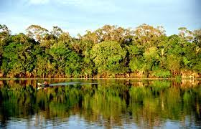 | 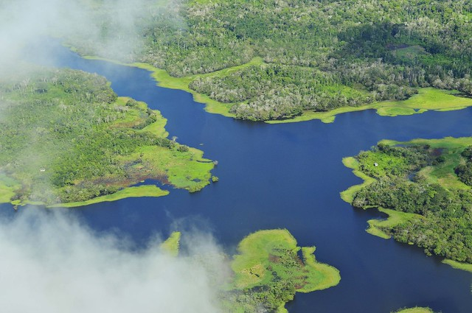

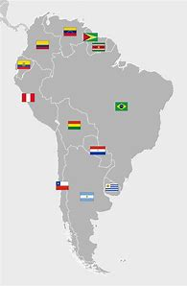
Countries in South America:
Argentina, Bolivia, Brazil, Chile, Colombia, Ecuador, Guyana, Paraguay, Peru, Suriname, Uruguay, Venezuela.

Links to past and future learning
In Year 5 we learnt about climate zones, latitude and longitude and the Koppen system. In Year 6 we have studied biomes and the continent of Asia.

Geography |  | RE
How many countries are there in South America?  What is the biggest country by land mass in South America?  In which countries is the Amazon Rainforest located?  Which physical features is Brazil famous for?  What is a push factor?  What is a pull factor? | 12  Brazil  Brazil, Bolivia, Peru, Ecuador, Colombia, Venezuela, Guyana, and Suriname  Amazon Rainforest, Amazon River  Reasons why a person moves from a particular area- lack of services, safety, crime, crop failure, drought, flooding, poverty, war.  Reasons why a person moves to a particular area- higher employment, increased wealth, better services, good climate, more fertile land, lower risk from natural hazards. | Match the Christian artwork to its creator:  Leonardo Da Vinci The Last Supper  William Holman Hunt Jesus, Light of the World  Lorna May Wadsworth Last Supper  Michelangelo Madonna of Bruges  John Piper Chichester Alter Tapestry
 |  | Why are cathedrals so big?  Give an example of a British cathedral  Give a reason why people should sell their building or artwork.  Give a reason why people should not sell their building or artwork. | - to make space for people to worship God in large groups  - to express the importance and grandeur of God  St Paul’s Cathedral (London)  Anglican Cathedral (Liverpool)  Metropolitan Cathedral of Christ the King (Liverpool)  - art and architecture don’t save lives  - there are spaces than required  - Doing good is more important- can be good without God.  - Worship encourages believers to be generous  - Poor people want to worship too.  - Religious buildings often have a wider community role  (Answers from Unit Plan)

