# H:\Logo.jpg

Year 5 – Summer 2: The Benin Civilisation

|  |
| --- |
| **Key Theme** |
|  |



|  |
| --- |
| **Core Value Focus** |
| Curiosity, critical thinking, resilience, compassion. |

|  |
| --- |
| **Key Texts** |
| African Tales : A Barefoot Collection |

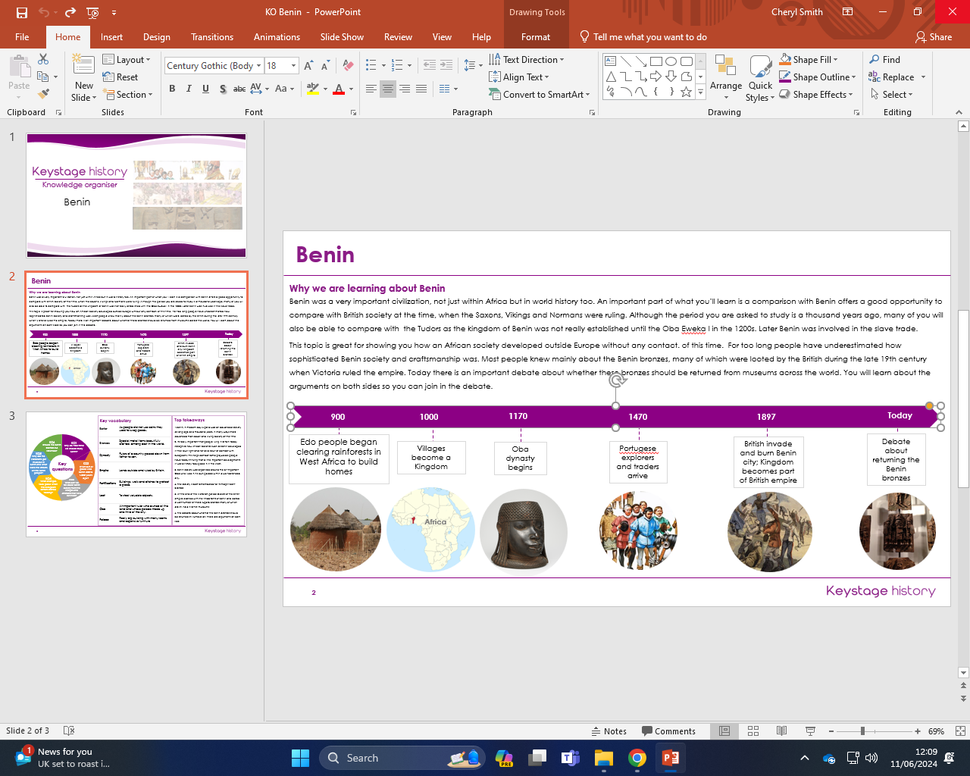

|  |
| --- |
| **Links to past and future learning** |
| In Y4 we learnt about Ancient Rome  In Y6 we will learn about World War 2 |

|  |  |
| --- | --- |
| **Key Vocabulary** | |
| **Barter** | As people did not use coins they used to swop goods |
| **Bronzes** | Special metal items beautifully crafted, among best in the world. |
| **Dynasty** | Rulers of a country passed down from father to son. |
| **Empire** | Lands outside and ruled by Britain |
| **Fortifications** | Buildings, walls and ditches to protect a place. |
| **Loot** | To steal valuable objects. |
| **Oba** | All-important ruler who owned all the land and whose palace made up one third of the city, |
| **Palace** | Really big building with many rooms and expensive furniture |

|  |
| --- |
| **Sticky Knowledge & Skills** |
| * **I know that Benin is now where modern day Nigeria is.** * **I know that Benin society was organized around the all-important Oba who lived in his own palace with well defended walls.** * **I know that they created magnificent bronzes.** * **I know how the Benin civilisation came to an end at the end of the Victorian period soldiers of the British empire clashed with the inhabitants of Benin and looted a vast number of these superb bronzes many of which are still held in British museums.** * **I know that people are still debating whether the Benin bronzes should be returned. There are arguments on both sides.** * **I can talk about sources of evidence and how useful they are in telling us about the past.** |

|  |  |  |  |  |  |
| --- | --- | --- | --- | --- | --- |
| History | | Science | | RE | |
| When was the Benin Empire?  Can you remember any characteristics of Benin daily life?  How do people know about life in Benin?  What was the ruler called?  Why did the civilisation end? | 900- 1897 AD  Farmers  Markets  Processions  Iron work  Used cowrie shells  Prized Coral  No written documents from the time  Oral storytelling  Some artefacts  Oba  The British invaded |  |  | Where do Jewish people worship?  What is the holy book of Judaism?  What is the religious leader called?  What is the Torah?  How is the Torah linked to the Bible?  How is respect shown to the Torah? | At home or at a synagogue  Tanakh  Rabbi  Part of Tanakh  Scroll  Given to Moses  Mount Sinai  Laws  The first five books of the Bible are the same as in the Torah  Kept in a special cupboard (ark)  Use a stick to read (yad) |