Key Theme

Year 4 – Autumn 1: Crazy Climates
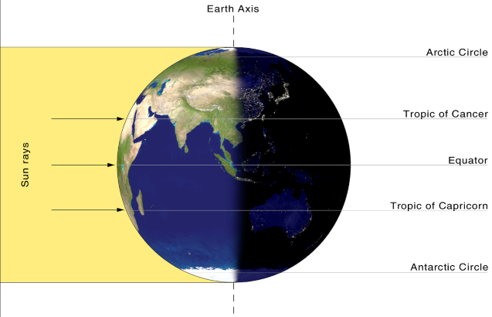
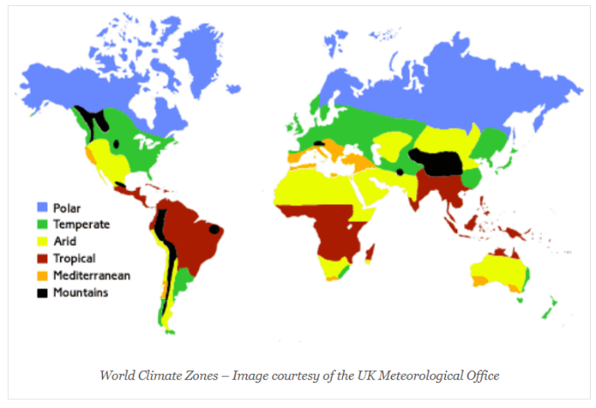
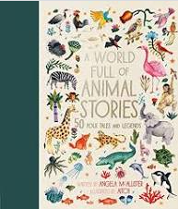
Climate Zones
Polar – cold and dry all year, Temperate – cold winters and mild summers, Arid – hot and dry all year, Tropical – hot and wet all year, Mediterranean – mild winters, hot try summers, Mountains (tundra) – very cold all year

Core Value Focus
Creative, Critical Thinking, Curious, Resilient, Emotionally Healthy

Place names
Cairo (Egypt)
London (UK)
Manaus (Brazil)
Nuuk (Greenland)
Santiago (Chile)
Seville (Spain)

Links to past and future learning
In Year 3 we learn some of the physical similarities and differences between the UK and other parts of the world. We use maps, atlases and globes to locate countries. In Year 5 we study how climate zones lead to different biomes, and the significance of latitude and longitude and the Greenwich Meridian.

Key Texts

Sticky Knowledge & Skills
- The tropics of Cancer (Northern Tropic) and Capricorn (Southern Tropic) mark the most northerly and southerly positions that the sun can be directly overhead.
- Between the tropics the weather is hot all year round.
- Rainfall can vary here. In some places there is very little rain, some places have a rainy season, and some places have lots of rain all year ground.
- There are 6 main climate zones: Polar, Temperate, Arid, Tropical, Mediterranean and Mountains (tundra).

Watch a video about the Earth’s tilt here!
Key Vocabulary
Weather | Day to day conditions in a certain place, e.g. sunny, rainy
Season | A part of the year marked by different weather patterns and daylight hours, resulting from the Earth’s changing position in relation to the sun
Temperature | How hot or cold something or somewhere is. Can be measured in centigrade or Fahrenheit
Equator | An invisible line equidistant from the North and South poles which divides Earth into the Northern and Southern Hemispheres
Polar | The area around the North or South Pole.
Climate | Weather patterns in a certain place which are measured over a period of time
Climate Zone | An area with a distinct climate, e.g. an arid climate zone which is very hot and dry
Meteorologist | An expert weather forecaster
Axis | The Earth is tilted on an axis and does a full spin every 24 hours

Geography |  | Science |  | RE
What is a climate zone?  What are the 6 main climate zones:  What is the climate like in each of the zones?  What is the equator? | An area with a distinct climate, e.g. an arid climate zone which is very hot and dry  Polar, Temperate, Arid, Tropical, Mediterranean and Mountains (tundra).  Polar – cold and dry all year, Temperate – cold winters and mild summers, Arid – hot and dry all year, Tropical – hot and wet all year, Mediterranean – mild winters, hot try summers, Mountains (tundra) – very cold all year  An invisible line equidistant from the North and South poles which divides Earth into the Northern and Southern Hemispheres | What causes a guitar to make a sound?  How do you hear sounds?  Bigger vibrations will lead to a _______ sound.  The further away from a sound the _________ it will be.  If you ‘twang’ an elastic band, as you stretch it the pitch will get _____________ | The strings vibrating  The vibrations travel through a medium (e.g. air) to your ear  Louder  Quieter  Higher | What is the Hindu view of life?  What is Moksha?  What could a Hindu do to help them to achieve Moksha?  Name a Hindu festival which is celebrated in Britain.  Name one thing that is exciting about being a Hindu in Britain.  Name one thing that is challenging about being a Hindu in Britain. | Reincarnation - Once you die, you are born again in another body, and live another life.  Release from the cycle of birth and death where Hindu’s are reunited with God.  Children can name any good deeds - chores/jobs/helping others/being selfless.  Holi or Diwali.  Vibrant culture, food, festivals, clothing, worship.  Two cultures, two languages, religious views that might clash with friend's views.

