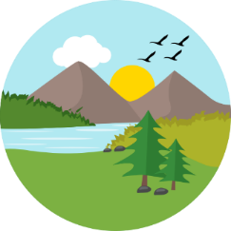
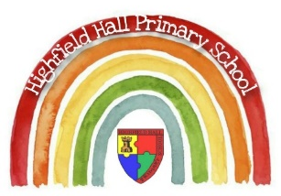
Year 4 – Summer 1 – The Greatest Show
Key Theme

Key Vocabulary
Settlement | Settlements are communities where people live. The different types of settlements are: town, city and village.
Agricultural Land | Land used for farming, cattle and crops.
Commercial Land | Land used for buildings aimed at making money.
Residential Land | Land used for houses and apartment blocks.
Recreational Land | Land which has buildings providing fun activities.
Transportation | A way of getting something from one place to another.
Ceramics | Things made from clay which are hardened using heat.
Form | Three dimensional shapes in art.
Found objects | Objects not considered art materials being used to make art.
Organic shape | Irregular natural shapes.
Sculpture | Three-dimensional art made by carving, modelling, casting or constructing.
Typography | The art of designing and arranging letters to make them look appealing.

Sticky Knowledge & Skills
- To know the names of some of the world’s most significant rivers.
- To know the name of some counties in the UK (local to our school).
- To know the name of some cities in the UK (local to our school).
- To know the name of the county that they live in and their closest city.
- To begin to name the twelve geographical regions of the UK.
- To know the main types of land use.
- To know some types of settlement.
- To know an urban place is somewhere near a town or city.
- To know a rural place is somewhere near the countryside.
- To know that a natural resource is something that people can use which comes from the natural environment.
- To know the UK grows food locally and imports food from other countries.
- To understand that a scale shows how much smaller a map is compared to real life.
- To know that an OS map shows human and physical features as symbols.
- To know the main types of land use (agricultural, residential, recreational, commercial, industrial and transportation).

Core Value Focus
Critical thinking, emotional health, compassion.

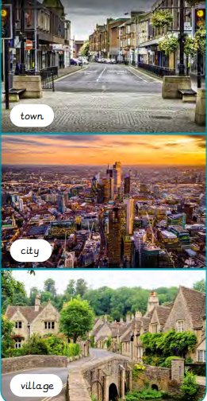

Links to past and future learning
Previously the children have learned the difference between human and physical features in the word around them and how these can be recognized.
When the children move to year 5 and 6 they will Investigate why certain parts of the world are more populated than others; exploring birth and death rates; discussing social, economic and environmental push and pull factors; learning about the population in Britain and its impacts.

Key Texts
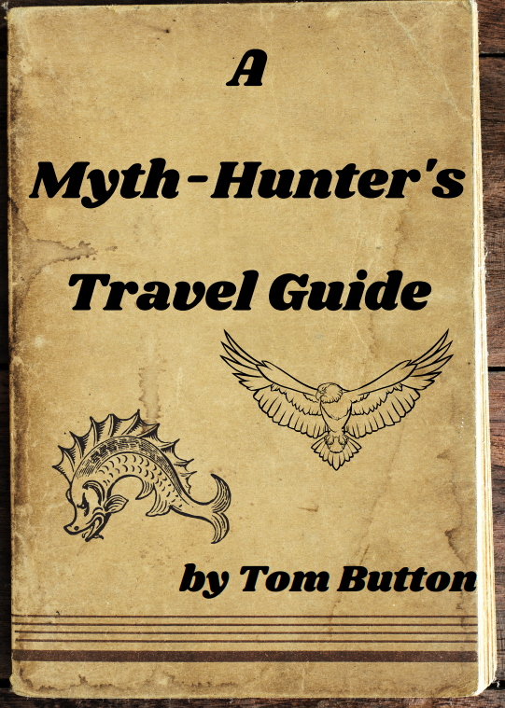

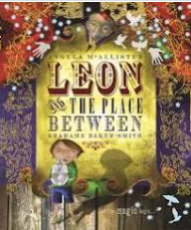

Geography |  | Science  (Dangers to living things) |  | RE
What are the three types of settlement?  What is the largest type of settlement?  A benefit of living in an urban area is that……  A benefit of living in a rural area is that……  What is an example of a physical feature? | Town, city and village.  A city  There are lots of entertainment and leisure facilities. (suitable choices)  There is lots of countryside to enjoy. (suitable choices)  An area of woodland, mountains, seas and rivers. | What is a food chain?  What is the difference between a vertebrate and an invertebrate?  How do the following vocabulary words link together – predator, prey, consumer and producer?  What does a producer do within a food chain?  What does a conservationist do? | A food chain shows how each living thing gets its food.  A vertebrate has a backbone (spine) whereas an invertebrate does not.  They are all elements of a food chain.  Predators eat prey, consumers eat something and producers are plants which make their own energy.  It produces its own energy. It is a plant.  They try to protect an environment from danger. E.g. From flooding or fire. | When did the last supper happen?  What did Jesus share at the last supper?  What is the name of the Christian ceremony where bread and wine is shared?  What does the bread and wine represent? | The day before Jesus’s death  Bread and Wine  Holy Communion  Bread = Body of Christ, Wine = Blood of Christ

